PERSONAL INFORMATION | Dijana Popovska 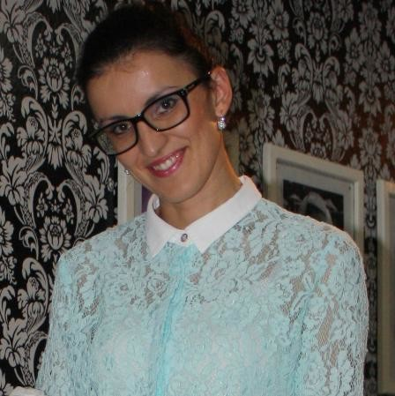  28.04.1983

Prevalec 15, 7000 Bitola

dijana206@yahoo.com
075/226-402

POSITION  WORK EXPERIENCE | VIDEO EDITOR  ___________________________________________________

08.02.2017 - Present  15/09/2015 – 15/08/2016  25/01/2015 – 30/08/2015 | Office Administrator  Kartomel Dooel – Bitola  - Constant communication with customers, gathering information about their needs, how they work and how can we optimize their business  - Assisting with all aspects of administrative management, directory maintenance,  logistics, equipment and storage  - Managing documents and files  - Assisting in various daily operations  Call Representative  Rohteinstein international – Bitola (Macedonia)  - Build sustainable relationships and engage customers by taking the extra mile  - Indentify customers needs, clarify information, research every issue and provide  solutions and / or alternatives,  Sales Manager  T.A. Teotravel – Bitola, (Macedoia)  - Working with customers, working with big hotels. creating travel offers  and other travel promotions,making contracts with other companies,  Cooperation with clients  - Leading big groups on tours across Europe

08/10/2007–01/05/2008 | Mentor on Pedagogical Faculty – Bitola
08/10/2007–01/05/2008 | University St. Kliment Ohridski - Bitola, (Macedonia), Bitola (Macedonia)
08/10/2007–01/05/2008 | - ​ Actively involved in multiple researches about  - Actively working with students as a mentor giving guidance and help  and working with professors improving the program  - Working on a team

07/11/2005–05/05/2006 | Translator
07/11/2005–05/05/2006 | Tv. Orbis, Bitola, Bitola (former Yugoslav Republic of Macedonia)
07/11/2005–05/05/2006 | - Translating documentary films​

01/04/2011–05/09/2011 | Columnist
01/04/2011–05/09/2011 | Astra Magasin, Bitola (Macedonia)

10/09/2003–2005 | Sales and marketing department manager
10/09/2003–2005 | "Diola" - Store for Healty food, Bitola (Macedonia)

01/10/2010–Present  2009 - 2014 | Court translator
01/10/2010–Present  2009 - 2014 | Bitola (Macedonia)
01/10/2010–Present  2009 - 2014 | Agent - Broker for insurance  Eurolink – Bitola, (Macedonia)

2007–2012 | Sales representative
2007–2012 | Avon Cosmetics, Bitola (Macedonia)

01/11/2013–01/02/2014 | Secondary education teaching professional
01/11/2013–01/02/2014 | KEC Consalting "Ceokon", Bitola (Macedonia)

EDUCATION AND TRAINING

01/10/2005–09/07/2009 | Professor for Macedonian and French language
01/10/2005–09/07/2009 | University St. Clement Ohridski - Bitola "Pedagogical faculty", Bitola (Macedonia)
01/10/2005–09/07/2009 | - Contemporary French  - Grammar  - Literature  - Contemporary Macedonian language
2015 | Diploma for Work Ready Now (USAID YES Network Projects)
2015 | Diploma for English Language IV degree

2011/present | Court translator
2011/present | Department of justice, Skopje (Macedonia)

PERSONAL SKILLS

Mother tongue(s) | Macedonian
Other language(s) | UNDERSTANDING |  |  | SPEAKING |  |  |  | WRITING
Other language(s) | Listening | Reading |  | Spoken interaction |  | Spoken production
English | C2 | C2 |  | C1 |  | C1 |  | C1
French | C2 | C2 |  | C1 |  | C1 |  | C2
 | Diploma from University St. Clement Ohridski
Spanish | A2 |  | A2 |  | A1 |  | A1 |  | A1
Serbian | C2 |  | C2 |  | B2 |  | B2 |  | B2
Levels: A1/A2: Basic user - B1/B2: Independent user - C1/C2: Proficient user
Common European Framework of Reference for Languages

Skills and specialties
- Communication.
- Social media.
- Content management systems.
- Analytics.
- Mobile advertising.
- Video content.
- Layout and design.

Computer skills | Good command of Microsoft office (word, excel​)  - Internet

Driving licence | B

