PERSONAL INFORMATION | Zalo Myftari
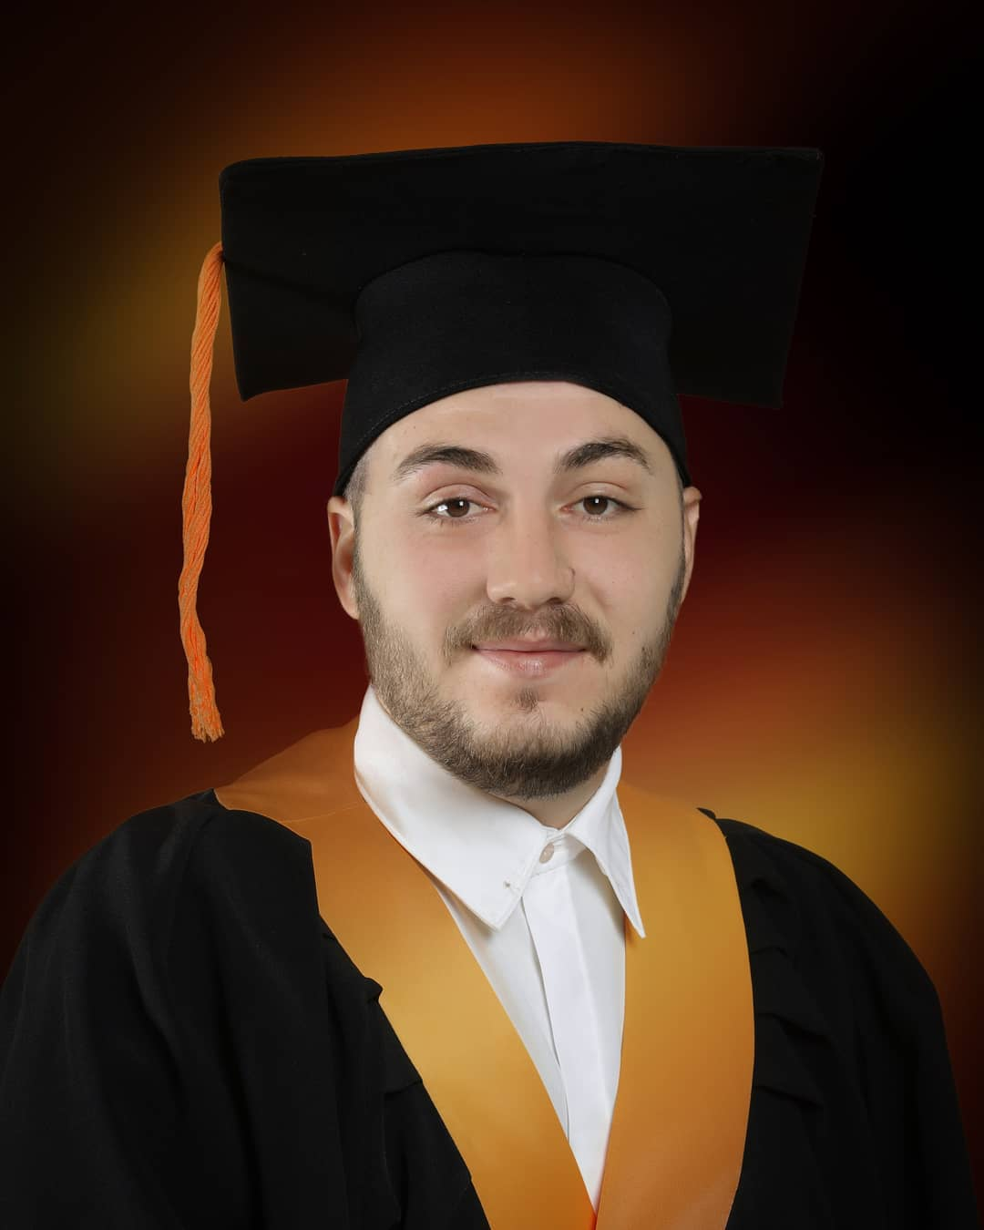 |   Car Samoil 278, Bitola 7000, R. North Macedonia

047 613 458  075 564 035

zalo-bt@hotmail.com
 | Sex Male Date of birth 08/10/1996 Nationality Albanian

APLYING FOR JOB POSSITION | Video Editor

WORK EXPERIENCE

Summertime job at “Partizan” - Bitola – 3 summers

Summertime job at “Olimpiski Bazen” - Bitola – 2 summers

Intern at “Fustelarko Borec” - Bitola – 2017 - 2020

EDUCATION

High school graduate at SOTU “Gorgi Naumov” - Electrical technician for computer technology and automation

University diploma at BAS – Biznis Akademija Smilevski – Operations manager

SKILLS

Native language | Albanian
Other laguages | MACEDONIAN |  | ENGLISH
Other laguages | Writing | Speaking | Writing | Speaking
 | 10 | 10 | 10 | 10

Comunication skills | Exelente comunication skills with clients and coligues.
Other skills | Microsoft office, Excel, Internet. Administration skills, management skills, Photoshop, Video editing skills(Sony Vegas) and Audio editing skills(FL Studio).

