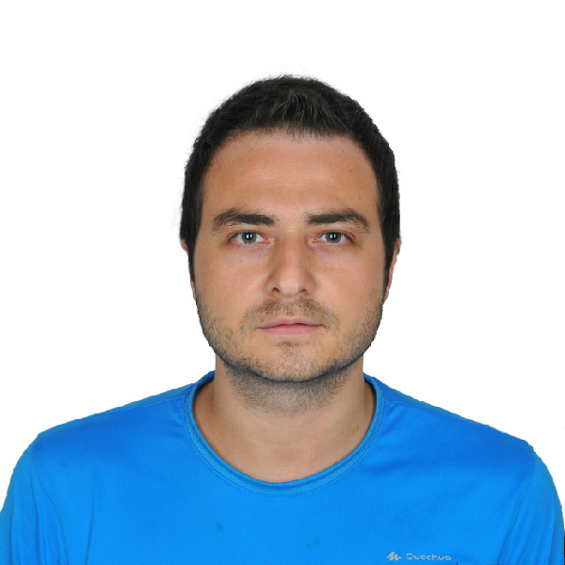
Frontend Developer
Erkam Computer - Turkey
SELMAN DEMIRDOVEN
FULL STACK WORDPRESS DEVELOPER DEVELOPER
WORK EXPERIENCE
TECH. SKILLS

HTML / CSS

PHP

JAVASCRIPT / JQUERY

BOOTSTRAP

WORDPRESS DEVELOPMENT

PHOTOSHOP

PSD TO HTML

PSD TO WORDPRESS

EDUCATION
Phone: +90 533 322 73 36 / +380 99 609 32 60
Email : dev.orion35@gmail.com
Skype : dev_orion35
Web : www.devorion.work
2012 - 2014
Full Stack WordPress Developer
Herasoft Software Co - Turkey
2019 - Present
IT Staff
Kocaeli University - Turkey

Faculty of Economy (Bachelor Degree)
Anadolu University
2014 - 2018
2017 - 2019
Full Stack WordPress Developer
Freelancer Platforms - World
LINKS
https://www.linkedin.com/in/selman-demirdoven
https://github.com/demirdoven
https://www.fiverr.com/orion35
https://bionluk.com/orion35

LANGUAGE SKILLS

Turkish
Native

English
Advanced

Russian
Beginner
2014 - 2017
PHP Developer
DataTech Co – Ukraine
2019 September – 2019 October (Temporary)
CONTACT DETAILS

