Kondeski Filip

Phone 071-641500 (mobile)
filipkondeski@hotmail.com

Technical skills

Adobe Photoshop
Microsoft office
Profound knowledge in Microsoft operating systems as in server products like Microsoft Server 2003/2008 with required official Microsoft certifications

Former engagements

Ein-Soft IT and Software Company in 2009, where worked at several project and assignments:

- Concept web design and photo editing for global Jonson Controls global web page
- II consulting, systems and networking servicing and administration
- SEO marketing

High Fashion company Elena Luka DOOEL Skopje from 10.2010 until 31.02.2015
- IT consulting and servicing
- Network administration
- Fashion photography and editing

Freelancer in IT consulting from 2015

Formal qualifications

Middle school: Economic Middle School – Vasil Antevski Dren
College degree in e-business from state university Cyril and Methodius, Faculty of Economics Skopje
Official Microsoft Certificates for MCST/MCP –Microsoft Certified Technology Specialist
QA Software Testing from SEDC -Seavus Education and Development Center

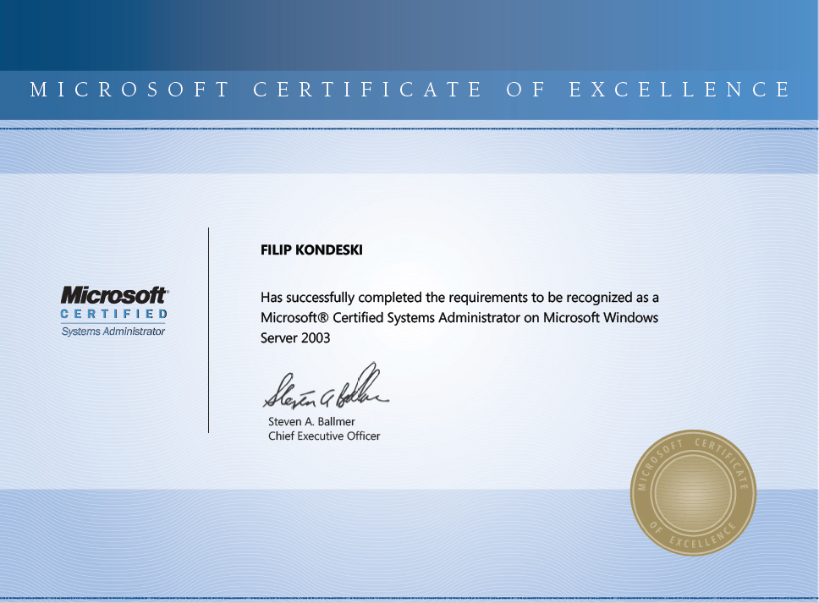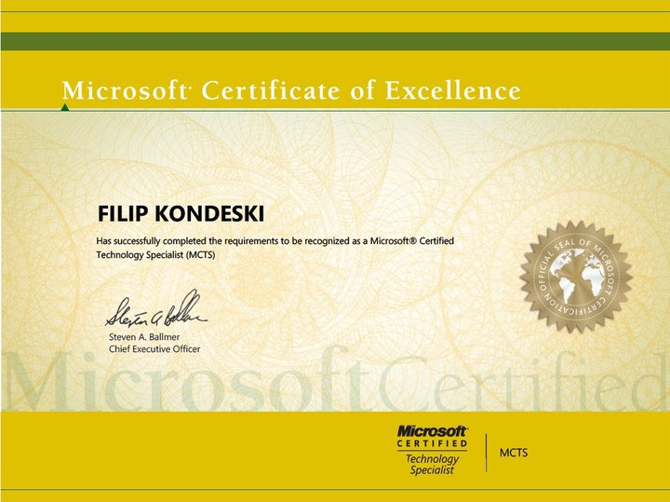

Personal details

Date of birth: 22.12.1985 Languages: Fluid English

Nationality: Macedonian Health: Excellent

Other Activities and interests

I am interested in digital photography and editing, 2D design, computer hardware and servicing computer systems.

