

Europass  Curriculum Vitae | 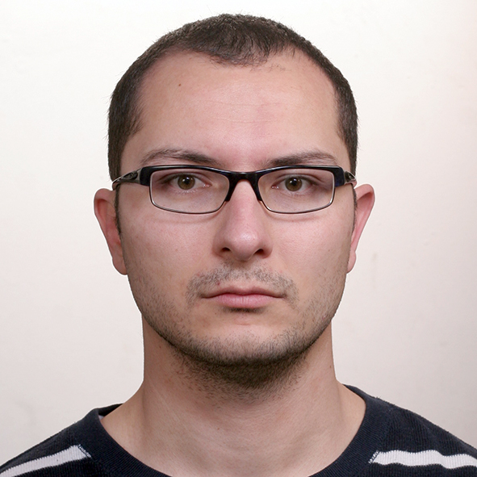
Personal information
First name(s) / Surname(s) | Ljupce Gocev
Address(es) | Dimitar Vlahov 66  2310 Vinica
Telephone(s) | Mobile (+389) 78 304 390
E-mail | ljupcegocev84@gmail.com
Nationality | Macedonian
Date of birth | 19 December, 1984
Gender | Male
Desired employment / Occupational field
Work experience  Dates  Occupation or position held  Main activities and responsibilities  Name and address of employer  Types of business or sector  Dates  Occupation or position held  Main activities and responsibilities | October 2012 – to date  Political Research Assistant  Undertaking relevant political research and analysis control over the work of the administration, conduct public opinion surveys, supervising junior staff, distributing information in a variety of formats, writing reports.  IPIS- Institute for Political Research - Skopje  Political  2011 - 2012  Work and Travel Program for Students in USA – Supervisor of lifeguards  Responsible for day-to-day supervision of assigned aquatic programs including scheduling of lifeguards. Increase lifeguards’ awareness of all healthy lifestyle factors, cleanliness and safety.
Name and address of employer  Types of business or sector  Dates | Continental Pools Inc. – MD, USA  Services  September 2005 – June 2009
Occupation or position held | Part time job as translator of seminar works for students from different faculties.
Main activities and responsibilities | Translation from Macedonian into English and vice verse.
Education and training  Dates  Principal subjects/occupational skills covered  Key Qualifications & Responsibilities  Name and type of organization providing education and training  Dates | October 2020 – May 2021  Software Test Engineer  Learned how to identify test scenarios, create test plans and estimate test effort. How to maintain regression test suite and other types of scenarios. Create audit processes and key metrics to ensure the established goals are met. I have managed to successfully edit assignments, solve problems and identify possible solutions.  Brainster – Academy for Software Testing  October 2010 – May 2011
Principal subjects/occupational skills covered | M.A of Public Policy at the Faculty of Political Science “Justinian I“.
Name and type of organisation providing education and training | Cyril and Methodius University – Skopje, Macedonia
Dates | October 2003 – June 2008
Principal subjects/occupational skills covered | B.A in Political Science – Law Faculty “Justinian I”
Name and type of organisation providing education and training  Mother Tongue(s) | Cyril and Methodius University – Skopje, Macedonia  Macedonian
Other languages  Self-assessment  European level (*)  English  German  Italian  Organizational skills and  competences  Technical skills and competences  Computer skills and competences  Driving license  Hobbies/ Interests | Enthusiasm, creativity and willingness to accept responsibility; Able to coordinate multiple projects and work under pressure; Willing to learn and apply new ideas and skills with detailed requirements; Determined and resolute.  Excellent interpersonal, communication and customer relations skills; High ability to work independently and as an active team member; Outstanding organizational skills; Hard-working, ambitious, dedicated, self-motivated and creative person; Ability to do public presentations.  Successful event and project managing; Office Management; Time Management; Change Management. Microsoft Office (Word, Excel, Power Point); Internet  B – category  Travelling and reading
  Understanding |  | Speaking |  |  | Writing
  Listening | Reading | Spoken Interaction |  | Spoken Production
  C2 Proficient User | C2 | C2 | C2 Proficient User |  | Proficient User
  A2 Basic User | A2 Basic User | A2 Basic User | A2 Basic User |  | A2 Basic User
  A2 Basic User | B1 Independent User | B1 Independent User | B1 Independent User |  | A2 Basic User

