Teodor Petrovski

Address:
Ilindenska 35, 7000 Bitola, Macedonia
Phone number:
+38978285449
Email:
petrovskiiteo@gmail.com
Date of birth:
25.10.1994

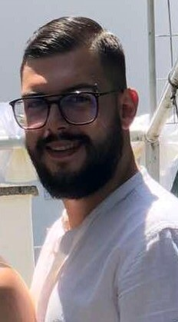

Work Experience

Coffee IN ( bartender ) ,
Cuba Libre Beach and Bar ( bartender ) ,
Street Bar ( bartender ) ,
Base Night Club ( barman ) ,
Sun Love Happiness ( bartender ) ,
Simbol ( bartender/barman ) ,
Central ( bartender ) ,
Caffe Caffe ( manager ) ,
Baroom Hotel and Lounge Bar ( manager ).

Education

University: FIKT (Faculty of Informatics and Communication Technologies)
- Ongoing

High School: SOU ”Taki Daskalo”

Personal Skills

Foreign languages;

- English (advanced),
- Serbian (advanced),
- German (beginner).

Computer skills;

- Microsoft office – Word, Power Point, Excel
- Adobe Photoshop
- Content editing
- Content writing

Social Skills

Teamwork and collaboration
Flexibility
Problem solving
Fast learning
Ambitious
Written and verbal communication
Fast adaptation
Collaboration
Leadership
Looking forward to learn new things and meet new people

