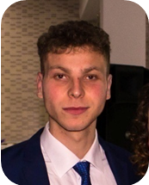
Personal info
Name and sername:
Arangel Jovanovski.
Date of birth: 27.07.1999
Address : ul.1 br.173 sStajkovci/Gazi Baba Skopje
Email Addres:
jovanovskiarangel@gmail.com
phone number:
075-296-327
Status :married

Work Experience
Curent .Since 2020 June .
Working as a professional solder in special forces “scorpions” army of Republic of North Macedonia.
Since 2019 July till 2020 June
Worked as a decontaminator in the army for Republic of North Macedonia for protection of nuclear ,atomic , chemical and biological weapons .
Since 2019 February till 2019 June
Working experience in a super market “TINEX” warehouseman.
Since 2018 may till 2018 august
working experience in a supermarket “VERO”
as a salesman for fruts and vegetables.
Since 2018 march till 2018 may
Part time worker in a factory for body oils ,medicine
“GALA FARM”
Since 2017 till 2018 march
Part time working experience on a construction site
Education
Since 2014 till 2018
High school “ Васил Антевски-Дрен” law and business management .

