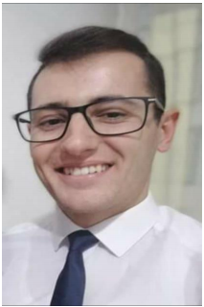 Andrej Jovanoski
Adress Street Brakja Nuneski 1A Prilep

Telephone 071 614 428

Е-mail andrejjovanoski42@yahoo.com
andrej_jovanoski@yahoo.com

Place and date of birth 03.04.1997 Prilep, North Macedonia

Nacionality Macedonian

Linkedin https://www.linkedin.com/in/andrej-jovanoski-5227b2235/
________________________________________________________________________

Education
High School: 2012-2016 SOU Gjorce Petrov – Prilep
Diploma for Registered Nurse

College: Faculty of Philology – English and German

Working Experience:

Medical Nurse for 6 months at Hospital Borka Taleski – Prilep
Customer Support Specialist and Mentor/Advisor for 2+ Years at CMX Solutions – Skopje (I still work there)

Personal skills
Mother language Мacedonian
Other languages English 100%
- Reading - excelent
- Writing - excelent
- Speaking – excellent

• I have skills that make me team oriented, persistent, committed to the tasks and tasks assigned
• Tolerant, Flexible, ready to give and receive help and advice
• Responsible, precise, creative persom
• I am with Calls – E-Mails the whole day. I help the customer with outside of the box thinking

Computer skills:
- Microsoft Word
- Microsoft Excel
- Microsoft PowerPoint
- Internet Explorer
- Mozilla Firefox
- Google Chrome
- Babelforce
- Zendesk
- Bria
- Nfone
- Outbound/Inbound

