Curriculum Vitae | 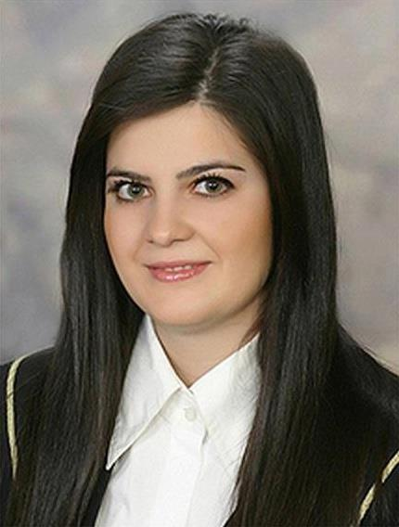
Basic informations
Name/Last Name | Emilija Turundzova
Address | Ari Angelovski 8a/3  7000 Bitola, Macedonia
Phone number | +389 70 205 037
E-mail | emilija_ilievska@hotmail.com
Nacionality | Macedonian
Date of birth | 13/03/1991
Sex | Female
Education
Date | 15.09.2009 – 02.07.2013
Name of qualification | Undergraduate Studies
Direction | Financial Management
Name of University | University “ Kiril and Metodij ”  Faculty of Economics-Skopje
Date | 2005 – 2009
Name of qualification | Mathematical department
Name of secondary school | “ Taki Daskalo ” Secondary school  Bitola, Macedonia
Personal skills

Mother tongue | Macedonian language
Other languages
Self-assessment |  | Understanding |  |  |  |  | Pronunciation |  |  |  | Writing
European level (*) |  | Listening |  | Reading |  |  | Interaction |  | Production
English |  | C2 | Proficient  user | C2 | Proficient  user |  | C2 | Proficient  user | C2 | Proficient  user | C2 | Proficient  user
 | (*) Common European Framework of Reference (CEF) level
Social skills | -Team working skills, great communication skills, reliable, sociable, hard-working
Computer skills | - MS Office, Internet
Driving licence  Work experience  Rewards and degrees | - B category  - QA Coordinator at Carswip, Danmark  - Freelance : outreaching  - Administrative Assistant at Kargo “ Ekspres ” Bitola  - Manager at Coffee and Pastry Shop “ Pikant ” Bitola  - Trainee at Stopanska banka A.D. Bitola  - Trainee at Accounting Office  - Computer Skills Certificate  - English language Certificate  - Certificate for passed exams in English

