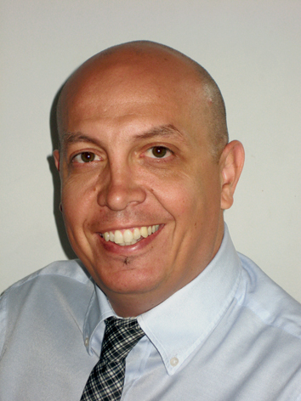
GOCE CHOCHKOV
Address: str. Victor Igo 4 Skopje
Date of Birth: April 24, 1974
Marital status: Married
Tel: + 389 71 373 283
E-mail: gcockov@gmail.com

PROFESIONAL PROFILE

Self-initiative worker with proven leadership and organizational skills, communicative, adaptable in multicultural environments, flexible, and capable of independence and teamwork. Identifying the key stakeholders in the business process, identifying and validating customer business needs, analyzing existing processes, and giving recommendations for their improvement. Defining and estimating business analysis activities, expected analysis results, timelines, and continuous knowledge transfer to other colleagues.

EDUCATION & TRENING

- Analyzing and Visualizing Data with Microsoft Power BIAnalyzing and Visualizing Data with Microsoft Power BI.
Semos EducationSemos EducationIssued May 2022 · No Expiration DateIssued May 2022 · No Expiration DateCredential ID PL-300.

- Analyzing Data with Excel Analyzing Data with Excel
Semos EducationSemos EducationIssued Apr. 2022 · No Expiration DateIssued Apr 2022 · No Expiration DateCredential ID 20779.

- Querying Data with Microsoft Transact-SQ Querying Data with Microsoft Transact-SQ
Semos EducationSemos EducationIssued Mar 2022 · No Expiration DateIssued Mar. 2022 ·No Expiration DateCredential ID DP- 080Credential ID DP- 080.

- Advanced MS Excel 2016Advanced MS Excel 2016
Semos EducationSemos EducationIssued Jan. 2022 · No Expiration Date.

- Bachelor of Economics. 2011

- Advanced course in communication and sales. 2007

- Project-management course and organization. 2009

WORK EXPERIENCE

- 2016 - present Adriamed LTD marketing and sales manager for medical devices.

- 2009 -2011 Plus Production - Head of Integrated photo editing management activities of photo editing editorial print editions

- 2000-2009 Daily newspaper "Vest" - photographer
Track daily events; drafting, editing, and archiving pictures

ADDITIONAL PROFESSIONAL ACTIVITIES

- 2009-2011 "Bato & Divajn" - freelancer in the Marketing department
Devising and organizing promotional activities and events, including the preparation of photo stories.

- 2005-2008 "Mak Auto Star" - freelancer in the marketing department
Devising and organizing promotional activities including preparing photos

- 2007 "Magnetic" - freelancer in the marketing department
Management activities were related to the choice of models (location, choreography, etc.).

- 2005-2007 "Porsche Macedonia" - Associate in the marketing sector in charge of the organization of promotional activities and market research as well as photographs of the promotions.

- 2006 "Fashion Group" - associate in charge of promotions and preparation of photos.

PUBLICATION AND EXHIBITIONS

- 2010 "Macedonia live 24/7" - author's collection of photographs Publishing House "Matica Macedonian"

2008 "The eyes of Macedonia" - an exhibition of photographs of 15
- photographers and photographers in the organization of the news agency "Makfax"

FOREIGN LANGUAGES

- English fluent

COMPUTER SKILLS

- Microsoft Office: Word, Excel, Power Point, Outlook
- Graphics / Image / Photo Software: Photoshop, Adobe.

HOBBY AND INTERESTS

- Yoga Student
- Yoga Trainer Hatha Vinyasa CYT 200 hours
- claiming, biking, diving, volleyball, nature lover,

