Vesna Ristovska
Dimitar Vlahov 72, 7000 Bitola
e-mail: lotusfilmbt@gmail.com
phone number: +389 79 233176

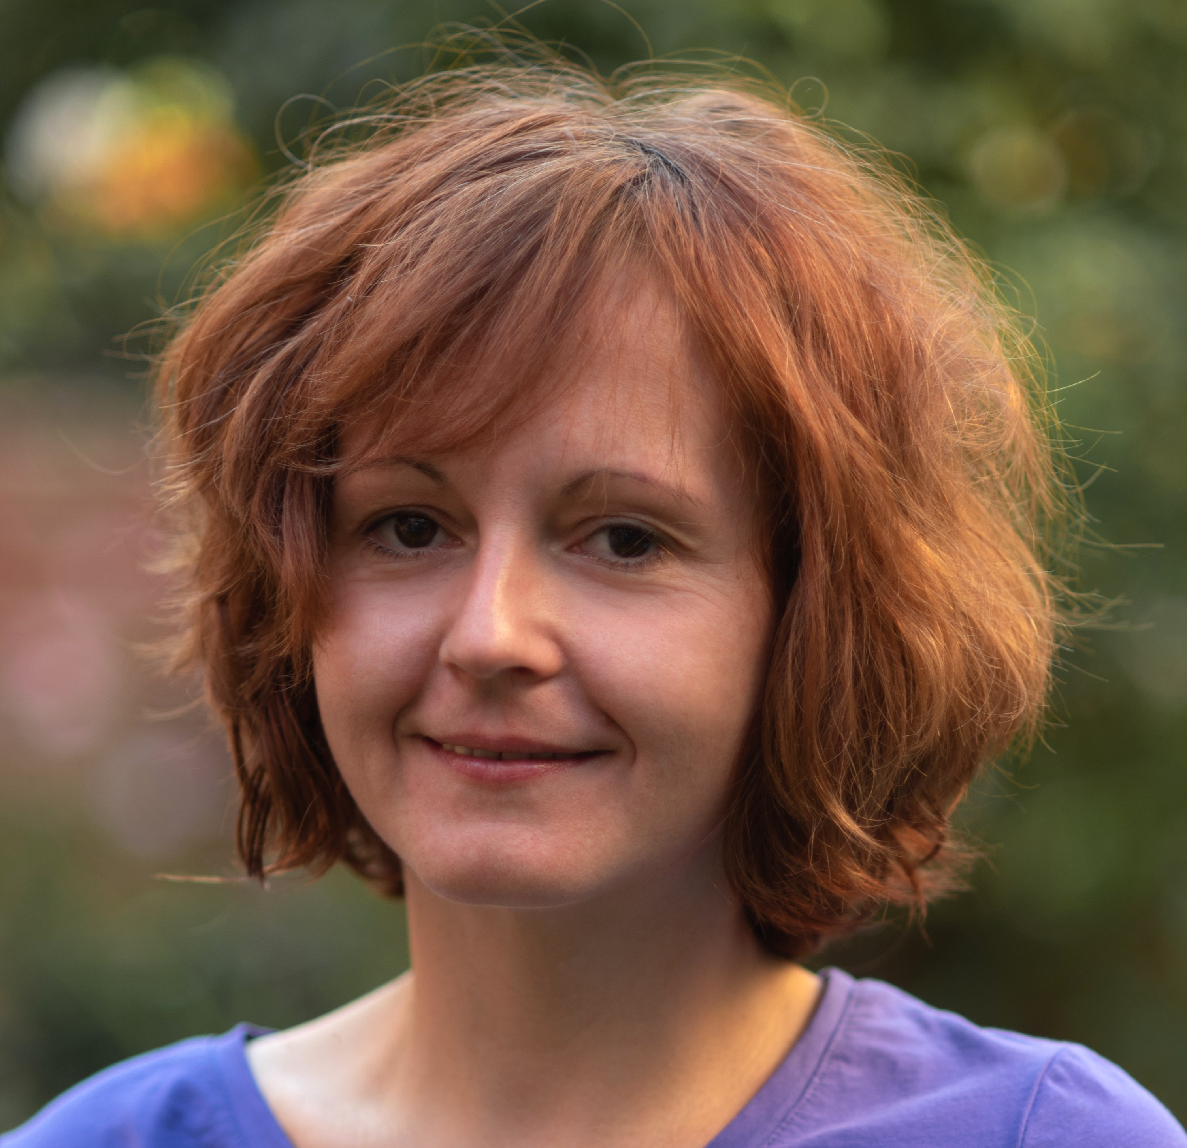
Personal Profile
Highly qualified and experienced person in the film industry. I have organized several film festivals, worked in the casting and directing of short films, and I have successful experience working as assistant director and casting director of feature films. I am a good organizer and able to work to deadlines, experienced at man management, but also work extremely well within a team and fully understand the pressurized environment of film making. In addition, I am multi-lingual and have worked on co-productions with other countries.

Key skills:
- Fluent in Bulgarian
- Great level of English and Serbian
- German A1 level
- Educated to Masters level in Film and TV Directing
- High level of computer and internet skills (Word, Excel and Outlook)
- Fully experienced in the film making industry
- Photography

Employment history:
Jan 2010 – Nov 2016 Key roles and projects:

- 2010 Script supervisor and Clapper loader of the Macedonian short film "Cherry Orchard" directed by Goce Dimovski;
- 2010 Second assistant director and casting of the Macedonian short film "The Myth of Sarah" directed by Sasha Stanisic http://www.imdb.com/title/tt2184271/?ref_=nm_knf_t2
- 2011-12 Administrator on the web aggregator for news http://hl.mk/
- 2012-13 Work with distribution of films in KTFILM&MEDIA PRODUCTION http://www.ktfilmedia.mk/
- 2013 Assistant Art Director of the Bulgarian film "The Woman of My Life," directed by Anthony Donchev
- 2014 Second assistant director and casting of the Macedonian short film "Down from Heaven," directed by Sasha Stanisic http://www.imdb.com/title/tt3653720/?ref_=nm_knf_t1
- 2014 Casting of Macedonian short film "The Pain Remains," directed by Vladimir Taleski http://www.imdb.com/title/tt5650646/?ref_=nm_knf_t3
- 2015 Casting director (in Macedonia) of the Italian feature film "Banat", directed by Adriano Valerio http://www.imdb.com/title/tt4881642/?ref_=nm_knf_i4
- 2015 Student program assistant, assistant for volunteers and kids program coordinator on 36th International Cinematographers Film Festival “Manaki Brothers” in Bitola
- 2015 Second Assistant Director and Casting (in Macedonia) of the Albanian feature film “Broken”, director Edmond Budina
- From December 2016 to August 2017 I was living in UK and working in cleaning and hospitality sector. (Indepth Services Cleaning Ltd, Café on the Water at Hanningfield Waterside Park)
- From September 2017 – March 2018 I was living in Switzerland and working in hospitality sector. (Rialto, Bistro Bar Gstaad)
- 2019 President of the association Film Center Bitola. https://bfc.mk/
- 15.05.2019 - 06.07.2019 Principal Coordinator and part of organization of the first Forum of Creative Cities from the UNESCO network: The role of innovation and education in the local development of cities, which took place in Bitola from 04.07.2019 to 06.07.2019, as part of the UNESCO film cities. The forum is an initiative of the Film Center Bitola and with support from Ministry of Culture of N. Macedonia. https://bfc.mk/
- 07.09.2019 – 13.09.2019 Coordinator for extras (set in Bitola) of the French feature film "Mermaid in Paris", directed by Matthias Malzou; https://www.imdb.com/title/tt9209312/
- 26 June 2020 - Representative of Mobile Festival at the virtual event World Peace & Tolerance Smartphone Humanitarian Gala, "2nd annual Karl Bardosh Humanitarian Cell Phone Award" as a part of Marché du Film - Festival de Cannes 2020;
- August 2021 Author of the video “A Day in Your City” for Busan Inter-City Film Festival
https://www.facebook.com/watch/?v=189568003210246
- 10.07.2020 - 27.08.2020 Principal Coordinator and part of organization of the Second Forum of UNESCO Creative Film Cities: The City of the future, which took place in Bitola from 25.08.2020 to 27.08.2020, as part of the UNESCO film cities. The forum is an initiative of the Film Center Bitola and with support from Ministry of Culture of N. Macedonia; https://bfc.mk/
- 10.09.2021 – 29.10.2021 Principal Coordinator and part of organization of the Third UNESCO Creative Cities Film Forum: The Creative Industries – The Future of Cultural and Creative Economies / Covid-19 Challenges which took place in Bitola from 28.10.2021 to 29.10.2021 The forum is an initiative of the Film Center Bitola and with support by UNESCO through the Ministry of Culture of the Republic of North Macedonia within the UNESCO Participation Program for 2020-2021.; https://bfc.mk/
- 29.11.2021 - Member of the International Jury for International Smartphone Film Festival SHOOT4EARTH GO GREEN - Green Philosophy – 2021. Global Short Film-making competition for environmental awareness.
https://shoot4earth.org/
- 10.10.2022 – 24.11.2022 Principal Coordinator and part of organization of the Fourth Forum of UNESCO Creative Film Cities "Women in Media - Highlighting The Role of Women in Media", which took place in Bitola from 21.11.2022 to 24.11.2022, as part of the UNESCO film cities. The forum is an initiative of the Film Center Bitola and with support from Ministry of Culture of N. Macedonia; https://bfc.mk/
- 2011 – 2021; Working as organizer and selector of the International film festival for films made with mobile phone Mobile Festival; http://www.mobilefestival.net/
- 2012 - Present; Founded her own film production company, Lotus Film and produced several short films and music videos.
- 2018 – 2022; Working with Cutaway Production in the Cinema and VOD distribution sector and on the first original Video on Demand platform Cinesquare.net

Independent projects:

- 2009 Director of the video for the theatre play "Kalesh Angja" in Bitola National Theatre
- 2013 Music video The Crew - Freedom, production assistant – (MTV ADRIA) https://www.youtube.com/watch?v=bWwws69kars
- 2013 Production assistant of the documentary film “The Road to Alicante”
https://www.youtube.com/watch?v=NuutCghR0tc
- 2016 Work in the organization of the festival “Attitude”- video/short & experimental film/photography in Bitola, Macedonia
- 2016 Producer of the Short documentary “Access”
- 2016 Working at the photo/video sector for the Festival of contemporary art “AKTO”
- 2013-2016 Work in organization of Debate Cinema “Kontra Kadar” in Bitola

Education and Experience:

2003-2008 Masters Degree in Film and TV directing - The South-West University "Neofit Rilski", Blagoevgrad, Bulgaria
Working as a director of student short films and documentaries in Macedonia and Bulgaria
1999-2003 High School Josip Broz Tito, Bitola, Macedonia
2002 Catering on the Macedonian film "The Great Water", directed by Ivo Trajkov
1991-1999 Todor Angelevski Secondary School, Bitola, Macedonia

Director of Student Films
The documented observation: "Meeting" 2004
Music video clip: Dark machines - "Unfinished business" 2005
https://www.youtube.com/watch?v=3l3SwZAG3OY
Short film "Modern Love" 2006
Short film "Somnium" 2008 https://www.youtube.com/watch?v=XsqOTiwfr-M
Short film "Silence" 2010 https://www.youtube.com/watch?v=y3YDua--QPQ
Assistant Director of the Bulgarian student short film, "Game", directed by Denitsa Georgieva

References available on request

