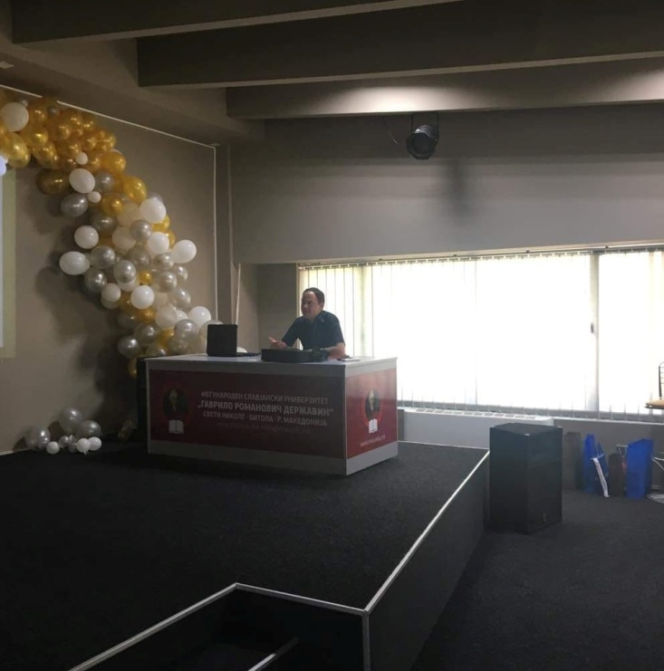
Name: Antonio
Surname: Stojanovski
Residential address: Blaze Koneski 49, Bitola
Phone: 076-528-797
e-mail: antonioinvestor@hotmail.com
Education and training:
- OU "St. Kliment Ohridski" - Bitola
- High School "Josip Broz Tito" - Bitola
- International Slavic University "Gavrilo Romanovich Derzhavin" - Bitola department:
Undergraduate Studies-Finance and Credit
Postgraduate studies-Marketing Management
Personal skills and competencies:
-Acquired certificates in the field of accounting, banking and financial markets
- Humanitarian work in the Rotaract Club from Bitola
- Organization of a large number of events
-Participation in speaking events
Mother tongue: Macedonian
Other languages: English, Serbian, Bulgarian
Organizational abilities and competences: Participation in a large number of humanitarian projects, including: "Hot tea for the citizens", "Donation to the home for infants in Bitola", "Educational training on safety when using the Internet", "Revitalization of the bazaar in Bitola" and many others...
Technical skills and competencies: Microsoft Word, MATLAB, Adobe Photoshop, basic knowledge of Python
Other skills: Leadership skills, work organization, communication skills, adaptability

