PERSONAL INFORMATION | Marjan Nedelkoski
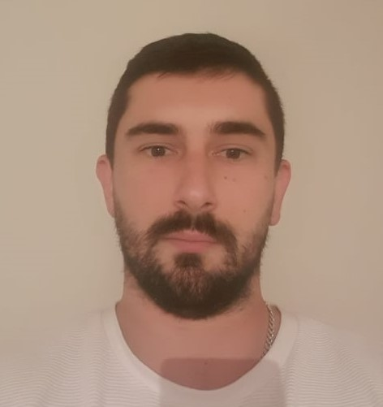 |   Str.Bitolska No.52b, Kravari, Bitola, R.Macedonia
 |  078/384-359

marjan_ned@hotmail.com
Sex Male
Date of birth 03.05.1990
Nationality Macedonian
Driving Licence B category

WORK EXPERIENCE
08.02.2023 - ongoing Lighting Reimagined

Receiving and completing orders from customers, entering them in the database, and making sure shipping and information from the customers are for the fastest shipping available.
Taking care of all e-mails regarding manufacturer updates on the product purchase, incoming, and outgoing emails regarding the orders (Feedback).

CRM – NetSuite and Big Commerce

10.2021. – 16.01.2023 | TaskForceBpo  Customer Care for (ClearChoiceDerm.com) Medical sector
10.2021. – 16.01.2023 | Full access to information on the patient under the HIPPA restriction by the USA.  Work obligations: Appointments, Cancellation, Rescheduling, Data entry, and Billing of CO PAY charges on the insurance or self-pay patient’s bills. (Extra duties included with progress)
02..2018 – 03.09. 2021 TUI UK. Cruse Ship Company Ships- (Explorer 1 Celebration)
Reception and Senior Receptionist
Handling all kinds of queries and complaints regarding the guest. Embarking the passengers. Preparation flights for emergency debark or embark + as a senior planning the shifts for the rest of the Reception team. Correction of the main ship log. Planning training for the new receptionists and correction of the work assignments of the existing ones

12..2016 – 01.2018
12..2016 – 01.2018 | Rotsthein (Call Center)  Marketing and Sale  Getting in touch with clients, getting all needed information, and analyzing to make sure they can be potential clients or investors with the company.
02..2014. – 01.2015  02.2013 – 09.2013 | Kromberg and Subert
02..2014. – 01.2015  02.2013 – 09.2013 | Rework
02..2014. – 01.2015  02.2013 – 09.2013 | Final inspection of the product and final reparations before export of the product
02..2014. – 01.2015  02.2013 – 09.2013 | Municipality of Bitola  Organization and coordination of activities  Organization and coordination of the activities in the municipality of Bitola
05..2012 – 10.2012 Odeon Tours (Antalya, kemer, Alanya), Turkey
Tourist guide
Main tourist guide with the support of “General Tours”, Skopje
2009 – 2012

Title:

2005 – 2009
2009 – 2012  Title:  2005 – 2009 | University of tourism and management, Skopje  Department: Tourism and management  Degree in Tourism and Management  SOTU “Gorgi Naumov”, Bitola  Electrical and telecommunication engineer

EDUCATION AND TRAINING

PERSONAL SKILLS

Mother tongue | Macedonian language
Оther languages | Understanding |  | Speaking |  | Writing
Оther languages | Listening | Reading | Verbal interaction | Verbal production
English language | C2 | C1 | C1 | C2 | C1
Spanish language | A3 / A3 / /

Communication skills | - Good communication skills acquired as an employee in a call center, excellent negotiating skills

Organizational/managerial skills | - Leadership  - Teamwork  - Organizational skills  - Coordination  - Motivation

Computer skills | - Good knowledge of the tools of Microsoft Office – Word, Excel, PowerPoint, knowledge of working on trading platforms such as Binance and Forex.

Other skills | - Creating a good working atmosphere  - Creativity  - Respecting rules and deadlines  - Dedicated to work

