TOMI DIMOVSKI
ELECTRICAL ENGINEER - INFORMATICS
C H A R A C T E R I ST I C S
Communicative, easily adaptable to new environments and positions, team worker, principled, punctual, with a great desire to progress and learn, always focused on the code of the future, does not ask many questions - implements! Experience as a general worker on multiple production lines
E D U C A T I O N

C O N T A C T
071235469
dedohuna@outlook.com

Ul. 6-ta Br. 6-a
-Bitola-

Tommy Dimovski Age 36 Bitola

S K I L L S

Creativity
Electrical technician
for Computer Technology
and Automation (secondary education)

Team Work

Comunication

PAST JOBS EXPERIENCE
TECHNICAL SKILLS
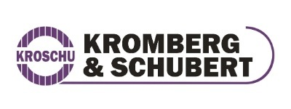

Microsoft Office
Textile
leather industry
"Sam Invest-Bitola"

Engish Lng


Documents, and presentations
making

P.P. Rosa Bitola
-Colonial- own business

Private presentations, scripts, diploms projects, magister works , brochures (for lazy children) of course for rmoney

(приватни порачки)

