CV
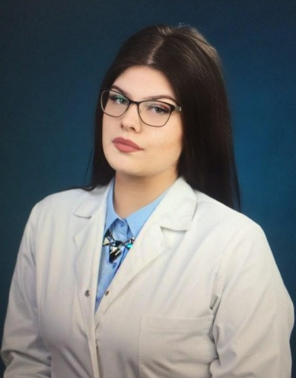

Personal information:
Name: Marija Markova
Address: Boris Budzevski 5/36 Bitola
Phone: 077 393 488
E-mail: marija.markova01@gmail.com
Date of birth: 16.07.2001

Education:
“OSMU Dr.- Jovan Kalauzi” (Dental Technician) - Bitola

Personal skills:
Macedonian language
English language

Other social skills:
Communication
Organizational

Other abilities:
Ambitiousness, creativity, flexibility, individual work and team work, persistence, acceptance of other people's ideas, communication skills to establish relationships with co-workers, quick learner, ability to work under pressure

Work experience
Task Force BPO- Customer Care support specialist 6/2021 – 12/2022
My previous work experience has given me a great understanding of the USA healthcare system. It also taught me how to work under pressure, grow my communicational and organizational skills, train other coworkers and also insurance and billing knowledge.
Veeva – Profiler 2/2023 – 6/2023
My freelance experience in Veeva gave me the ability to improve my research skills and decision-making regarding information selection.

