European
curriculum vitae
format

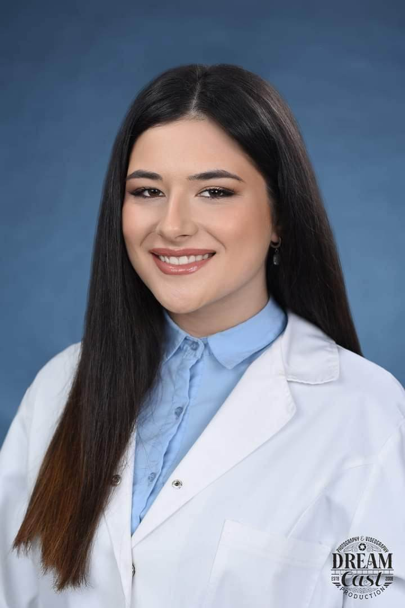

Personal information

Name |  | Iva Hadzi-Kirkova
Address |  | [ Prilepska 60/2/25, 7000 Bitola, Macedonia]
Telephone |  | 075-258-068
E-mail |  | hadzikirkovaiva@gmail.com

Nationality |  | Macedonian

Date of birth |  | [19.07.2003]

Education and training

• Dates (from – to) |  | [2022- ]
• Name and type of organization providing education and training |  | High Medical School,University St.Kliment Ohridski – Bitola
• Dates (from – to) |  | [2018-2022]
• Name and type of organization providing education and training |  | High School D-r Jovan Kalauzi-Bitola
• Title of qualification awarded |  | Excellent
• Dates (from – to) |  | [2009-2018]
• Name and type of organization providing education and training |  | Elementary School Todor Angelevski- Bitola
• Title of qualification awarded |  | Excellent

Work Expirience  • Position  • Dates (from – to) |  | AMO Freight LLC Taskforce BPO  Safety Department Floater-Healthcare division  22.08.2022-31.12.2022 30/01/2023-

-Innovative
Personal skills
and competencies

-Creative
-Alert
-Ambtious
- Confident
- Dedicated
- Flexible

Mother language |  | [Macedonian]

Other languages

 |  | [English]
• Reading skills |  | [Excellent]
• Writing skills |  | [Excellent]
• Verbal skills |  | [Excellent]

Social skills  and competencies |  | - Team Player  - Leadership  - Excellent communication skills  - Making and maintaining people relationships  - Good listener  - Respectful  - Building trust

Technical skills  and competencies |  | [Microsoft Office]  excellent

