Curriculum Vitae

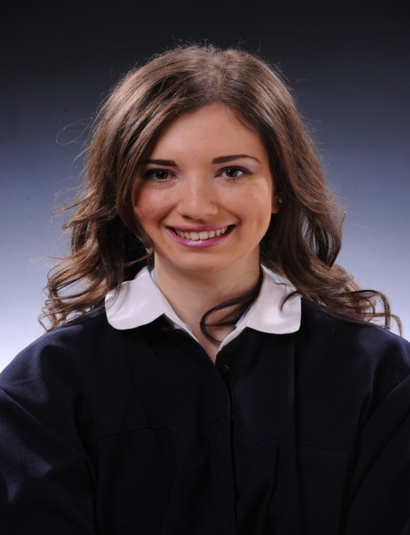

|  |
| --- |
| CONTACT INFORMATION |

|  |
| --- |
| First Name: Elizabeta |
| Last Name: Dimitrovska |
| Adress: 8 Jane Sandanski Str. Kriva Palanka Macedonia |
| Country: Macedonia |
| Mobile Number: +38970762847 |
| Email Adress: deli_feit1992@outlook.com |
| Marial Status: single |
| Gender: Female |
| Date of Birth: 5th June 1992 |

|  |
| --- |
| EDUCATION |

|  |  |  |  |
| --- | --- | --- | --- |
| Name of University: Faculty of Electrical Engineering and Information Technologies of Skopje | | | |
| Type of Degree: Bachelor’s | | | |
| Country: Macedonia | | | |
| Major Field of Study: Automatics and Robotics | | | |
| Relevant Courses Taken: Mathematics, Informatics and Programme languages, Physics, English | | | |
| Dates: | Start: 15 September 2011 | | End: 03 March,2017 |
| High School Attended: Gjorche Petrov High School | | | |
| Country: Macedonia | | | |
| Dates: | Start: September, 2007 | | End: May, 2011 |
| Certificates: | | Certificate of High School Graduation | |
|  | | Certificate of English language | |
|  | | Certificate of taking part of manifestation of Robomac | |

|  |
| --- |
| SKILLS AND ADDITIONAL INFORMATION |

|  |
| --- |
| Computer Skills: MS Office, C#, CSS, HTML, Java Script |
| Manifestations: taking part of manifestation of Robomac 2015 and got a sertificate for participation |

|  |
| --- |
| PROFESSSIONAL EXPERIENCE |

|  |  |  |  |  |  |
| --- | --- | --- | --- | --- | --- |
| Company 1: Livedooh Gmbh | | | | | |
| Job Title: Quality Assurance Engineer | | | | | |
| City: Skopje, Macedonia | | | | | |
| Dates: | Start: May 1,2019 | | In progress | |  |
| Describe Job Duties:  - performing manual testing of all the functionalities of the current system;  -writing scripts for automation testing in Java Script, C#;  -API testing (Postman);  - Performance testing  -Regression testing | | | | | |
| Company 2: Sorsix International | | | | | |
| Job Title: Quality Assurance Engineer | | | | | |
| City: Skopje, Macedonia | | | | | |
| Dates: | Start: September, 2018 | | End: April, 2019 | |  |
| Company 3: Nebiz DOOEL | | | | | |
| Job Title: Internship | | | | | |
| City: Skopje, Macedonia | | | | | |
| Dates: | | Start: May ,2018 | | End: August, 2018 | |
| Describe Job Duties:  -coding some basic functionalities of the system using Python, Javascript, HTML and CSS; | | | | | |
| Company 4: ITgma Sourcing | | | | | |
| Job Title: Support Engineer | | | | | |
| City: Skopje, Macedonia | | | | | |
| Dates: | | Start: 15 October, 2016 | | End: 30 April, 2018 | |
| Describe Job Duties:  -2nd level support for sCRM and BSCS system , client: MK Telekom, Skopje  -3rd level support for BSCS system,  -Technologies in use: SoapUI & WinSCP server, Oracle Database, Jenkins, Putty | | | | | |
|  | | | | | |

|  |
| --- |
| Courses taken |
| Name: PHP and MySQL Development |
| Place: Seavus Educational & Development Centre, Skopje |
| -Basics of Laravel Methodology;  -PhP syntax, functions, forms;  -OOP;  -MySQL database development; |

|  |
| --- |
| HOBBIES AND INTERESTS |

|  |  |
| --- | --- |
| Hobbies: | Running, swimming, playing volleyball, studying foreign languages |
| Interests: | Programming and Database support |