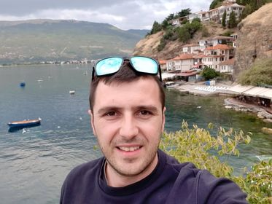

**Aleksandar Naumov**

Email: naumov86@gmail.com

Phone: +38977566844

Objective  
Streaming for a career, which will not only help toward building a better living, but a better life as well!  
  
Strengths

* Ability to work effectively under time pressure
* Ability to multitask
* Diligence and dedication to the work place
* A good memory and an eye for details
* Ability to understand different kinds of people
* A keen observer
* Great sensitivity to the needs of others
* A friendly, cheerful, and polite attitude
* Last but not least, a Team work makes the dream work!

Latest accomplishments

Student, October 2019 - October 2020  
“Brainster Academy” - Skopje

Programs covered in the course period:

* [GIT](https://codepreneurs.brainster.co/full-stack/), [MySQL](https://codepreneurs.brainster.co/full-stack/)
* [HTML](https://codepreneurs.brainster.co/full-stack/), [CSS](https://codepreneurs.brainster.co/full-stack/), [Bootstrap](https://codepreneurs.brainster.co/full-stack/)
* [PHP](https://codepreneurs.brainster.co/full-stack/), Laravel
* [JavaScript](https://codepreneurs.brainster.co/full-stack/), [jQuery](https://codepreneurs.brainster.co/full-stack/), [AJAX](https://codepreneurs.brainster.co/full-stack/)

The end result has provided a solid comprehension of the material that was gathered over a series of exercises provided by the program.  
  
Verified certificate for “Full Stack Web Development”  
 **Experience**Operator, March 2018 - May 2019  
“ST Microelectronics”, Kirkop, Malta

Responsibilities:

* Maintaining and sole responsibility of the assigned molding machine.
* Maintaining and sole responsibility of the assigned machine –plazma (balzer).
* Selection of “lots” as well as their marking and removal of improper produced peaces.
* Notes and record keeping of the "lot traveler".
* Complete documentation of events, possible defects and the total number of products made for the working day.

**Cashier/ Administrator/ Manager, October 2009 - January 2017**  
“BetCity Balkan”, Skopje  
  
Responsibilities:

* Cashier starting position leaned towards a simple funds exchange combined with high customer experience.
* Admin position, handled the responsibility and safety of the premise, as well as the needs of the establishment.
* High risk Funds handling and organizing their safe transport and retain.
* Manager position involved certain record keeping and organizing Roster for the upcoming work days.
* Gathering statistical analysis for all sport events affecting the premise’s interests
* Consultant obligations towards the Regional Managers and Bookmakers involving all sport types, especially Balkan region leagues’ estimated odds due to advanced knowledge of all sport types and their ranking.

Personal Information:

* Date of birth: June 02, 1986
* Place of living: Skopje, K.Voda
* Married

Academic qualifications:  
  
Student at the Faculty of Truism and Hospitality, Management of Insurance, Ohrid  
DSU Vlado Tasevski Skopje, Technician for Electronics and Telecommunication