Curriculum vitae



PERSONAL INFORMATION Ile Jovanovski

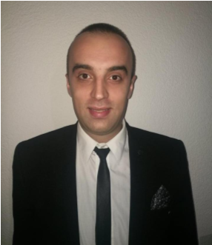

Blaze Rogozinaro 10, 7000 Bitola (North Macedonia)

+38976365609

ile.jovanovskii@gmail.com

WORK EXPERIENCE



|  |  |
| --- | --- |
| 17/04/2013–25/04/2017 | Product quality inspector  Kromberg & Schubert, Bitola (North Macedonia) |
| 08/07/2019–20/09/2019 | Food production and packing operator  Travora Personal Gmbh Weimar-Wenkbach, Marburg (Germany) |
| 02/10/2019–Present | Card dealer Croupier  Hotel Epinal - SPA & Casino, Bitola (North Macedonia) |

EDUCATION AND TRAINING 

|  |  |
| --- | --- |
| 2005–2009 Present | Economic technition  Economic High School, Bitola (North Macedonia) |



|  |  |
| --- | --- |
| Mother tongue(s) | Macedonian |

Foreign language(s)

English German

UNDERSTANDING

SPEAKING

WRITING

Listening

Reading

Spoken interaction

Spoken production

C2

C1

C1

C1

C1

A1

A2

A1

A1

A1

Levels: A1 and A2: Basic user - B1 and B2: Independent user - C1 and C2: Proficient user

|  |  |
| --- | --- |
|  | [Common European Framework of Reference for Languages](http://europass.cedefop.europa.eu/en/resources/european-language-levels-cefr) |
| Communication skills | ▪ Excellent written and verbal communication skills.  ▪ Confident, articulate, and professional speaking abilities (and experience) ▪ Empathic listener and persuasive speaker.  I posses skills and qualities required by your side. I am very flexible to your needs . During my work I promise you my full dedication and expertise in pursuit of it. |
| 16/1/20 | © European Union, 2002-2019 | http://europass.cedefop.europa.eu Page 1 / 2 |

Curriculum vitae Ile Jovanovski



|  |  |
| --- | --- |
| Job-related skills | Deadline driven  Hardworking and self motivated  Fast learner  Organized  Outgoing personality |

Digital skills

SELF-ASSESSMENT

Information

processing

Communication

Content

creation

Safety

Problem

solving

Proficient user

Proficient user

Proficient user

Proficient user

Independent user

[Digital skills - Self-assessment gri](http://europass.cedefop.europa.eu/en/resources/digital-competences)

[d](http://europass.cedefop.europa.eu/en/resources/digital-competences)

Driving licence B

16/1/20 © European Union, 2002-2019 | http://europass.cedefop.europa.eu Page 2 / 2