**CURRICULUM VITAE**

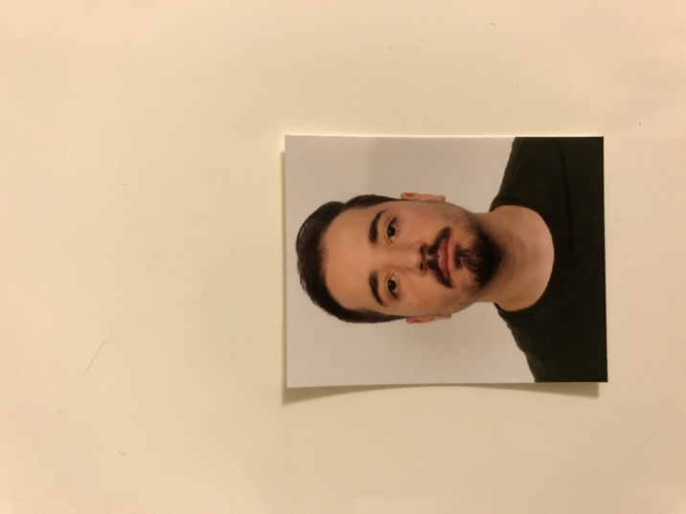

**Personal information:**

Last Name: Shehaj

First Name: Ardi

E-mail: [ardi.sh06@gmail.com](mailto:ardi.sh06@gmail.com)

Phone: +355 69 73 555 72

Gender: Male | Date of birth: 19.06.1996 | Nationality: Albanian

**Education:**

Bachelor of Science, Information and Communications Technology,

Faculty of Natural Sciences, University of Tirana

**Work experience:**

Product Manager – Globe Albania

October 2018 – ongoing (3 years experience)

**Languages:**

Albanian – mother tongue

English – Advanced (C1) – Oxford English placement test

Italian – Advanced (C1)

**Computer skills:**

Advanced knowledge of CSS, HTML, C, C++, JavaScript, SQL, Microsoft Office

**Certificates:**

C programming, C++ programming, C# Basics, C# Intermediate, C# Advanced, Telecommunications and Information Security (Vodafone)

**Driver license category: B**