CV

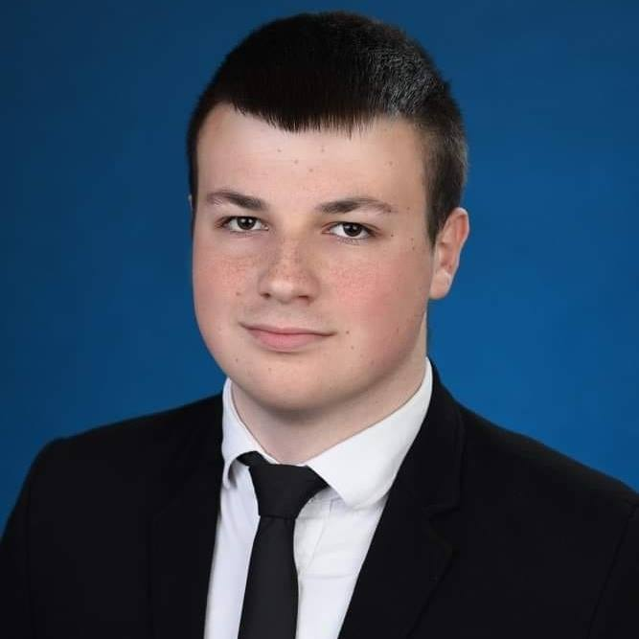

*Personal information:*

Date of birth: 16.02.2001

Place of birth: Bitola, Macedonia

Nationality: Macedonian

Street: Smilevo No.41

7000, Bitola, Macedonia

Phone: 078/454-370

E – mail: mimobim52@gmail.com

Mihail Dimovski

EDUCATION:

High school: **SOTU "Gorgi Naumov" - Bitola** ,Macedonia

Technical school-Auto technique 2015/2019

Elementary school: “Todor Angelevski” - Bitola

PREVIOUS WORKING EXPERIENCE:

-“Sinpeks”, Machine installer, in Bitola from June 2020 to this day

-“Avto Nova”, Mechanic, in Bitola from September until December 2020

PROJECTS:

Presentation: Did a 10-minutes long presentation for The history of Ford Motor company

Workshop: - Volunteering as a member at ”Red Cross”,Bitola

* Volunteering as a Member at ”American corner”, Bitola
* Volunteering as a Member at “Speak out”, Ohrid
* Volunteering in “Scouts camp”, Ohrid

SKILLS: Computer: Good working knowledge of Microsoft Office Word, Power point, IT-skills, Excel.

Language: Fluent English C2 (written and spoken).

Organizational: Time management skills, schedule – making skills and respecting deadlines.

Communication and Interpersonal: team working skills, communication with other employees and colleagues.

Writing: Excellent writing skills, creative writing skills, essay writing skills, blog writing and commenting skills.

ACHIEVEMENTS: - Certificate of finished C2 proficiency level: oral and written English language from ‘’Leksika’’ centre, Bitola.

INTERESTS AND HOBBIES:

- Driving cars

* Travel
* Model car collection “Hot wheels”
* Basketball
* Idea exchange for project cars