-**CV**-

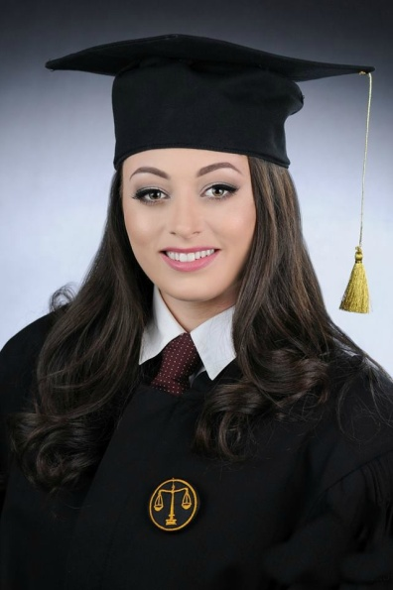

**Personal information**

**First name(s) / Surname(s)** Teodora Sekulovska Galovska

**Address** Klanica 7/29,7000 Bitola (Macedonia)

**Mobile** +38975888401

**E-mail(s)** sekulovskat4@gmail.com

**Nationality** Macedonian

**Date of birth** 06.08.1993

**Gender** Female

**Work experience**

**Dates 2013-2016**

**Occupation or position held an intern**

**Main activities and responsibilities administrative tasks**

**Name and address of employer Law office Ivanoski-** **Filip Vtori**

**Makedonski No.13 / 8 -Bitola**

**Type of business or sector Law office**

**Dates 2014-2016**

**Occupation or position held Coach**

**Main activities and responsibilities Teaching gymnastics**

**Name and address of employer KGS Partizan-Bitola**

**Type of business or sector Sport**

**Occupation or position held Referee**

**Main activities and responsibilities Gymnastics Referee**

**Name and address of employer Federation of Gymnastics Sports of**

**Macedonia**

**Type of business or sector Sport**

**Occupation or position held Personal trainer**

**Main activities and responsibilities Sport classes**

**Name and address of employer Oriflame-Orilifestyle**

**Type of business or sector Health and beauty**

**Occupation or position held: Receptionist**

**Main activities and responsibilities: Reservation, reception,and various**

**responsibilities in the hotel**

**Name and address of employer Milenium Bitola**

**Type of business or sector Hotel**

**Occupation or position held: Administrative worker**

**Main activities and responsibilities: Certification,transcripts,contracts**

**Name and address of employer Notar Marincho Veljanovski-Bitola**

**Type of business or sector Notary**

**Occupation or position held**  **jurist**

**Main activities and responsibilities: administrative tasks, contracts,** **advises of**

**legal matters.**

**Name and address of employer Law office Ivanoski-** **Filip Vtori**

**Makedonski No.13 / 8 -Bitola**

**Type of business or sector Law office**

**Education and training**

**Dates 2008-2012**

**Title of qualification awarded High School Diploma**

**Principal subjects / occupational skills covered Specialized Area of study:**

**Individual and Society**

**Name and type of organisatio**  **Josip Broz Tito (Gymnasium)**

**providing education and training**  **7000 Bitola (Macedonia)**

**Title of qualification awarded (Bachelor) law school graduate**

**Principal subjects Criminal law**

**Occupational skills covered Law**

**Name and type of organisation Megjunaroden Slavjanski**

**providing education and training Univerzitet "G.R.Derzhavin"**

**7000 Bitola (Macedonia)**

* **2015 Seminar of FGSM for judges in women's sports gymnastics**
* **2016 Seminar of FGSM for coaches in men's sports gymnastics**

**Personal skills and competences**

**Mother tongue(s)** **Macedonian**

**Other language(s) English;Serbian**

**Hobbies and interests**

**Sport,reading books**

**Personal characteristics**

**responsibility**

**communicativeness**

**flexibility**

**loyalty**

**persistence**

**creativity**

**negotiation skills**

**team work**

**Computer skills and competence Windows OS,Microsoft Office Pack**

**Driving licence(s) B category**