CV

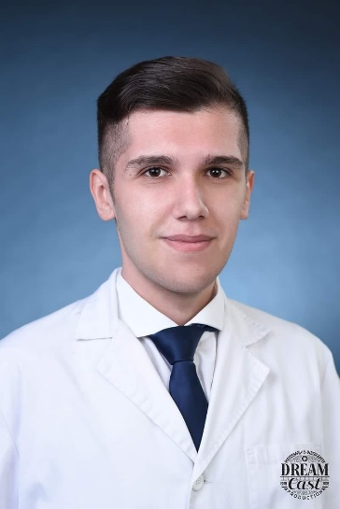**Personal information:**

Name: Andrej Bojovski

City: Bitola

Contact phone: 077-698-562

E-mail: bojovskia@gmail.com

Nationality : Macedonian

Date of birh: 16.07.2001

**Education**: Medical high school Dr. Jovan Kalauzi-Bitola

**Languages:**

Mother language: Macedonian

Foreign language: English

-Reading: Good

-Writing: Good

-Speaking: Good

**Personal skills:**

-Team player

-Communication

-Organisation skills

**Technical skills**:

-Good computer skills

-Microsoft office

-Operating system: Windows

(Without previous working experience willing to learn fast)