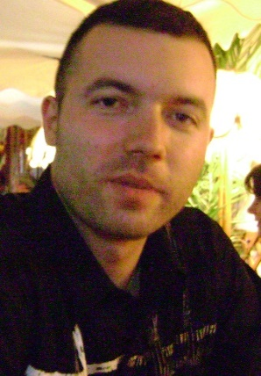

**Oliver Stevanovic**

077 696 000 (mob) **Skopje, Macedonia** [stevanoviko@gmail.com](mailto:stevanoviko@gmail.com) DOB 20/05/1980

**Sales Management**  Top sales producer with expertise in different types of sales. Repeatedly promoted into senior leadership roles based on demonstrated success in executing strategy and breaking into new markets. Maximizing revenue, surpassing sales objectives, and improving client satisfaction.

**Education** -Montclair State University; New Jersey; BS: Business Administration; International business, December 2012

-St Cyril & Methodius University; Skopje, Macedonia; AS: Law School; Mass Media ( Journalism ) May 2002

**Professional Experience**

-Production/Warehouse -FOOD INDUSTRY; Skopje, Macedonia;Nov 2019 – Nov 2021

- Logistics/Dispatcher – TRANSPORT SERVICE; Skopje, Macedonia; Nov 2016 – Nov 2017 Dispatching for all types of transportation services. Office duties.

- Life & Health Insurance Agent – EMERALD FINANCIAL; New York & Chicago; Apr 2013 – Jan 2015 Selling Life and Health insurance , marketing , appointments, and training.

-Manager – RUSSIAN RESTAURANT; New Jersey; Jan 2010 - Mar 2013 Management and supervision of employees. Marketing, customer service, event planning and delivery.

-Salesperson & Team leader - KIRBY Co; New Jersey & New York; Oct 2005 - Nov 2009 Presented and sold Company’s products (home cleaning units). Trained and managed sales teams (representatives) Responsible for new appointments and helping the agents when closing the deals.

-Store Associate – WAWA MARKET; New Jersey; Jun 2002 - Oct 2003 Organizing and sorting store products, and Cashier Services

**Skills**  Microsoft Office – Word and Power Point, Computer Accounting, Excel and Access Language proficiency: Macedonian, Serbian, English, Russian.