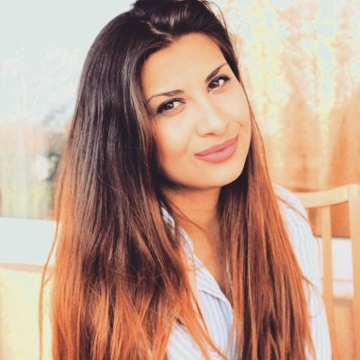

**Personal statement**

Sofija Nikolova

[• 072225536• sofijanikolova1@gmail.com](mailto:•%20072225536•%20sofijanikolova1@gmail.com)

Conscientious and a professional individual with experience in administration, public relations and marketing. High level of efficiency and organization, whose approach is precise and profound which results on a satisfying level.

• Writing 50 words per minute

• Experienced in Microsoft Office, including Access, Excel, Word and Microsoft PowerPoint

• Extraordinary communication skills, including writing and verbally

* Photoshop
* Google Analytics

**Work experience**

**Public relations/ Marketing manager, Hotel Ovche Pole**

*(June 2011 – April 2012)*

• Establishing a professional and friendly impressionof the company and giving support to the clients for a further collaboration

• Responsibility for maintaining press conferences, preparations and design of presentations and brochures, leading the main books, ledgers

• Organizing business meetings and liaising with clients

• Always ensuring high level of efficiency of the management in the company

**Clerk for legal activities, Law sector, Municipality of Sveti Nikole**

*(June 2014– September 2014)*

• Maintaining and organizing the archive system of the company

• Answered incoming calls

• Typed all necessary documents and correspondence as required

• Printing notes as required

• Decision making in the municipality for legal advice

**PR and Marketing account, TV Nova, Skopje, Macedonia**

*(October 2016 -present)*

• Promoting the outer look of the company

• Liaising and consulting with clients with clients

• Team building

• Exploring the market

• Making agreements and deals with clients

• Evaluations of danger of crisis for the company

**Consultant, Radio Hepi within TV Nova**

• Marketing consultant

• Work with clients

**Manager of a marketing agency, Pulse Media, Skopje**

***(September 2017 – present)***

• Liaising with clients

• Creating a marketing plan

• Maintaining contact with the clients

• Bookkeeping

• Prepared full documentation for the agency

* Digital marketing
* B2B/BTC content media plan
* Analyzing and applying on metrics
* Making a creative brief
* Founding and making of buyer person

• Breaking new products on the market

• Surveying and analyzing the market

**Marketing Manager, Panther Farm, Skopje, Macedonia**

(September 2018 - present)

• Communication with customers

• Making and enforcing contracts

• Realize marketing budget

• Breaking new products on the market

• Surveying and analyzing the market

• Promotion of new products

• Organizing seminars, trainings and presentations

• Communication with collaborators from abroad

• Communication with televisions, web portals, magazines

**PR and Marketing account, Balcan Music TV , Skopje, Macedonia**

*(November 2019 -present)*

• Promoting the outer look of the company

• Liaising and consulting with clients with clients

• Team building

• Exploring the market

• Making agreements and deals with clients

• Evaluations of danger of crisis for the company

* Team Building
* Event organization
* PR organisations
* Making videoclips for our clients.

Marketing executive, Techcon , Sweden

(November 2020-present)

* **Digital marketing**
* **CRM updating**
* **Video production**
* **Video scripts**
* **Linked in managing**
* **Social media profiles managing (Facebook, Instagram)**
* **Purchasing for the company**
* **Meetings and meetings scripts creator**
* **Team building creator**
* **Attending and organizing fairs**
* **Event’s organizer**
* **Sale representative (contact with clients sending offers…)**
* **Marketing media budget**
* **B2B selling**

**Education**

Master in Digital Marketing

**Institute for Business & Management HEIDELBERG-Skopje**

(September 2020-still)

Public Relation Manager

**Justinijan Ist, Skopje, Macedonia**

*(September 2013 – June 2016)*

**SOU Kocho Racin, Sveti Nikole, Macedonia**

*(September 2009 – June 2013)*

**Hobbies and interests**

I have attended various seminars and practical trainings in relations to the political situations concerning Macedonia where I have received various diplomas and certificates. I am a passionate literature reader and a great fan of tennis.