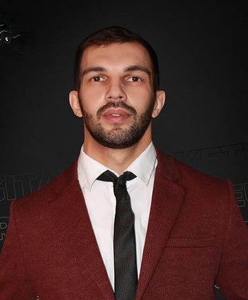 **Stefan Spasovski**

**Digital Marketer**

**Skopje, Macedonia**

**075 226 872**

**Date of birth 10/03/1993**

spasovskist@gmail.com

LinkedIn: linkedin.com/in/stefan-spasovski-48b28a183

Professional Summary

Creative Digital Marketing professional experienced in coordinating and implementing online promotion strategies. Expertise in marketing campaign development, email marketing strategy and social media engagement. Proven history of stellar industry performance, including writing sales copy, developing landing pages and improving user experience.

I'm a digital marketer, with experience in small businesses and projects on how to want to grow their social media store, campaigning, better web E-commerce businesses. I'm here to corporate with you for everything that is digital marketing, Teamwork is the best to work. I want to help you to grow, sell more of your product, and grow your business!

**Skills**

**Work History**

August 2018 to July 2019

Foxconn Slovakia, P.R.O Nitra, Slovakia

Operations Specialist

Tracked and analyzed reports to determine needed improvements.

Developed and updated tracking spreadsheets using .

Processed inbound and outbound shipments with high accuracy by directing associate teams and managing inventory processes.

Coordinated with General Manager in different operational issues and promotional activities.

Applied performance data to evaluate and improve operations, target current business conditions and forecast needs.

Developed and maintain operational guidelines for staff.

August 2019 to December 2020

B watch Skopje, Macedonia

Sales Executive

Presented products to clients using dynamic presentations and practical use-case scenarios.

Increased sales with execution of full sales cycle processing from initial lead processing through conversion and closing.

Negotiated prices, terms of sales and service agreements.

Worked with sales team to collaboratively reach targets, consistently meeting or exceeding personal quotas.

Built and maintained positive relationships with diverse stakeholders.

Collaborated with managers to provide customer feedback and recommend operational changes to meet emerging trends.

Met with customers to discuss and ascertain needs, tailor solutions, and close deals.

Met or exceeded sales, customer service and loyalty program standards.

November 2020 to July 2021

Private Company Skopje, Macedonia

Sales Consultant

Cold called and conducted face-to-face sales calls and assigned sales territory.

Increased sales by fostering relationships with customers, implementing business strategies and suggesting areas for improvement.

Retained consistent client base by conducting market research to develop brand strategy.

Boosted sales by conferring with customers to evaluate purchase requirements and recommend best-fit company offerings.

Applied knowledge of market and full range of innovative and unique products to meet customer needs, expanding company's customer base.

Responded to telephone and in-person requests for information.

Maximized customer retention by resolving issues quickly.

Implemented up-selling strategies, encompassing recommendation of accessories and complementary purchases.

Followed up with existing customers to provide additional support and address concerns.

Oversaw diverse account portfolio, including daily outbound calls to identify services that address primary needs.

Education

September 2009 – July 2012

S.U.G.S Lazar Tanev Skopje

Chef

AuGUST 2015 – 2018 OCTOBAR

Network Marketing AustRia

Community Skills And Business Strategies

DEcEMbER 2018 – JULY 2020

Insurance WITH MULTI LEVEL MARKETING

2020 OCTOBAR - May 2021

Creative Hub Skopje

Digital Marketing

