RESUME

# PERSONAL INFORMATION Zalo Myftari

Car Samoil 278, Bitola, North Macedonia

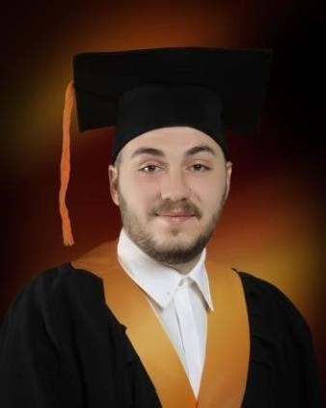

zalo-bt@hotmail.com  075 564 035

Date of birth 10/08/1996

WORK EXPERIENCE

Part-time jobs

# EDUCATION

High school graduate at SOTU “Gorgi Naumov” – Bitola – Electrical technician for computer systems and automation – 2011 - 2015

Student at Biznis Akademija Smilevski – Bitola - Strategic manager – 2017 - 2021

|  |  |  |  |
| --- | --- | --- | --- |
| MACEDONIAN | | ENGLISH | |
| WRITTEN | SPOKEN | WRITTEN | SPOKEN |
| 8 | 8 | 8 | 8 |

OTHER LANGUAGES

SKILLS

Photo editing in Adobe Photoshop, Video editing in Sony Vegas and Music and sound effects production in both FL Studio and Ableton Live.