Curriculum Vitae

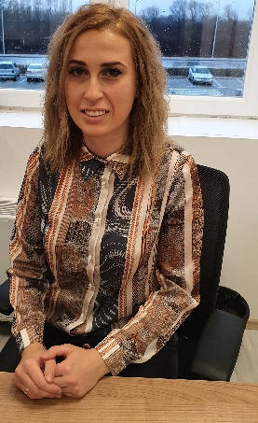

# Personal information

Name: Pavlinche

Surname: Spaseska

Date of birth: 02 February 1993

Nationality: Macedonian

Profession: Responsible for Human resources

## Contact information

Address: Ilindenska, 25, Leskoec, Ohrid

E-mail: spaseskapavlince@gmail.com

Phone number: 075/892-138

Work experience

**01.02.2021 – 30.06.2022**

**Responsible for Human resources**

* Selection of job applicants
* Interviewing around 800 job applicants in last 5 years
* Posting job advertisements
* Full operation for all employees in AVRM
* Developing of human resources
* Making records of all personal, employees documentation in SAP system
* Implementation of training programs for new employees
* Preparing different analysis for the employees
* Preparing daily reports, for workers errors messages from SAP
* Part of the project Dual education from first beginning, in collaboration with Delegation of German industry and commerce
* Preparing contracts, statements, different annexes for new/existing employees
* Introduction of new forms change of existing form, termination of existing form
* Responsible for organization of different trainings with external companies (first aid, fire protection, safety and health at work)
* Create and approve training plans
* Implementation and responsible for induction training
* Implementation of job appraisal
* Creation of company organigram, and complete act of systematization
* Preparation of documentation for the law of personal data protection

**01.07.2017 – 31.01.2021** **Human resources Assistant**

**01.09.2016 – 30.06.2017** **Assistant in administration**

* Administrative support of the plant manager
* Archival work

**30.12.2015 – 31.08.2016** **Worker on production line**

Education

2011-2014 University st. ,,Kliment Ohidski’’ - Bitola

Faculty of tourism and hospitality – Ohrid

Insurance Manager

Languages

**Mother language: Macedonian**

**Other languages:**

**English language:** writing, reading, speaking and understanding - Excellent

**German language** writing, reading, speaking and understanding - Basic

Courses and Training

* 07.02.2019 - AHK – Certificate for Employment contracts and manager’s contracts
* 01.01.2020 - 26.09.2020 - AHK – Certificate of member in commission for dual education
* 27.09.2020 - 26.09.2023 - AHK - Certificate of membership in the commission for dual education
* 17.02.2020 - Economic Chamber - Procedure for establishing employment, rights and obligations from employment.
* 26.06.2020 - Economic Chamber - Work absence with compensation of salary
* 22.12.2020 - Economic Chamber - Аmendments to the Labor Law in the field of inspection
* 29.01.2021 - Economic Chamber - Mandatory elements of the employment contract, salary reduction, work from home during a pandemic, work absence of pregnant women
* 23.02.2021 - Economic Chamber - Frequent violations in the field of labor relations and their avoidance during inspection, vacation, sick leave,
* 27.04.2021 - Economic Chamber - Payment for work and measures to reduce salary
* 23.03.2022 – 24.03.2022 - Agency of personal data protection - Introduction to personal data protection
* 11.05.2022 - Agency of personal data protection - Personal data protection
* 20.05.2022 - Economic Chamber – Internal acts of the employer, as the best mechanism for preventive action, protection of worker’s rights.
* 26.05.2022 - Economic Chamber - Digitalization in Human resources, improving processes for easier managing of employees
* 01.02.2022 – present – Clover language center - Learning German

Personal skills

* Excellent communication and negotiation skills, problem solving abilities, organizing skills
* Advanced knowledge of SAP HR, Microsoft Office products (Excel, Word, Power Point, E-Mail – Outlook, Visio)
* Flexibility for individual and teamwork, able to successfully work across different cultures
* Team player
* Precise, creative, ambitious
* Very communicative
* Team player
* Open to learn
* Driving license B-Category

Hobbies

Hiking and cycling, watching movies, traveling.