Contact

**Address:**

Sotir Brbevski 26, Bitola, 7000 North Macedonia

**Phone:**

 077 540 175

**Email:**

leobosevski2@outlook.com

Languages

English – C1

Macedonian - C2

Serbian – C1

Hobbies

* Chess
* Technology
* Basketball

Leo Bosevski

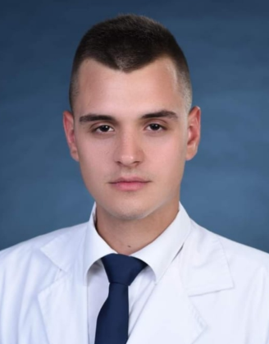

Skill Highlights

|  |  |
| --- | --- |
| * **Multitasking** * **Strong decision maker** * **Working on computer** | * **Creative design** |

Education

2017 – 2020 Medical High School Dr. Jovan Kalauzi Bitola.

2020 – present Business Academy "Smilevski" Bitola