###### **Igor Gjoreski**

Beogradska 20/1 Bitola 7000, Macedonia

Mobile Phone 077/578-751

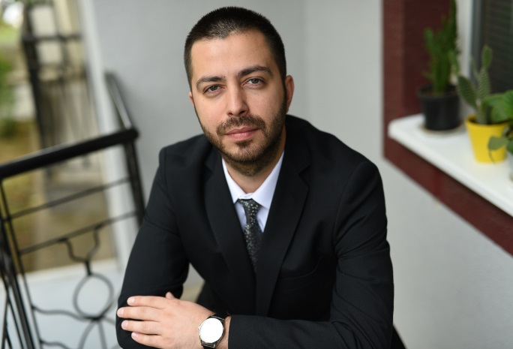

PERSONAL IDENTITY

Name : Igor Gjoreski

Sex : Male

Place/Date of Birth : Bitola/ 15 May 1987

Religion : Christian/Buddihst

Current Address : st.Beogradska 20/1 Bitola 7000 Macedonia

Phone : +389 77/578-751

E mail : goreski.igor@yahoo.com

EDUCATIONAL BACKGROUND

* - FON University – Economy studies
* - High School at SOMU ”D-r Jovan Kalauzi” – Bitola, Macedonia / Laboratory tehnician
* **-** Elementary School at ”Elpida Karamandi” – Bitola, Macedonia

WORK HISTORY

* 2009-2010 Managing at “Segafredo Zanetti” bar Skopje
* 2013-2014 Office work at “Palamida Ekspres”
* 2014-2017 Managing at “Instinct” caffe and bar Bitola
* *2017-2018 Managing “Gold Slot”Casino Bitola*
* *2019-2022 Working at kitchen bar “Aurum” chief of staff*

ADDITIONAL INFORMATION

* **Computer Skill -** Proficient in Microsoft Word, Excel, PowerPoint
* **Languages –** speaks fluently, reads and writes English and Croatian,beginner at Italian

* **Interest –** Art**,** humanitarian projects, travelling, reading books, soccer ,cooking , working out, languages, history, movies, music ,fishing
* **Abilities and attitude –** Great at communication with people; Good at multi-tasking, friendly, hard working, reliable and honest; Excellent verbal communication skills. Have a high motivation to learn and try, and to be a successful person; Disciplined, open-minded, self-confident, well organized, accountable. Positive and cheerful. Great leader.