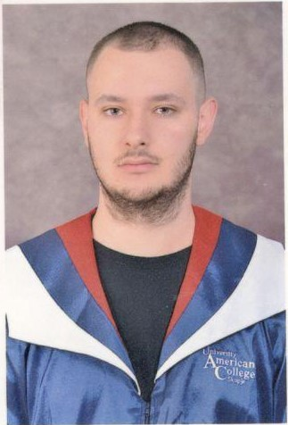

Curriculum Vitae

***Personal abilities:***

-Name and Surname STEFAN ILIEVSKI

-Adress St”Kuzman Josifovski” No.18 Bitola

-Telephone 075 524 679

-E-Mail Stefan.ilievski00@gmail.com

-Date of Birth 31.12.2000

-Place of Birth Bitola.RS Macedonia

-Nationality Macedonian

-Мarital status Single

**Education**

**-** University American College Skopje 2019/2022 year

- Senior Student of SCSIT(Software Engineering) 180 ECTS

- High School Bitola

**Certificates, trainings**

Participation in the International Conference in BAS Bitola 2015.

Participation in a seminar on Energy Efficiency 2018.

***Work experience:***

Dooel Stil Bobi - IT systems maintainer from 2020-2022

**Technical skills:** Excellent knowledge of computers

(Microsoft word, excel, internet, power point)

-knowledge of IT networks,

-web design and animations

-general knowledge of programming languages (C, C++, java, java spring, python)

***-languages*-** Excellent English (speaking, reading, writing)

***Organizational skills:***

***-*** efficient and effective work organization, flexibility and adaptability to the environment

***-*** ***Personal abilities:***

-Creativity, teamwork, operational efficiency, ability to take initiative, ability to work under pressure, desire to upgrade, responsibility, loyalty, ambition.