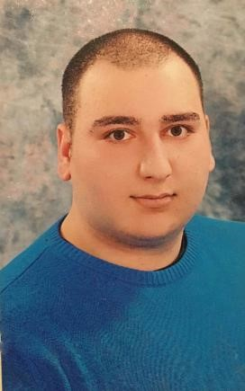

Name Radoslav Jankoski

**Email**:jankoskisradoslav@Gmail.com

Adress:Skopje,Moskovska 7/4-1

**Contact number :**+38972515026

**Education**

Graduated from the Faculty of Economics at the University of Tourism and Management Skopje , (2014 – 2018)

# Additional Education: Semos education QA automation

**Languages :** Proficient Macedonian,English b2 German B2 Level

**Working expirience**:

Stilgo komerc - Marketing b2b Sales- 2014 – 2016

# Sagitarius komerc - Маркетинг b2b- Sales- 2017 -2018

Delta Bet – 2018 – 2020 System Operator

Casino clerk ,Casino manager,Data entry,accounting

Customer Service 2021 bbs skopje

Customer Support Erm macedonia

**Main duties performed:**

* Preparing and sorting documents
* Data input and manipulation in Excel spreadsheets
* Ensuring the safety and security of the company’s data systems
* Ensuring report tables and listings accurately reflect data within a database
* etc

**Achievements**

Able to work fast and also accurately

### Skills

Excellent data entry skills (for both accuracy and speed);

Attention to detail without compromising the tasks’ speed and performance

Excellent IT skills and hands-on knowledge of spreadsheets and databases

Perseverant and patient when dealing with repetitive tasks