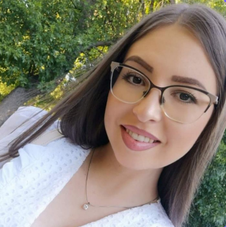

Contact

**Phone:**

+389 77/700-378

**Email:**

[zivanka.miteva@gmail.com](mailto:zivanka.miteva@gmail.com)

**LinkedIn:**

linkedin.com/in/zhivanka-miteva-5b98471b6/

Skills

* Problem solver
* Analytical thinking
* Logical thinking
* Self-learning
* Project management
* Strong decision maker
* Teamwork
* Communication

References

*available upon request

Summary

IT Software Administrator specializing in software installation, testing and maintenance of different systems. Experienced of all stages of implementation cycle of software – presentation of the software, managing the client’s requirements, development new solutions, implementation and technical support.

Experience

**IT Software Administrator** - 10/2020 -4/2023

**Riversoft**, Strumica

* Presentation of the software to the clients
* Manage the requirements of the client, adjusting the software with the already made modules or writing scripts for non-existing solutions
* Modification of the user interface upon the client requirements
* Simple network configuration needed for server-client communication including remote access
* Solving complex-based solutions and problems
* Carry out quality maintenance and technical support for the clients

**Booking coordinator** - 11/2017 -08/2020

**TA Atlantis**, Strumica

* Back office administration for travel agency
* Analyses and analytic plans

**Digital Marketing & Web Maintance** - 10/2013 -11/2017

**TA Atlantis**, Strumica

* Digital marketing and graphic design
* Web Page maintenance and SEO
* IT Support for software

Education

Bachelor of Science: **Information Technology**

**Goce Delchev**, Shtip, 2009-2013

Certifications

* Programming with HTML, CSS, JavaScript

*Semos Education (Microsoft certificate)*

* Programming in C#

*Semos Education (Microsoft certificate)*

* Developing ASP.NET Core MVC Web Applications

*Semos Education (Microsoft certificate)*

Knowledge of Programming Languages :

FrontEnd: **HTML, CSS, JavaScript**

BackEnd: **PHP, Java, C#, .NET Core, MVC**

Zhivanka Miteva