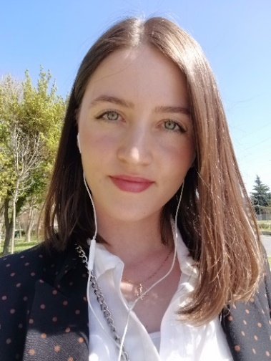**Personal information**

**Name**: Keti

**Surrname**: Gavrilovska

**Date of birth/ place** : 12.08.1994, Kocani , R. Macedonia

**Citizenship**: Macedonian

**Address**: Skopje

**Cell phone**: 077-856-814

**E-mail**: [ketitodorova94@gmail.com](mailto:ketitodorova94@gmail.com)

**Education**

**University/Faculty**: University “St. Kiril and Medodij” – Skopje,

Faculty of philology “Blaze Koneski” – Skopje

**Study:** German Language and Literature

**Started:** 2013 - /

**Completed the Automation Software Tester Academy - Semos Education:**

**Learning objectives**:Introduction to software testing, Introduction to types and level of testing, Introduction to the tools used in the software testing process, Foundation Agile software development and different Agile approaches to testing, Introduction to HTML5 and CSS3, Introduction to C#, Introduction to automation testing, Programming in Visual Studio with Selenium WebDriver, Software testing with Azure DevOps, Writing test cases and Bug reports.

**Started:** 15.03.2021 – 02.10.2021

**Additional knowledge and experience:**

* Good knowledge of Microsoft office
* Basic experience in Jira and Azure DevOps
* Experience in Salesforce and CRM
* Social media
* Basic knowledge in Adobe Premiere Pro
* Basic knowledge in Adobe Photoshop
* Basic knowledge in Canva

**Job experience**

**Date:** 01.11.2021 – 30.11.2022

**Employer:** Test IO

**Job position:** Software Tester

**Main activity and responsibilities:** Testing Websites, Games, Apps. User Story testing, Usability testing, Exploratory testing, Test Case testing.

**Date:** 15.05.2019 –15.03.2021

**Employer:** Lycamobile

**Job position:** Quality Assurance Analyst (German and English language)

**Main activity and responsibilities:** Monitoring/evaluating the call center agents, checking the quality of the call. Giving feedback to the agents regarding their calls. Translating documents. Social media support. Looking for new candidates who speak German, Interviewing them and checking their assessments and the level of German and English knowledge. Providing training to new candidates.

**Date:** 07.03.2018 – 31.12.2018

**Employer:** Alma Fashion

**Job position:** Correspondent - German and English language

**Main activity and responsibilities:** Communication with German and English companies, for requirements and problems in the production of clothing. Preparation and procurement of all production material. Making invoices for export.

**Date:** 01.02.2018 – 01.03.2018

**Employer:** ELS Veneras

**Job position:** Correspondent – German language

**Main activity and responsibilities:** Seeking accommodation for seasonal work in Germany for students. Interviewing the students, and checking their level of German, and other administrative duties.

**Date:** 15.06.2016 – 31.12.2017

**Employer:** CMX – Solutions – Skopje

**Job position**: Customer service representative

**Main activity and responsibilities:** Helping customers with their issues.

**Date**: 15.06.2014 – 15.09.2014

**Employer**: McDonald’s – Frankfurt am Main

**Job position:** Cashier

**Personal skills and knowledge**

Native language: Macedonian

Other languages: English (written and spoken)

German (written and spoken)

**Other skills:**

* Good communication skills
* Ambitious and hard-working
* Patient and understanding
* Problem solving and detail oriented skills
* A fast learner who can handle deadlines
* Can work independently but also in a team

**Hobbies and interests:**

* Exercise
* PS and PC games
* Travel
* Photography and video
* Music
* Learning new things