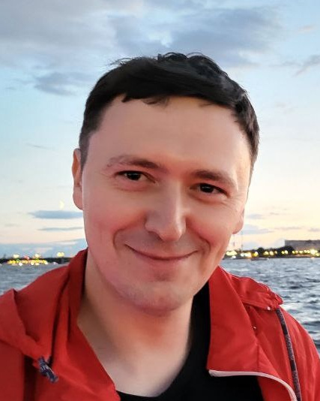**Info**

**Name:** Alexey Pobery  
**Phone:** +7-921-38-50-499  
**Marital status:** married  
**Date of birth:** 3rd may 1990  
**Email:** [poberyaa@gamil.com](mailto:poberyaa@gamil.com)

**LinkedIn**

<https://www.linkedin.com/in/alexey-poberiy-963616111>

**Github**<https://github.com/comrat>

**Objective**  
Software engineer. Problem solver.  
Concern: Computer Science, SmartTV, Back-end & Front-end development, Computer Vision, Optical Character Recognition  
  
**Skills**

C, C++, C#, QML, JavaScript, SmartTV, TypeScript, node.js, Python, Assembler, Linux, Git, PCB mounting, AndroidTV, Apple tvOS   
  
**Languages**

Русский, English, Deutsch

**Education**

* Syktyvkar State University, department of Computer Science, Bachelor’s degree in Computer Science (2008—2011)
* Syktyvkar State University, department of Computer Science, Bachelor’s degree in Computer Science (2011—2013)
* Hackspace AM&P Lab <http://amplab.ru/>([profile page](http://wiki.amplab.ru/cgi-bin/awki.cgi/ПоберийАлексей))

**Work experience**

##### **AMEDIATEKA** (<https://www.amediateka.ru/>) (Premium content provider: HBO, Showtime, Starz, WB, Sony Pictures movies and series) march 2020 - … Objective: - back-end microservice supporting - SmartTV application supporting Achievements: - Support various back-end services (written in typescript and django), like video transcoding services (based on node-ffmpeg), video streaming services, user authentication services, CMS - SmartTV app UI/UX redesign. Implement various product features like parental control, player multiple language switching, QR-code authorization etc. - Port the SmartTV client for the ZTE and EKT STB platforms.

##### **Platforms & Solutions Ltd.** Senior Developer august 2018 - march 2020 (~1.8 year) Objective: - create the SmartTV clients - back-end typescript programming Achievements: - Implement and support video transcoding typescript service based on node-ffmpeg - Implement player config storing service - Implement and distribute the new app version of Amediateka streaming service (from scratch) for SmartTV platforms: - LG WebOS - LG NetCast - Samsung Tizen - Samsung Orsay - ZTE, EKT STB

##### **START Film Ltd.** (<https://start.ru/>) september 2017 – july 2018 (~1 year) SmartTV developer Objective: create the SmartTV clients for the all popular platforms from the ground up Achievements: Make the START application for SmartTV from scratch for platforms: - [LG WebOS](https://ru.lgappstv.com/main/tvapp/detail?appId=360956&catCode1=&moreYn=N&cateYn=N&orderType=0&headerName=&appRankCode=&sellrUsrNo=) - LG NetCast - Samsung Tizen - Samsung Orsay - Apple tvOS - AndroidTV - EKT and ZTE STB Publish them in corresponding stores and support them.

##### **GS Group Holding Company** (<http://gs-group.com/>) Senior Software engineer october 2013 – september 2017 (~4 years) St. Petersburg. Objective: New UI/UX implementation with declarative programming language (QML-like language with the native C++ code) Achievements: - implement new applications for STB: Personal Account, Records, Reminder, Channels Editor, Cinematheque (application for movies recording in standby mode), VK client. Implement IPTV functionality on STB - UI/UX team leading experience.

##### **FAM-Robotics** (<http://fam-robotics.ru/ru>) Software engineer august 2013 - october 2013 (3 months) St. Petersburg. Objective: Programming and mounting automatic welding systems. Achievements: Mounting auto-welding system for doors production in Novosibirsk (<https://www.youtube.com/watch?v=UVL5u_KnscQ>)

##### **Si-Teh Ltd.** (<http://si-teh.ru/>) Sofware engineer october 2011 – july 2013 (1 year 10 months) Syktyvkar. Objective: - Supporting software and firmware for measure equipment, Repairing and mounting measure equipment. - PCB design and mounting. Achievements: Create software for the bulk density of wood chips calculating.

**Open Source  
PureQML Project**[PureQML](https://pureqml.com/) is a QML-inspired declarative JS-framework for web (and other platforms). You can simply describe the UI in a QML declarative way and this code can be deployed on various platforms: OperaTV, Samsung Orsay SmartTV, Samsung Tizen, LG WebOS, LG NetCast, Android / AndroidTV.  
Some projects based on this framework were successfully published in LG Content Store, Samsung Store and Google PlayMarket (some commercial showcases you can see [here](https://pureqml.com/showcases.html)).  
You can also deploy your code on android using cordova or create native android add using [qmlcore-android](https://github.com/pureqml/qmlcore-android)  
  
**Side Projects**

**Baku.TV**

Implement the SmartTV application for the "Baku.TV" channel. Published on platforms:

* [LG WebOS](https://ru.lgappstv.com/main/tvapp/detail?appId=1034073&catCode1=&moreYn=N&cateYn=N&orderType=0&headerName=&appRankCode=&sellrUsrNo=)
* Samsung Tizen
* Android / AndroidTV

**Echo Of Moscow SmartTV application**

Implement the SmartTV application for the "Echo Of Moscow" channel. For platforms:

* [LG WebOS](https://ru.lgappstv.com/main/tvapp/detail?appId=1120067&catCode1=&moreYn=N&cateYn=N&orderType=0&headerName=&appRankCode=&sellrUsrNo=)
* Samsung Tizen
* AndroidTV

**PLINQ**

Implement UI for the PLINQ TV Netherlandian IPTV service. This application was ported on:

* Amnio STB
* EKT STB
* [Android / Android TV](https://apkcombo.com/ru/plinq-tv-app/nl.plinq.itv/)
* iOS

**Pet Projects**

**OCTOsmart**

CHIP8 engine games collection from the [Octojam](https://johnearnest.github.io/chip8Archive/?sort=platform) for SmartTV  
LG content store link [here](https://ru.lgappstv.com/main/tvapp/detail?appId=461366&catCode1=&moreYn=N&cateYn=N&orderType=0&headerName=&appRankCode=&sellrUsrNo=)

**Fontanero**SmartTV port for the [Fontanero](https://www.reddit.com/r/roguelikes/comments/ejj28/fontanero_a_10ko_javascript_roguelike/) game  
LG content store link [here](https://ru.lgappstv.com/main/tvapp/detail?appId=446911&catCode1=&moreYn=N&cateYn=N&orderType=0&headerName=&appRankCode=&sellrUsrNo=)