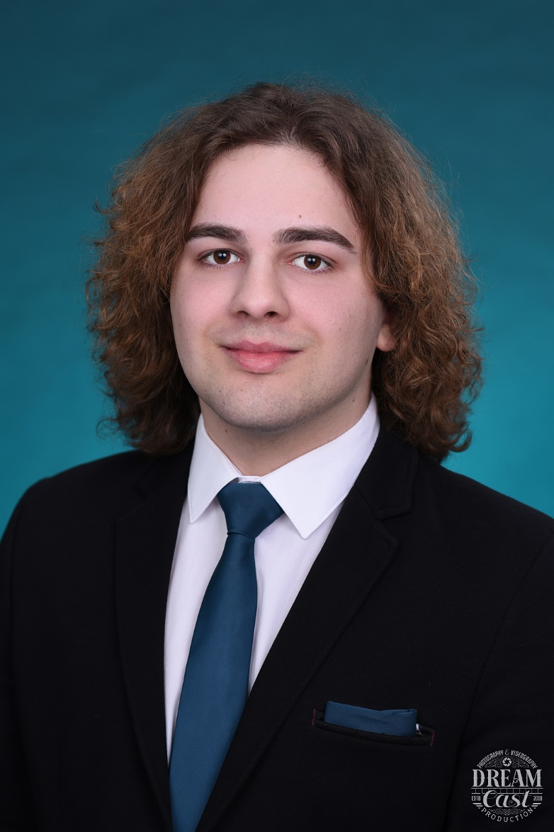

Contact

**Location:**

Bitola, North Macedonia

**Phone:**

+389 (0)75 555 223

**Email:**

mihi.krstevski04@gmail.com

Profile

A high school student with an excellent academic achievement. Participant of many local and international competitions and events. Fluent in Macedonian and English. Keen to pursue a higher education and career in anthropology and political science.

Education

**High School Gymnasium ,,Josip Broz Tito” | Bitola** **Sep 2019 – May 2023** Matura grade: A Key subjects 3rd year: Programing, Latin, Geography Key subjects 4th year: Biology, Chemistry, Physics Awards: twice second place in the local biology competition and third place for an astronomy presentation

Civic engagement

Partaken in a wide range of conventions in and out of the country including:

* speaking in parliament on the topic ,,E-books for schools in the future”
* presented on the ,,3rd World Cultural Heritage Youth Symposium” in Greece
* participated in Panda lab Junior Achievement

Additional skills

**Languages:** Macedonian (Native), English (Advanced C1)

**Microsoft office:** Word, PowerPoint and Excel

Hobbies & interests

Acting: performed at the theater for a play on Eco-awareness, short form videos and a TV appearance on a kids show. Music: playing guitar

Krstevski

Mihail