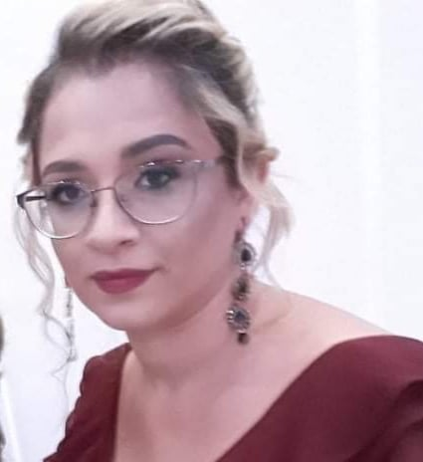

*Personal information*:

Name:Aleksandra Jovanovik Milosevska

Address: Krste Nale br.43- Bitola

Phone:078-303-498

e-mail: [aleksandramilosevska66@yahoo.com](mailto:aleksandramilosevska66@yahoo.com)

Nationality: Serbian

Date of birth: 25.11.1987

Education:

* Hight school- Taki Daskalo
* Student of pedagogy

Training and certification

* Certification of personal assistant
* Certification of Accounting
* Certification for medical coder- AAPC CPC certified
* Ophthalmological specialist

Personal skills:

Language: English, Serbian, and a little German

Technical skills:

Great computer skills

Office applications: Word, Excel, PowerPoint

Other abilities:

* Ambition
* Desire for success
* Creativity
* Flexibility
* Accepting other people’s ideas
* Individual work and teamwork

Work experience:Worked as a medical coder and biller for over a 3 years, and now I working on Denials in the ophthalmological clinic in NY for over 1 year.