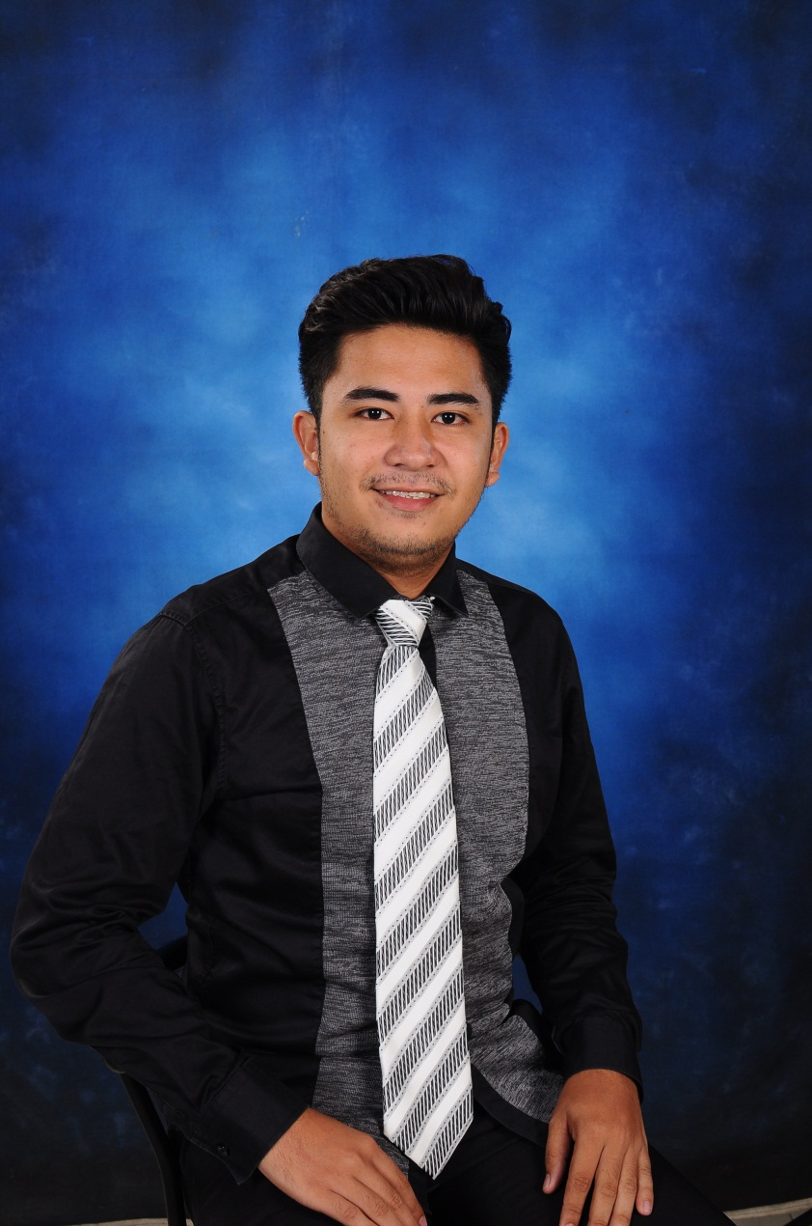

**DIXSON L. PALMERO**

San Isidro Ibaba, Lemery, Batangas

Email Add.: palmerolamadrid@gmail.com

Contact No.: 09493490623

**CAREER OBJECTIVES**

**-**To engage myself working within an organization that I would certainly learn, useful, love and enjoy and excel in my field through hard work, research, skills and perseverance.

-To serve my family, my country, and my future workplace with the best of my abilities.

**EDUCATIONAL BACKGROUND**

Tertiary Education

Bachelor of Science in Information Technology

Cagayan State University

Sanchez Mira, Cagayan

(2013-2017)

Secondary Education

Batobalani National High School

Batobalani, Paracale, Camarines Norte

(2009-2013)

Elementary Education

BatobalaniElementary School

Batobalani, Paracale, Camarines Norte

(2003-2009)

**PERSONAL DATA**

Age: 28 years old

Date of Birth: April 13, 1995

Place of Birth: Batobalani, Paracale, Camarines Norte

Nationality: Filipino

Civil Status: Single

Language: English, Tagalog, Ilocano

Height: 5’4

Weight: 50kgs

**SKILLS**

-System: Windows XP, 7, 8

-Software: AutoCAD Operator, Adobe Photoshop Editor, MS Office (Word, Excel, Power Point)

**STRENGTHS**

- Hard Working

-Flexible-Self Motivation

- Computer Literate

**CHARACTER REFERENCES**

**DR. FREDDIE P. MASULI Ph.D.**

Dean-College of Information Technology

Cagayan State University

Cell Phone #:09557280505

**LOURDES M. PADIRAYON Ph.D.**

Faculty Member

Cagayan State University

Cell Phone #:09391992769

**JENNER GUINUCAY**

Local Legislative Officer IV-Vice Governor’s Office

Cagayan Provincial Capitol

Cell Phone #: 09351812169

**WORKING EXPERIENCE**

* Vice Governor Office

Provincial Capitol of Cagayan

Caggay, Tuguegarao City

* WonLab Editor

Lemery, Batangas

* Abenson

Lotus Mall

Tanzang Luma II

* Picture City

Waltermart, Makati

I hereby certify that the above information given by me is all true and correct to the best of my knowledge and ability.

**DIXSON L. PALMERO**

(Applicant)