Curriculum Vitae

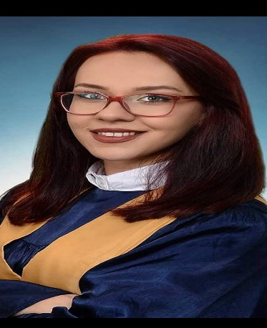

**Personal Info**

Simona Markovska

Birth date: 27.06.1998

Gjorche Petrov 39, Bitola 7000

North Macedonia

Phone: 071 320 294

Email: [itsokaysammy07@hotmail.com](mailto:itsokaysammy07@hotmail.com)

**EXPERIENCE**

Admiral, MA GAMING – cashier and operator

*August 2021 – February 2024*

• Demonstrated effective communication and customer service skills while in a fast-paced casino environment.

• Possessed a thorough knowledge of games and regulations, while maintaining a safe working environment.

• Served drinks and maintained a clean and organized work area, ensuring a safe and hygienic environment for staff and customers.

• Exchanging tickets and payment with large sums of money.

Sistina, Nefroplus – Dialysis nurse

*March 2024*

* Successfully cared for and monitored patients undergoing dialysis treatments.
* Maintained a high level of patient satisfaction by providing professional, compassionate care.
* Monitored dialysis equipment and made necessary adjustments to ensure patient safety.

**EDUCATION**

* OSMU Dr. Jovan Kalauzi – technical nurse, September 2014- June 2017
* Certified technical nurse, February 2021
* Visoka Medicinska Skola, Present

**SKILLS**

* Oral and written communication
* Computer skills ( Microsoft Office )
* Documentation
* Creativity
* Organization skills
* Teamwork
* Adaptability
* Active listening

**LANGUAGES**

* English – Very Good
* Spanish - Basic

**HOBBIES**

* Travel
* Drawing
* Reading
* Hiking