Valentina Sokolovska

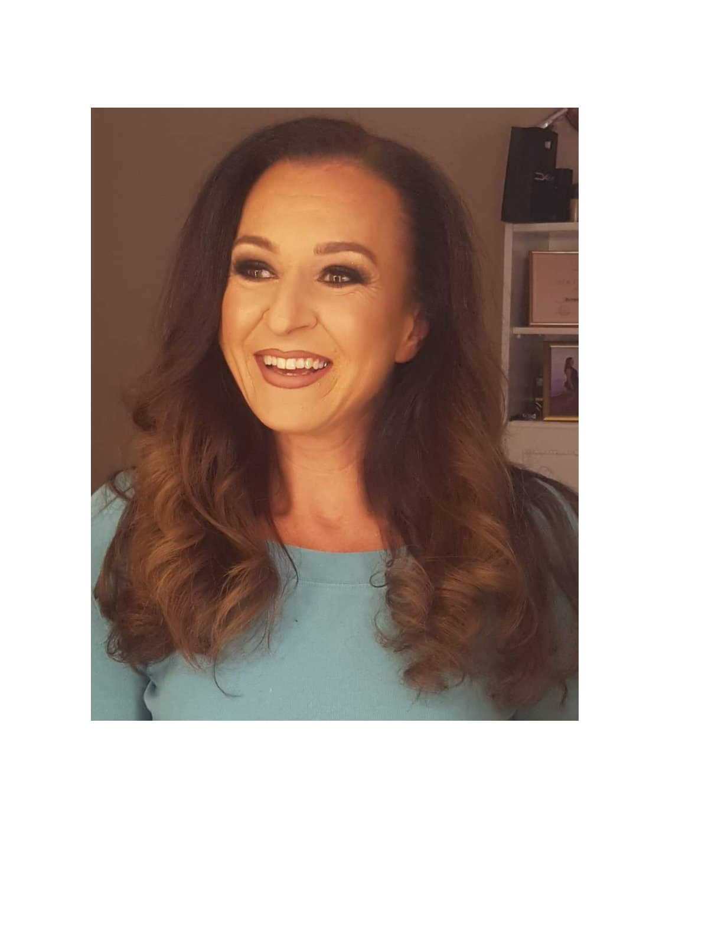

072 561335

[valovska@yahoo.com](mailto:valovska@yahoo.com)

Prilepska 80/8 Bitola

15.04.1975

# Experience

Dispatch, “D&YLines” Bitola — 2023 - Present

Finding, negotiating & booking loads for US based company. Constant correspondence with brokers and drivers via phone or mail. Setups, record keeping.

Driver Recruiter, “D&YLines” Bitola, “Atlas Credo” Bitola 2022 - 2023

Recruiting interstate truck drivers for US based companies. Advertising driver jobs on well-known job listing sites, interviewing the applicants (50 calls per day), screening the applicants, keeping records.

Dispatch/Customer representative, “Puzzle Brains” Bitola — 2021-2022

Dispatching car-hauler trucks for US based company. Making sure customers are satisfied with the schedule and the service.

Medical Biller, BPO “Taskforce” Bitola — 2020-2021

Bookkeeping & payments, but also going through claims & denials for various companies in health sector in USA.

Office Administrator , “SINPEKS” Bitola - 2016 - 2020

Financial supervisor, bookkeeping, billing, payroll, invoices, claims, and 2 years manager of the bulletin “Zelena Berza” managing sales and marketing.

HR Assistant, “APV Partner” Bitola - 2013 - 2016

Recruiting, hiring, interviewing, managing payroll & benefits, organising recruiting events, etc.

# Education

UKIM Skopje, Faculty of Philosophy — Pedagogy training in Pedagogy, Psychology & Methodology in education - Oct 2000

UKLO Bitola, Faculty of Pedagogic Education — Master’s degree in Education management - May 2019

UKLO Bitola, Faculty of Economics — Bachelor’s degree in Economincs - Feb 1999

DSU “Jane Sandanski” Bitola, — High school degree in economics, - May 1993

# Skills

Languages - fluently: English, Greek & Serbian .   
Languages - intermediate: German  
Computer skills: MS Office (Word, Excel, PowerPoint), Google Docs, Google Sheets  
Social Skills: communicative, team player, good at improvising when needed, organised, persistent, competitive & goal driven.

Driving licence: B

# Other

I’ve also worked as a personal fitness trainer & Zumba instructor. English tutor & translator, and tutor in statistics.

# Something about me…

I love animals, so I’ve rescued, vaccinated and found home to almost 100 stray dogs. My goal is to save them all :)  
I love fitness & bodybuilding.  
  
Please consider me for the job position. I can be a valuable player in your team.