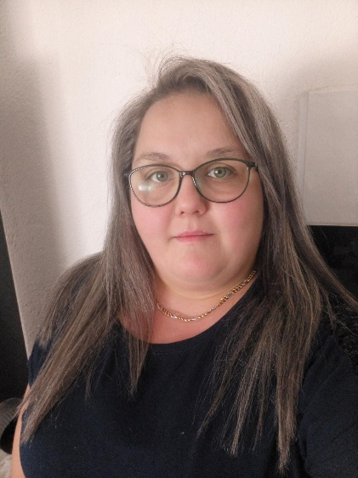

***Personal information***

Name and surname: Ankica Dimik Strezovska

Date of birth: August 10, 1992, 31 years old

Place of residence: Gorno Aglarci village, Bitola

Country: Republic of North Macedonia

Driving license B category

contact phone: +38975752111

email:strezovska41@gmail.com

***Education***

Finished secondary textile profession

Garment technician

Work experience

Work experience 8 months in

auto industry Kromberg & Shubert

Work as a salesman

***Foreign languages***

English (initial)

Serbian (good)

Croatian (good)

Work with computers

MS Office (Word.Excel.Power Point)

***Internet Explorer***

Mozilla Firefox

Opera

Google Chrome

***Other abilities***

Ambition, desire for success, creativity, flexibility, persistence, acceptance of other people's ideas, individual work and team work