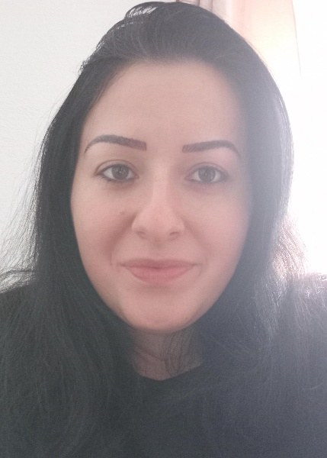**Curriculum vitae**

**PERSONAL INFORMATION**

**Name:**Valerija Davceva

**Date of birth:**31.01.1993

**Nationality:**Macedonian

**Telephone:+**38976863445

**Email address:**davceva03@gmail.com

**Education**

High school Gymnsium

**Work experience**

Promoting and presenting natural-based products, selling clothes, folding and stacking clothes, working in a textile factory on a gluing machine.

**Languages**

Macedonian- native

English-exelent knowledge writing and speaking

German-basic knowledge

**Skills:**

Presentation ,active listening,fast learner,teamwork,creativity and problem solving