**Assignment 1**

**Title: Generate Bruteforce password guessing attack. Use password cracking tools- Aircrack Ng/ Burp Suite**

**Theory:**

1. Open Burp Suite (BS)
2. Select temporary project (Don’t go for upgrade), Use Burp default
3. Start Burp
4. Select the tab ‘Proxy’, Keep Intercept OFF.
5. Click on Open browser
6. Enter the URL/webpage on which you like to perform Brute force attack.
7. write incorrect username and password (don’t hit on login/submit button)
8. Come back to BS, HIt on Intercept ON.
9. and now click on the login button.
10. It will record all your actions.
11. 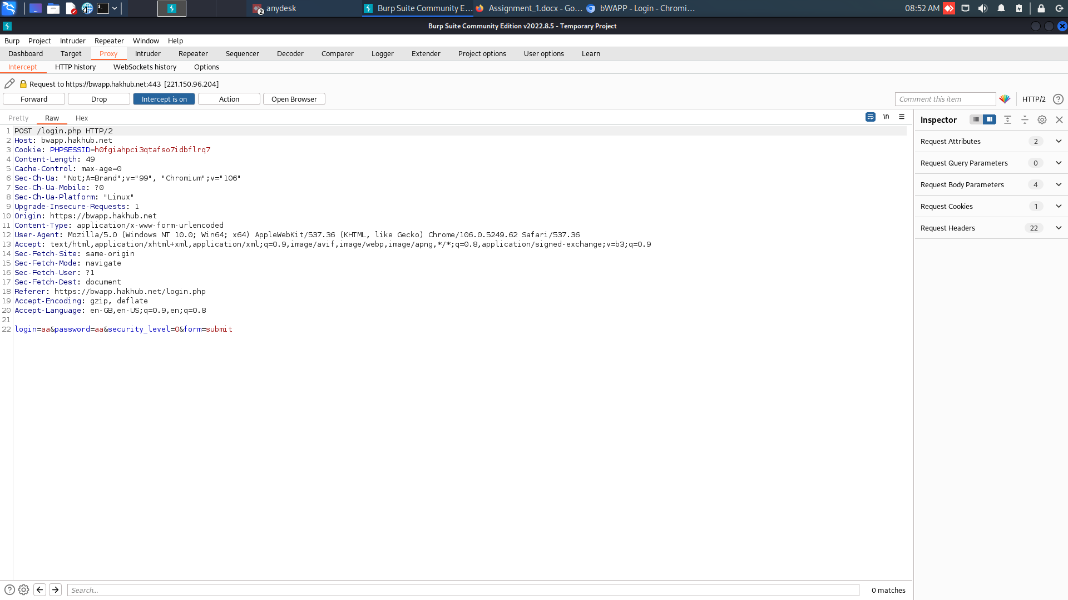
12. Right Click to this proxy window and hit on select intruder
13. pointer will move to intruder tab (observe carefully)
14. position and payload are important tabs over here
15. from position add payload markers. select type of attack as cluster bomb
16. set payloads for username and password
17. hit on Start attack
18. Observe the output window. The values of Status and Length are important parameters.
19. change in either one of the values to showcase the correct set of username and password.

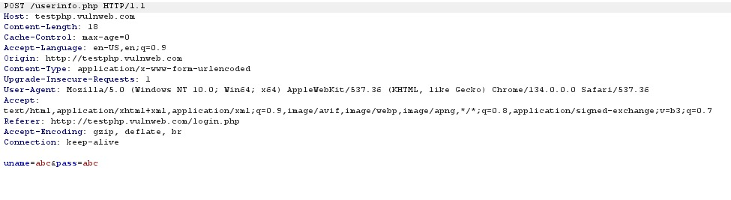

Request sent to vulnweb.com was captured using BurpSuite Proxy.

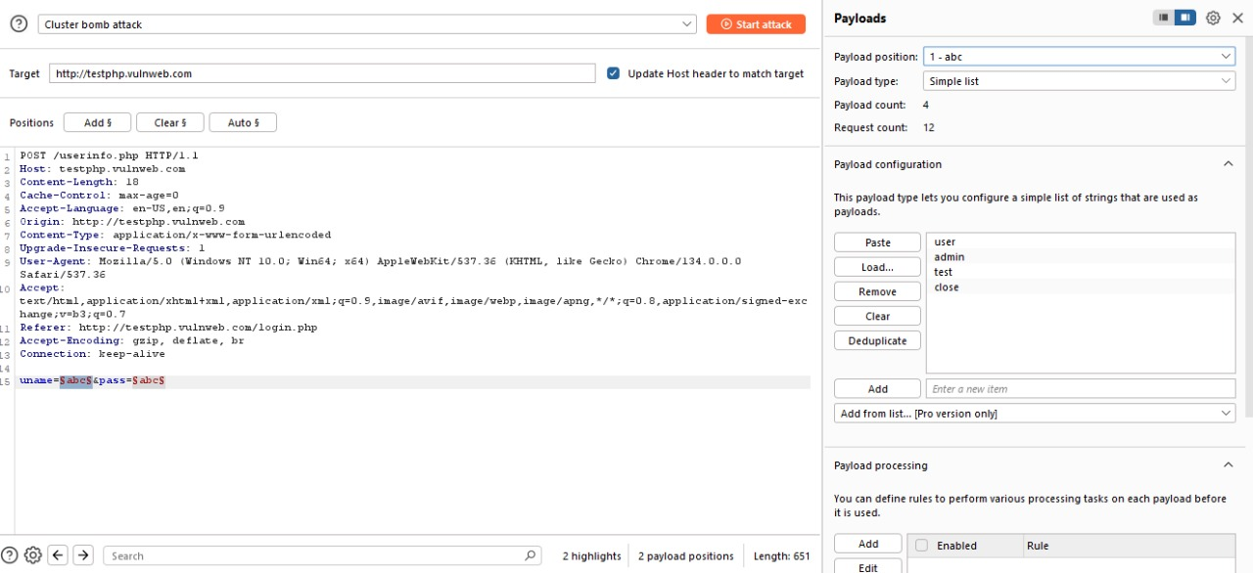

Payloads added for username (similarly for password)

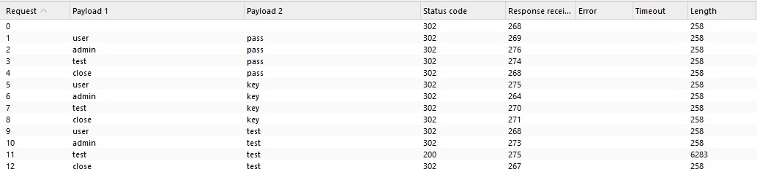

Different response length and status code for username = test, and password = test suggests that these are the valid credentials.

**Conclusion**: We studied how to orchestrate a brute force attack using Burp Suite Intruder & how to capture HTTP requests using Burp Proxy.

**FAQs**

1. What are the features of the Burp Suite tool?
2. What are the three versions of it?
3. Is Burpsuite safe to use?
4. What is the purpose of the proxy tab in burp suite?