# PRD: Barco

**Date last updated: 12/3/2014**

## For those who enjoy boating, but do not have easy access to a boat, Barco is a new community marketplace that matches boat owners with willing renters. Unlike rental companies or boat shares, Barco will tap into the millions of unused boats in the world, lowering prices for renters and providing newfound income to owners.

## Motivation

### Customer Segments

Boat Owners:

Boat owners do not currently have a good way to monetize their unused capacity. Their boat sits idle, and they continue to pay moorage and maintenance costs even when they’re deriving no utility from the vessel. Based on survey results, 2 out of 3 current boat owners would rent out their boat to accrue income. Our hypothesis is if we make this easy, boat owners will flock to our website to rent their boat in times when they don’t want to use it themselves.

Possible Renters:

Possible renters are casual recreationalists that want to use a boat 1-4 times per year, but rely on friends or acquaintances with access to a boat to fulfill these desires. Most of these individuals indicate that cost is the reason why they do not own a boat themselves; although other reasons prevail this is the primary concern. Our hypothesis is that if there were an easy way to rent a boat, these renters would be willing to pay.

Possible Investors:

Investors invariably are non-boat owners that have expressed interest in buying a boat, but did not follow through with it due to the cost of ownership. Of survey respondents that had considered buying a boat (but did not end up buying one), cost was the sole reason why they did not follow through with the purchase. Our hypothesis is that Barco can help people realize the financial benefits of boat ownership, which opens up potential partnership opportunities with boat dealers and financiers.

Personas:

Family man Frank

Frank has a wife and two young children. Between their mortgage, payments on their SUV and mini-van, and saving for their children’s education, Frank doesn’t have anything leftover to buy a boat. Frank loves boating, and wants boating to be a part of his children’s lives as it was a big part of his. Frank would rather pay $200 for a half day of boating than $200 on schlepping the entire family to a Mariners game.

Socialite Sarah

Sarah loves spending time with her friends. She moved to the big city after college because there isn’t too big of a pond for her to flourish. Part of what makes Sarah so good as socializing is organizing fun events for her and her friends. Since they’re all still in their mid-20s, nobody has the capital to spend on a boat - but everybody that Sarah spends time with loves to go boating. Sarah and her friends would rather spend $200 on a half day of boating than just going to the usual hangout.

### Unmet Needs

Boat Owners:

Boat owners currently do not have a seamless, safe and reliable way to rent their boats out to certified or professional boat captains. Their only option is to rent their boat on Craigslist, which has no insurance options and can be difficult to coordinate with potential captains and renters. Boat owners need to rely on accepting cash, or another payment sharing method that may lead to scams or potential non-payment. Lastly, boat owners have no way to verify the reliability and responsibility of renters.

Possible Renters:

Renters have a few options to rent a boat, all of them are more expensive than Barco and more cumbersome. As a result, possible renters do not rent boats as frequently as they would like. With Craigslist, they face the same issues of reliability and peace of mind as owners. With a boat rental agency, costs are higher and inventory (options) are fewer.

Possible Investors:

Not surprisingly, our survey discovered that individuals considering to buy a boat invariably decided not to due to cost. Our results also indicate that a segment of these non-owners would follow through with the purchase if costs were mitigated (or the purchase produced cash flows). This will increase the inventory available for renters.

### Existing Solutions

The current solutions that our target customers rely on, fall into two categories; the first is formal, like Seattle Boat Share where an agreement is documented between the renter and rentee, the second is informal, such as the process used on craigslist where no documentation is used and is relied solely on handshake agreements that aren’t enforceable. The two existing solutions currently, Seattle Boat Share and Craigslist, don’t meet the current customer needs in that people renting boats don’t have insurance, don’t necessarily know how to or want to drive a boat and it is very hard in both options to get a guarantee that the boat is in the condition that is listed. Seattle Boat Share falls short in that it requires rentees to become members of this club and there is a limited number of boats that can be rented. On the other hand, craigslist has a lot of boats available but no guarantees and/or insurance. An intermediary (such as Barco) in this market should be able to provide guarantees for both parties, such as the boats working condition and sees that the boat is returned in the same condition that it was rented in.

## Storyboards & Verbal Use Cases

**Sarah**

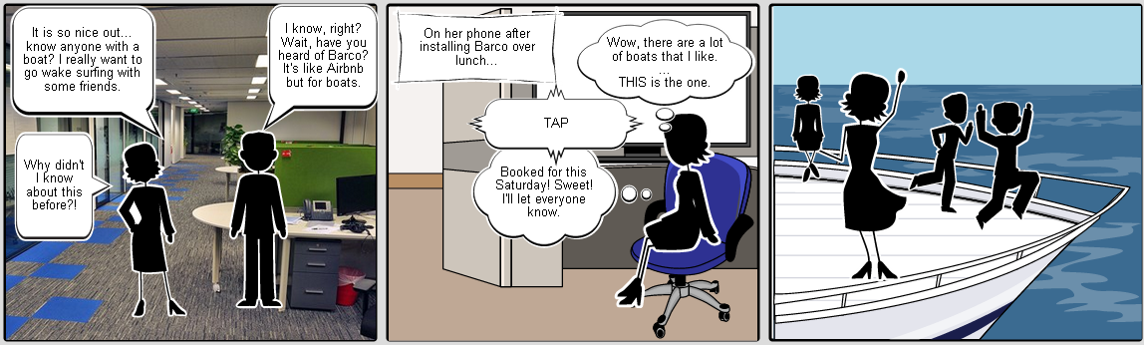

Sarah comes home from work on Friday. It has been a long week and seeing her friends will help put things in perspective. It’s supposed to be beautiful all weekend, so she checks Barco availability on Saturday, lines up a sweet ride and texts her friends to meet her at the docks.

**Frank**

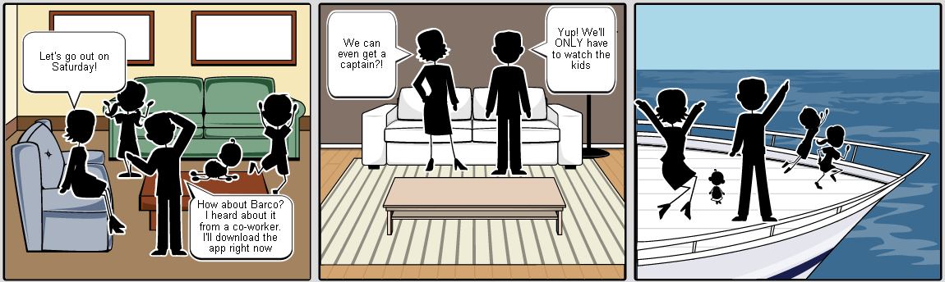

Frank has a busy, full life. He has a mortgage, kids, a couple of cars, and is saving for his children’s education. Frank also loves boating. When his kids come home from after-school activities and are raving to go do something over the to-be sunny weekend, instead of pulling up Stub Hub for Mariners tickets, Frank goes to Barco. He finds an available boat for a half day that is in his budget and can fit the entire family. Heck, he even hires a captain so that he doesn’t have to drive *and* help watch the kids.

**Jill**

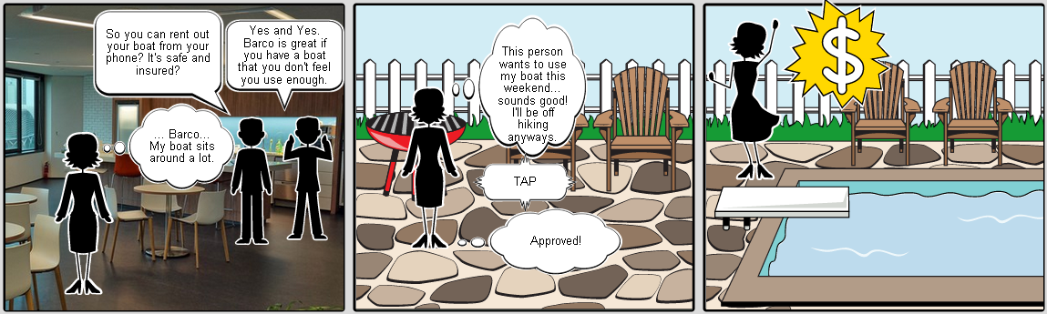

Jill enjoys her boat, but she does not use it as often as she thinks she should. She is contemplating selling it because she wants to make sure it is utilized. While at a work meeting, she overhears someone talking about Barco – they rented a boat from someone in the area who was going to Mt Rainier for the weekend. Jill joins the conversation, does some research, and quickly determines that Barco will fit her needs: renting out when she wants to whom she wants. Jill creates an account, lists her boat, and has a renter lined up for next Saturday while she goes for a hike.

**Ahab**

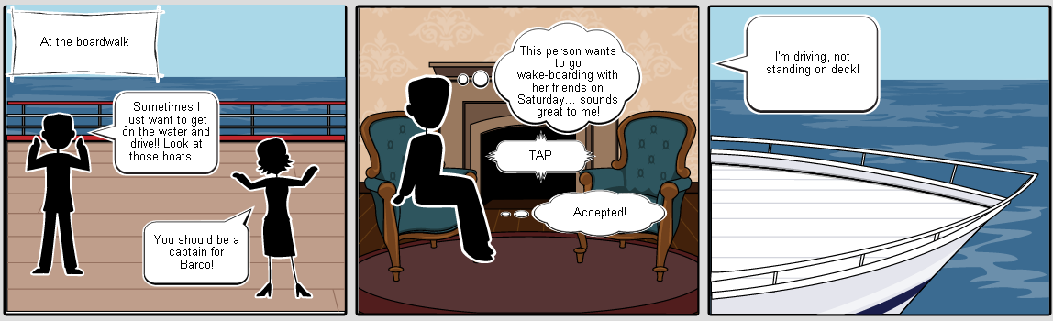

Ahab loves driving boats. While not a boat owner himself, he really enjoys being on the water. While walking through a marina one day, one of the staff (who knows Ahab well) suggests that he look into captaining for Barco. Ahab installs the app, creates a profile, and puts his extensive boating skills out on the market. He doesn’t bid on jobs, jobs come to him. He also doesn’t do it full time; he has bigger fish to fry.

**George**

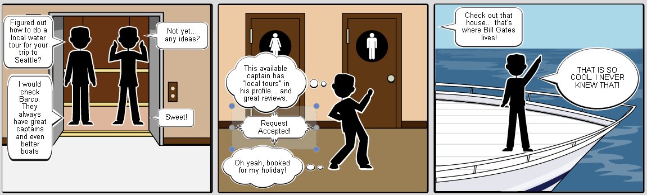

George has never been to Seattle, but he has heard a lot about it. Supposedly there are plenty of places to sightsee along the water. He is having a discussion with his friends at a bar about his upcoming trip and one of them recommends checking out Barco. George installs the app, sets up a profile, and finds a nice boat with a captain to take him sight-seeing around Lake Union and Lake Washington.

The Bottom Line: Barco allows a diverse group of people to enjoy boating without having to own a boat.

## 

## Detailed Design & Features Description

### Design Principles

* Design for the 80%
* Ease of use
* Modern/clean
* Backward functionality
* Scalability
* Intuitive to Owners
* Intuitive to Renters
* Intuitive to Captains

### Features/information architecture

|  |  |  |  |
| --- | --- | --- | --- |
| **Feature** | **Detail (Also on Wireframes)** | **Dependencies** | **Priority** |
| Sign on | Able to choose between Renter, Owner, and Captain  Continuing takes users to correct “create profile” screen | Barco must build own backend to handle the signing in and authentication process | 1 |
| Create Profile | Personal information  Payment Info  License (if applicable, optional if not captain)  Default Location  Messages  Reviews  Boat info (owner only) | Tie into GPS  Tie into banks for payment info (start with just Pay Pal)  Messaging working  Reviews working | 1 |
| User Status Page | Pending reservations/jobs (not booked)  Current reservations/jobs (booked, not taken place)  Past reservations/jobs (booked, already occurred) |  | 1 |
| Renter Map View | Toggle to List View  Map with accurate thumbnails of boat locations  Filters: Date, Ratings, Price, Capacity  GPS location of you, if on map | Map of default location  Map of current location  Map of target location (“change location”) | 1  2 = GPS location |
| Renter List View | Toggle to Map View  Locate by GPS  Locate by profile default  Locate by manual entry  Location, Price, Rating (average), Capacity  Filters: Date, Ratings, Price, Capacity | GPS location  Boat profile info | 1 (GPS  2 (manual entry)  3 (profile default) |
| Renter Boat Profile | Boat images  Boat description  Availability  Pricing  Contact owner/renter  Select captain  Boat ratings  Book it button | Owner info  Captain info | 1 |
| Captain Selection | Filter: rates, proximity to boat  Availability already confirmed boatview/boat profile  Contact captain | Captain info  User selected availability in boatview/boat profile  Messaging | 1 |
| Renter Reservation Confirmation | Summary of boat, location, begin & end dates & times, captain info (if applicable), total price  Confirm |  | 1 |
| Rating System | Renters rate: owners & captains  Owners rate: renters & captains  Captains rate: renters & owners  5 star system. Select by tapping on chosen star |  | 1 |
| Owner/Captain Job Info | Dual links to messaging: “message from X” and “Contact X”  Propose new time  Ratings, images, reservation details as applies to appropriate parties, boat details | Messaging  Propose new time | 1 |
| Captain Boat Profile | Contact owner  Boat images & description  Boat ratings |  | 1 |
| View Captain | Picture(s)  License  Ratings |  | 1 |
| Messaging | Inbox very similar to email |  | 1 |

**MVP: Minimum Viable Product**

Priority 0 – Critical Features

* Can login to Barco
* Can create selected profile (Renter, Owner, Captain)
* Renter 🡪 PayPal info, location
* Owner 🡪 PayPal info, bank info, availability
* Captain 🡪 license, availability, location
* Renters can view boats based on their GPS location
* Renters can rent boats based on their price, location, and availability
* Boats that require captains are marked as such and allow renters to pick an available captain based on price and location to boat
* Owners can view renter and captain info for inquiries
* Owners can accept, decline or propose new times for inquiries
* Captains can accept, decline or propose new times for inquiries
* Captains can only review renters and owners
* Renters can only review owners and captains
* Owners can only review renters and captains

Priority 1 – Nice to have features

* Renters can change their location while in list view
* Renters can change their location while in map view
* Renters can designate a default location for their profile

vNext

* Owners can have multiple boats
* Captains can have multiple licenses
* Renters can have multiple locations in profile
* Renters, Owners, and Captains can use banks and credit unions, not just PayPal
* Push notificationss

vLongTerm

* Inbox filters
* Recommended boats
* Recommended captains

## User Walkthroughs: Visual Use Case Walkthroughs with Comments

**Renter** – After installing the app, Frank inputs his name, email address, and selects that he is a renter.

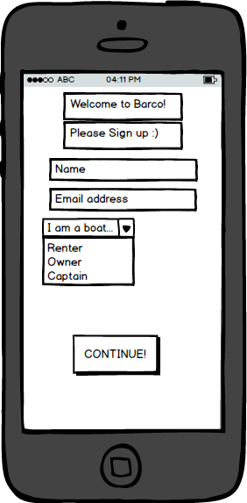

After selecting Continue, Frank creates his profile that includes his name and email (You), payment info (initially only PayPal). Later iterations will include default location. The messages and reviews section are blank because Frank has not yet contacted any owners, received messages from owners or captains, and has not been reviewed or submitted any reviews. Barco autosaves Frank’s information so he does not have to worry about hitting a save button every time he enters something.

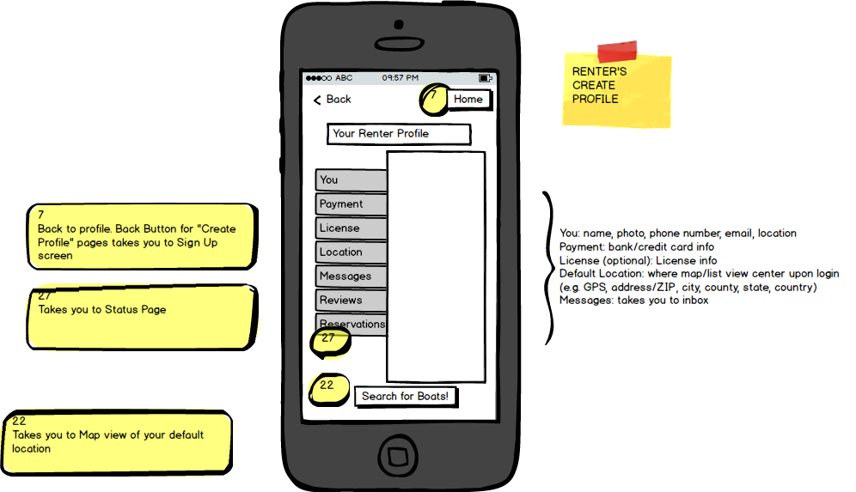

Now that Frank has his profile created, he can browse the map, centered on his GPS location, for a nice boat for his family outing. He can zoom in and out using the maps’ controls and move the map around to find the location where he wants to search. Boats will show up as thumbnails at their location and clicking on them takes Frank to the Boat Information page.

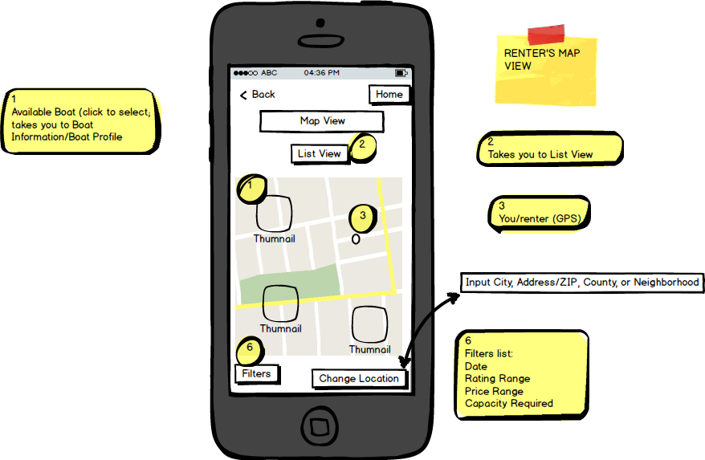

Frank can filter by date, rating, price, and capacity, while also changing the search location to an address/ZIP, county, or neighborhood. Later versions will also include country selection. As with all pages in Barco (except for the sign up page), there is a back button and a home button. Tapping Back takes you to your previous screen while Home takes you to your profile. If Frank prefers a different look to searching for a perfect boat, he can select List View.

List View displays all boats in the area that meet Frank’s filter criteria and displays them in the below grid. Here, Frank can quickly see location, price, rating, and capacity. He can also toggle back to Map View, and Change Location. Just like in Map View, clicking on a boat thumbnail will bring up the Boat Info page.

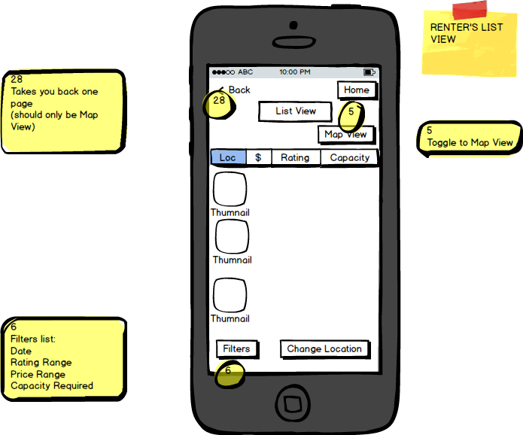

Once at the Boat Profile/Boat Info/Boatview page, Frank can quickly determine if this is in fact the perfect boat for his family outing on the water this weekend. Clicking on the boat images expands the page so he can swipe through them. There is a brief description of the boat as well. Below that is pricing, to the left is availability. Frank can select the calendar pop up to more quickly see when he may take this boat out on the water. The Contact Owner button takes Frank to a new message so that he may ask the owner any questions he has about their boat. Right below this is Select Captain. Frank is very excited about this because if he can find someone to drive the boat, he does not have to do that *and* make sure the kids don’t fall in the water or on their heads. Or maybe Frank will become Frank the Tank, who knows? Below these two buttons are Book It! which takes Frank to the Reservation Confirmation screen, and the boat’s averaged ratings that Frank that once selected expand to include more detail. Later iterations will enable Frank to filter reviews based on date, high, low, and allow renters to tag reviews as helpful or not. But right now, Frank wants to find a captain!

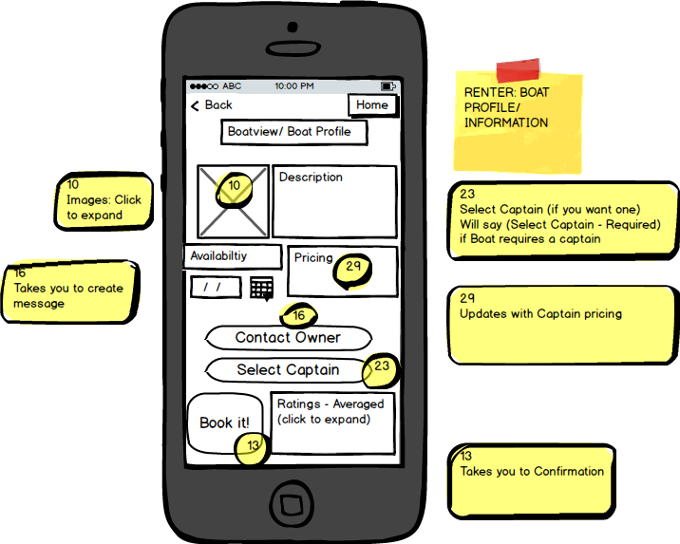

Captain selection allows Frank to find a captain based on rate and proximity to the boat Frank wants to rent. This page only shows captains who are available for the selected dates from the Boat Info page and licensed for the selected boat. Frank can also contact the captain to ask questions. Once Frank has found the person who he wants to drive the awesome boat he is about to rent, he selects OK, which takes him back to Boat Info. There, he selects Book It! which then displays the Reservations Confirmation page.

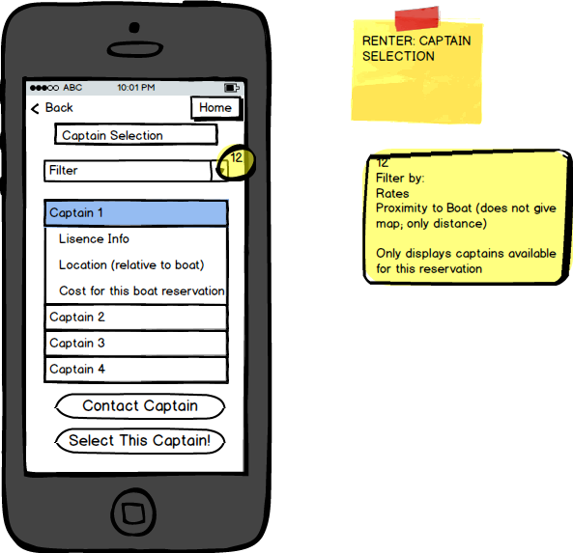

Frank is able to easily see the details of his reservation. He may go Back to change details or select another boat, but Frank knows this is what he wants to do, so he takes decisive action and hits Confirm! Now, the reservation request goes to the boat owner for confirmation.

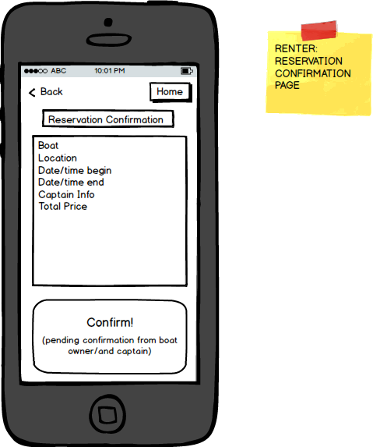

Upon completing his awesome day of boating with his family, Frank goes to his profile and selects reservations.

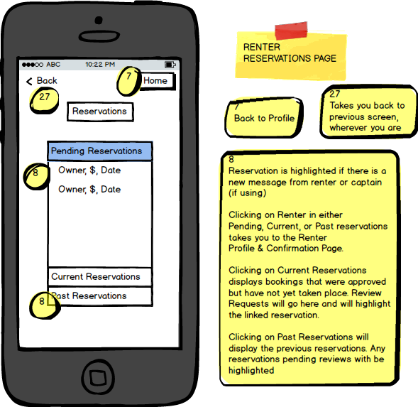

He selects Past Reservations, taps the highlighted item and reviews both his captain Ahab and Jill.

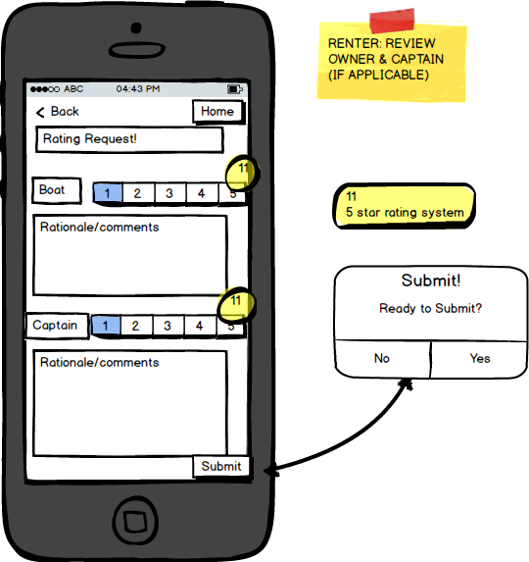

**OWNER** – Jill wants to monetize the unused capacity of her boat. Sweet! Barco makes that easy. She signs up with her name and email address, indicates that she is a boat owner, and selects Continue!

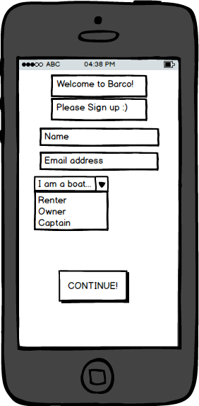

Just like with Frank, this takes her to her Owner Profile, where she has her name/email address under You, messages (blank until she receives them), and Ratings (blank until she has at least one). She also has her boat information, boat availability, and bank information for receiving payment (again, initially only PayPal). Once Jill is done inputting her information, she selects Create Profile! to take her to her status page. For some reason, she ignores the highlighted Messages tab indicating she has a new message.

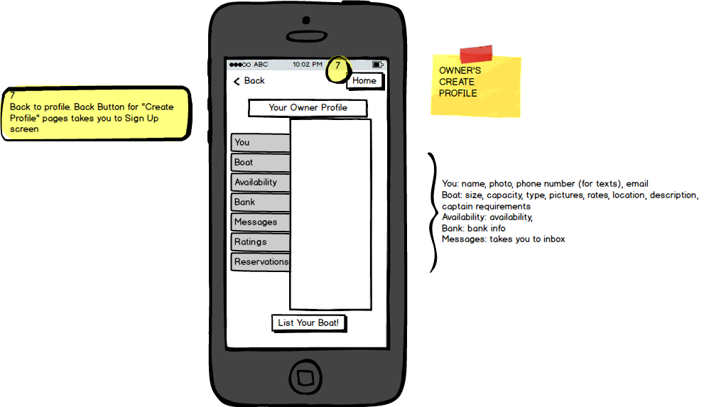

At her status page, Jill can see pending reservations, current reservations (those that are confirmed but have not yet occurred), and past reservations. She notices that she has a pending reservation from Frank for this Saturday. She selects the reservation and Barco takes her to the Job Information page.

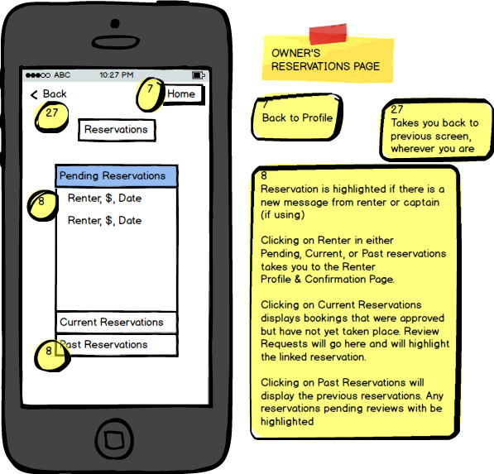

The Job Information page displays the reservation details below the renter profile information. Jill can click on Frank’s ratings to expand and read in more detail if she would like. Frank’s ugly mug is also on display to make the renting and selling experience more personalized and friendly. That, and Jill hates clowns. No one whose picture is them dressed as a clown is allowed to rent Jill’s boat. Also on this page, Jill can quickly navigate to messages from the renter (in this case, Frank) or contact the renter if she has any questions. Jill can also view the renter’s selected captain, if applicable. She can approve, decline, or propose a new time for the reservation. Jill wants to take a look at the captain Frank selected. While she knows all captains are licensed, she just wants to make sure the captain is not literally a clown.

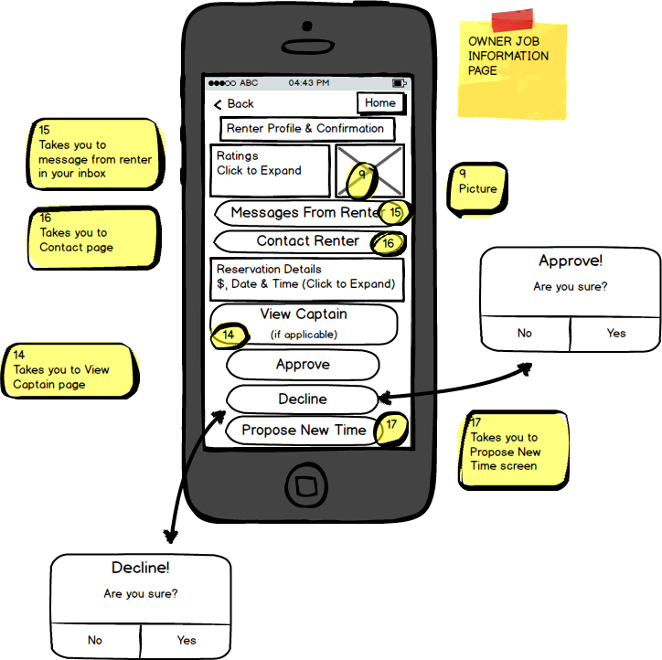

Phew! Ahab is not a clown. Plus, he is very well rated and can drive anything from a row boat to a whaling ship. Selecting Back, Jill returns to the Job Information page and selects Propose New Time because the boat she may not be fully awake when Frank wants to rent the boat.

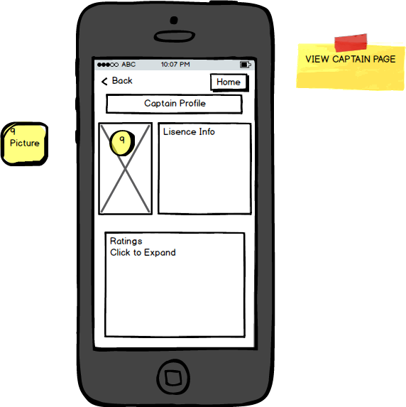

Jill proposes a new time of 15 minutes later to give her enough time to get everything ready. The newly proposed time goes to Frank for approval. If approved, the reservation updates. If not approved, Jill can either approve or deny the reservation. Frank sees the newly proposed time in his Status Page and confirms. Ahab does the same. The reservation is on!

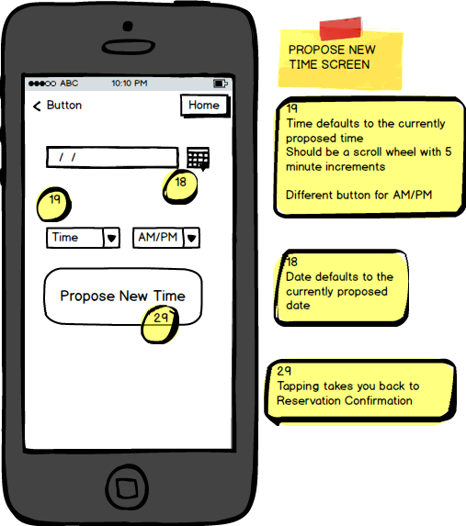

Once the reservation has occurred and Frank has returned the boat, Jill goes into her past reservations and reviews both Frank and Ahab.

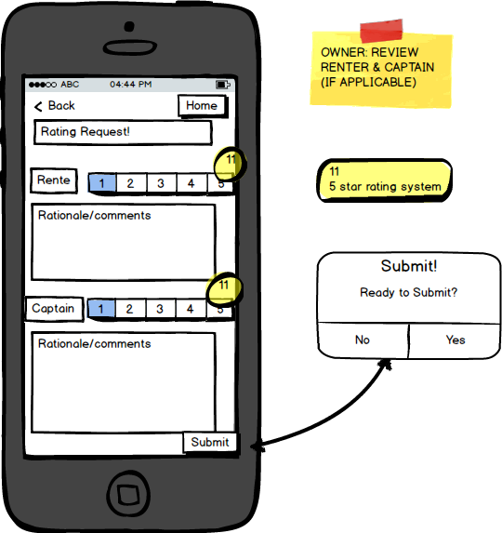

**Captain** – Ahab signs up for Barco because he really, really loves driving boats in his free time. He inputs his name and email address, indicates that he is a boat captain, and selects Continue!

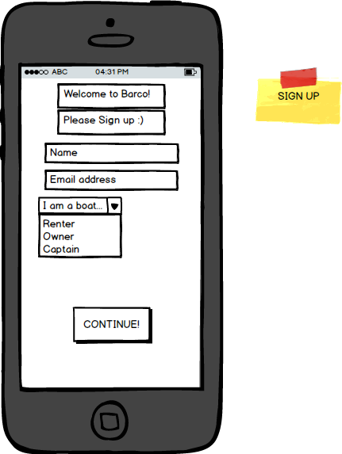

Just like with the Frank and Jill, this takes Ahab to create his profile. He inputs his information under You, his license information, availability, rates, bank info (initially only PayPal), and the messages & reviews are blank until he receives any. Ahab does not see messages or reviews highlighted, so he knows he does not have any new ones at this time. Just like with Frank and Jill, Back takes Ahab to the previous screen, and Home takes him to his status page. Once he is done filling in his profile, Ahab hits Create Profile! and goes to his status page.

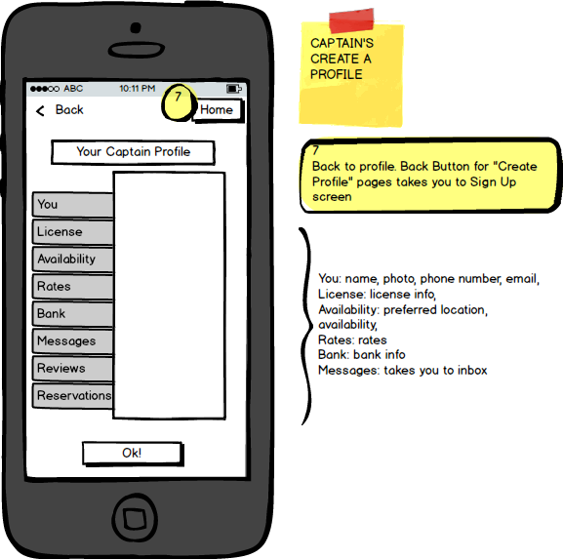

Well, that was fast. Ahab already has a pending reservation from Frank! He selects the reservation and that takes him to the Job Information page.

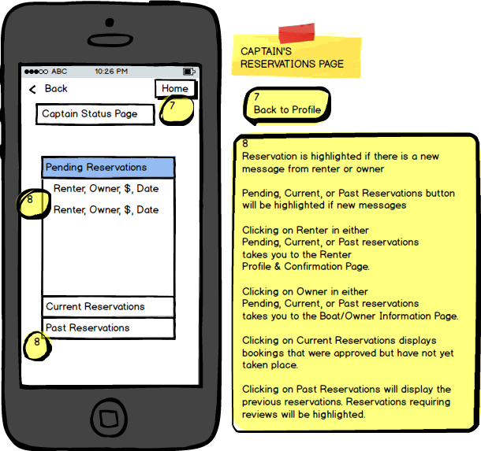

This page looks exactly like Jill’s, except Ahab may contact the renter instead of the owner. If Ahab has questions for the owner, he must go through the boat details to the Boat & Owner Profile by tapping on Boat Details. Ahab wants to check out the boat a bit more and send the owner any possible question, so he taps on the Boat Details.

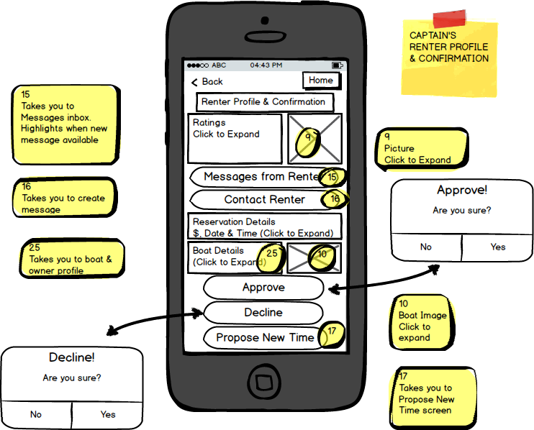

The boat description and images are displayed for Ahab to peruse. The owner ratings are also available. Ahab has a question about the boat so he selects Contact Owner which takes him to the Contact Page.

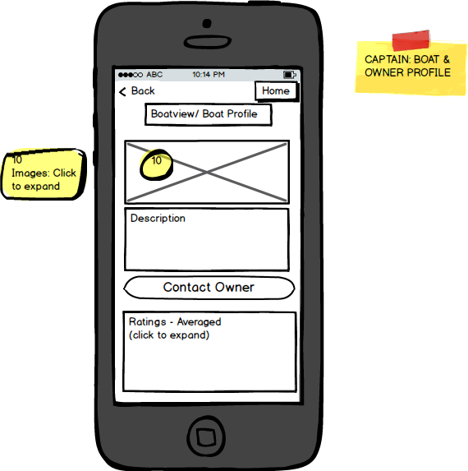

Ahab types in his message and hits send. There is no available history from this reservation because he is the first one to reach out. Once sent, Barco takes Ahab back to the Boat & Owner Profile. There, he selects Back to take him to the Job Information page. Ahab has no more questions and is ok with the proposed dates, so he approves the job request. This takes him to his status page. He wants to

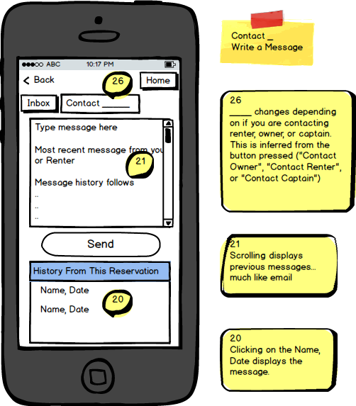

Ahab wants to check his inbox, so he taps back to take him to his profile. There, he taps messages and this takes him to his inbox. Even though the messages tab was not highlighted, Ahab verifies that he has no new messages by looking at his inbox.

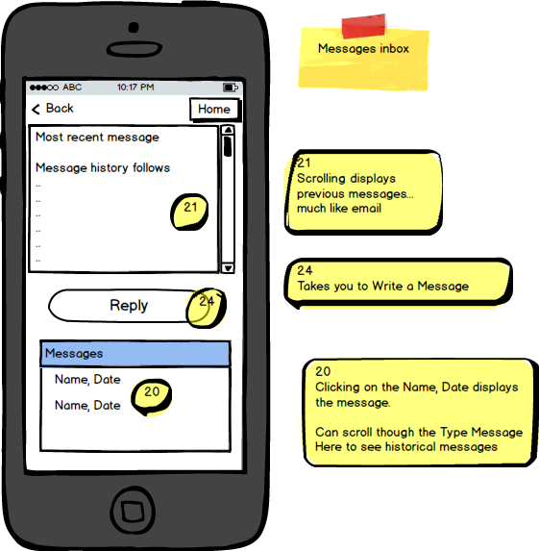

Once the reservation is complete, Ahab is required to review both Frank and Jill. He sees this pending review request in his status page; the past reservation tab is highlighted within that the specific reservation is also highlighted.

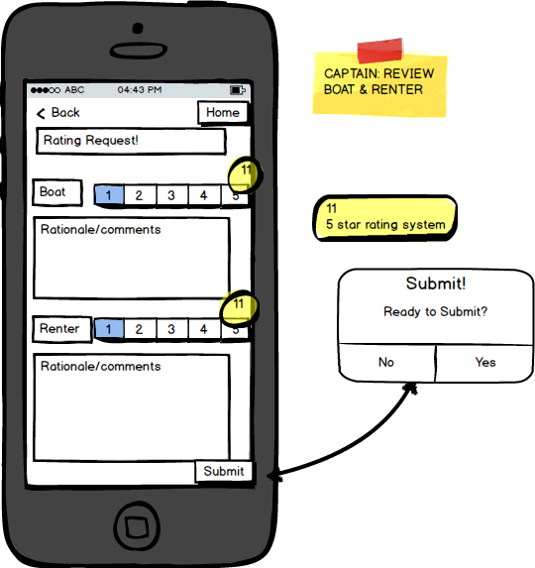

## 

## Roadmap / Timing

The rollout of the product concept has already begun. We launched a splash page with email signups for customers that want to take part in our beta product launch. Accordingly, we will already begin marketing the concept before the MVP is available for public use.

Alpha Launch: We anticipate having the product ready for internal use after one month of development time. This launch should include every screen from our wireframes, with all the functionality necessary for beta launch. We will provide our internal team (plus friends and family) 1 week to test the system from every angle, each user type, and log bugs into our bug tracking system. After this testing has occurred, we will take an additional week to fix all of the bugs found during Alpha.

Once the Alpha bugs have been fixed, we will launch our product Beta – this is our MVP. This will be initially sent to individuals that have signed up via our splash page. We will not widely promote our product during beta, but allow anybody to sign up for Beta. We will send active email communications during Beta soliciting feedback from our users, and measuring their usage with Mixpanel to judge where they’re running into challenges, and where they spend the most time.

Once we have gathered statistically significant usage data from these users, which we anticipate will take one month’s time, we will set our product roadmap for version 2 of the application. Through UX critique sessions, we have already identified several modifications that we would like to adopt for versions 2 and 3.

We will attempt to release features every two weeks and do A/B tests to scientifically judge how these product enhancements affect conversion rates from individuals that simply sign up, to individuals that complete their listing (owners and captains) or book a boat.

Version 2 of Barco will have push notifications for captains and owners when they have a pending reservation. It will also include a ‘masked’ communication feature – meaning you can text message with one another without seeing each other’s actual phone numbers.

Version 3 of Barco will allow you to propose a different time for pickup/drop off. It will also allow boat sales advertisers to send targeted marketing communications to frequent renters with Barco ownership specific messaging and offers.

## Metrics

Boat Renter:

10%

50%

90%

20%

50%

**Owner and Captain:**

10%

50%

15%

Each of the above stages in our user acquisition funnel on the renter side. We will track conversion rates from each one, and do a cohort analysis from one stage to the next when we make product changes to evaluate how the changes affect our conversion rates at each stage of the user acquisition funnel.

For the top of the funnel we will use Google Analytics, we will also use Google analytics to measure how many of these users register for an account. We’ll then use our own tracking software - Mixpanel – to determine how many users click the “complete registration” button.

We will also use Mixpanel to determine which distinct users complete the next stages in the funnel.

The total number of users that purchase multiple times (renters) and accept bookings (captains/owners) that we’re trying to achieve will depend on our financial goals from our full business plan.

## International

Expansion into international markets isn’t something that we believe is make or break for the overall success of Barco. While internationalization could give us a leg up on competition, we feel that the success of Barco will rely heavily on knowledge of the local markets, to determine current players, supply and demand, currency risk and costs of insurance. With that being said, we do not currently have plans, at this time, to include international options with our future versions of Barco due to the complexities of insurance, lack of knowledge of international markets and limited resources.

However, we believe that once our brand becomes better known and we complete our expansion into all U.S. markets, we believe that expansion into the Caribbean islands would be the most ideal. The Caribbean Islands will be a natural expansion due to its proximity to the U.S., the maturity of its boat rental business and ease of doing business there (currency and insurance for example). Initial research of the Caribbean market showed a lot of small to medium players with not one single company having a majority of the market. Some of the larger charter companies in the Caribbean are VRBO, CharterWorld and YachtCharterFleet. We cannot stress enough how much additional research will be needed with regards to expansion into the Caribbean Islands as the boat rental business in the U.S. is drastically different from the boat rental business in the Caribbean. Our target customer goes from your average boat owner and single day renter to a higher end cliental that are paying for multi-day and week usage that will range from the thousands to hundred thousands.

## Projected Costs

The number of engineers will fluctuate as our financial resources fluctuate. Ideally we will have at least three engineers working at any given time (2 of which will professional software engineers and 1 will be a college intern), which should allow us to complete the Barco application for iOS in 6 months. A research firm AYTM, with the help of Kinvey, surveyed 100 mobile designers to determine the average time to develop an application. Their research showed that on average the time for development of an application is 18 weeks or 4.5 months. As a group, we believe that this timeframe might be obtainable if we had three seasoned developers. It is our decision, in order to minimize costs, that the benefits of hiring two seasoned engineers and an intern for development far outweigh the additional costs of hiring seasoned engineers in hopes of launching only 1.5 months earlier. We project, based on the average salary for a software engineer in Seattle of $120,000 per year, that we will pay $120,000 in salaries for Barco. After all major rollouts (planned V1-V3), we will go to one software engineer and one intern, which we will scale up based on usage. Additional costs, such as office space via shared space company, Thinkspace, is estimated to cost $1,000 per month. Hosting services (see below) is scalable, so at the beginning there will be no costs associated with this product, however we expect by launch of V3 our monthly costs will be $500 and will increase from that point as usage increases.

We don’t believe that using physical machines for hosting would be the best choice. We would like to work with Amazon Web Services for hosting using their Software-as-a-Service (SaaS) model. SaaS will allow us to pay as we use, which in the beginning will allow us to realize cost savings as our product will most likely take time to ramp up usage. Additionally, Amazon’s Simple Storage Service (Amazon S3) will provide Barco with a scalable storage service, which provides additional layers of security for our users personal information. In addition, Amazon S3 is minimum fee free, with no setup costs.

## Operational Needs

Support and operational assistance is going to be very important to the longevity of Barco. Our plan is to establish a strong online and social media presence in order to provide a strong customer experience that will allow us to communicate directly with our clients. At launch we will hire a social media expert that will manage all online content and customer service issues. Once Barco begins attracting more clients we will then need to hire customer service personnel in order to facilitate the customer’s needs (this will start off small and hopefully grow as Barco becomes more popular). A lead software engineer will be hired full-time to work on development of the Barco application, which will include new versions and maintenance of Barco. We will also work with local Universities who have Computer Science programs to provide internships for students in order to leverage their skills and provide them with learning opportunities.

## Addressing Caveats/risks

As with most new ventures, Barco has some key strategic risks that must be accounted for in order for the product to succeed. The management team at Barco has identified three primary strategic risks: Privacy Concerns, Insurance Confusion, and Competition.

**Privacy concerns** - Barco customers have a number of potential concerns related to Barco that could prevent them from adopting this product, especially in the product’s early stages. Personal data concerns and concern about violation of personal property are two of the most common concerns that have been expressed by potential Barco renters.

With regard to personal data, potential customers are concerned about both the security of data stored by Barco as well as concerns about renters entering their personal space. Issues related to data security will be addressed by ensuring that all data is double encrypted and stored on an AWS S3, secure data instance. Barco will also ensure that owners do not feel that their personal property is being violated by assuring that the experience is described thoroughly and that owners have options available to minimize the personal contact required to successfully complete a transaction. Finally, in order to ensure that appropriate controls are deployed quickly, all Barco employees, owners, and renters will be provided a privacy ‘andon cord’ process. This will ensure that issues are identified immediately and addressed as quickly as possible.

**Insurance confusion** - Insurance is a material point of confusion for owners on the Barco platform. Owners will never be comfortable using Barco if there is uncertainty about who is responsible for damage to their boat. In order to address this Barco will make it clear that owners are responsible for insuring their boat while it is used by renters. Renters will be bound by the terms of use. In addition to ensuring that Barco provides consistent messaging to owners, we will also break out the portion of the rental payment to the owner that is included as compensation for ‘cost to insure’.

**Competition** - Barco is a service that will become more valuable to owners and renters as the scope of use increases, because of this well funded competitors are a material concern and Barco needs to ensure that the service provided is low cost and fun for users. An additional measure to mitigate this risk is to partner with other key players in the recreational boating market. Through various strategic partnerships Barco will work to insulate their position and make increase barriers to entry for competitors.

|  |  |
| --- | --- |
| Risk | Solution |
| Privacy Concerns | * Consistent customer messaging regarding how interactions between renters and owners will occur. * Secure sign-in and encrypted data storage (AWS S3). * Andon cord process for all customers and employees on any privacy violations. |
| Insurance Confusion | * Require owners to insure boat. * Break out portion of compensation to owners as compensation specifically for “cost to insure”. |
| Competition | * Maintain low cost. * Keep it fun. * Alliances with key partners in the recreational boating market. |

## 

## Group Members

Will Wyatt- Admiral

Will performs the duties of the Admiral of the fleet here at Barco. Functionally the same role as CEO.

Nate Kimball- Czar of Customer Experience

Nate is the team member responsible for understanding, crafting, and perfecting the customer experience for all Barco customers. This role includes the technical role of crafting a beautiful website and mobile experience as well as handling the logistical issues related to the business.

Eric Holan- Maestro of Marketing

Eric is obsessed with customers. Even more he is consumed by his passion for evangelizing Barco to customers. He is responsible for understanding Barco customer pain points and communicating the benefits of Barco to users.

Chase Thompson- Kingpin of the Finance and Legal

Barco, like any business needs to have lawyers and accountants in the back room to keep the train on its tracks. Chase is the leader of these teams and is primarily responsible for reigning in the other members of the Barco crew and making sure that Barco’s business model is legal and responsible.

**Bibliography**

Rice, K. (2013, January 8). How Long Does it Take to Build a Mobile App? Retrieved November 30, 2014, from http://www.kinvey.com/blog/2086/how-long-does-it-take-to-build-a-mobile-app