**TABLES**

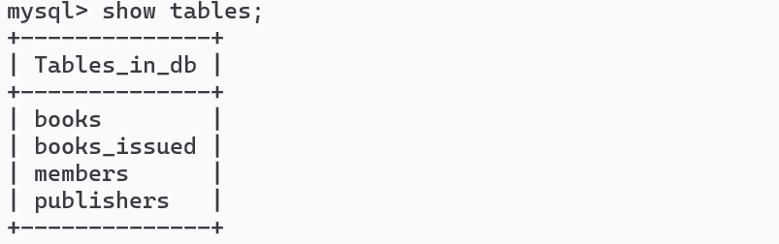

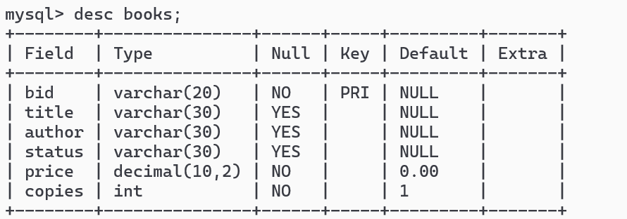

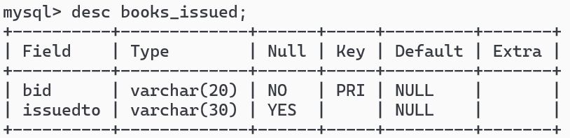

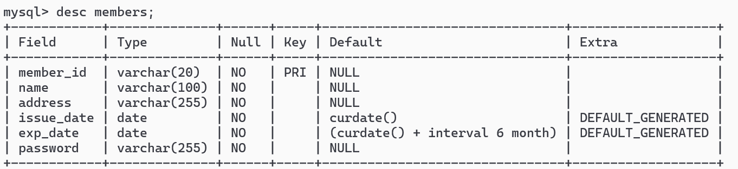

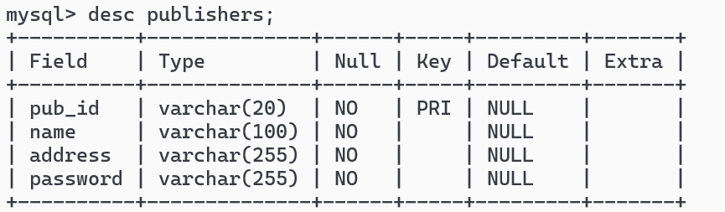

**INSERTION INTO TABLES**









**TABLE WITH RECORDS**

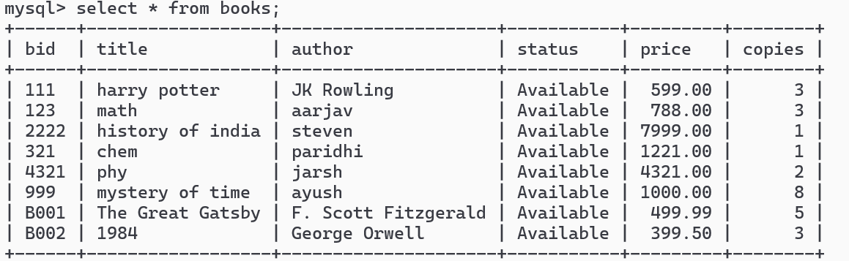

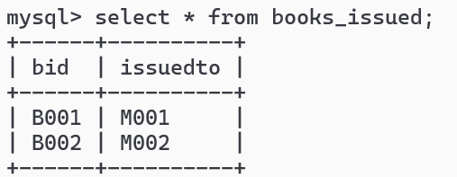

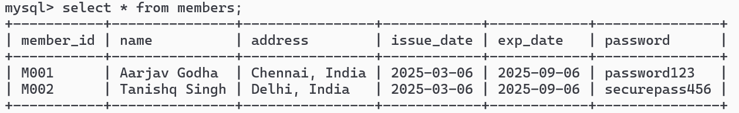

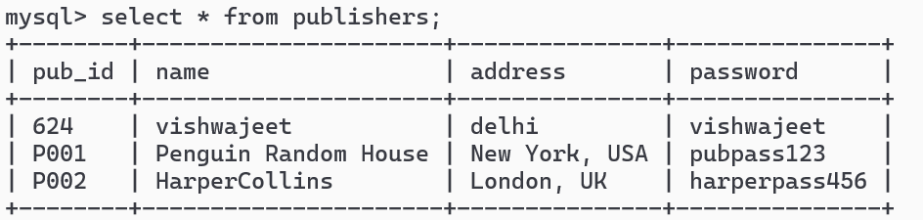

**SOME QUERIES**

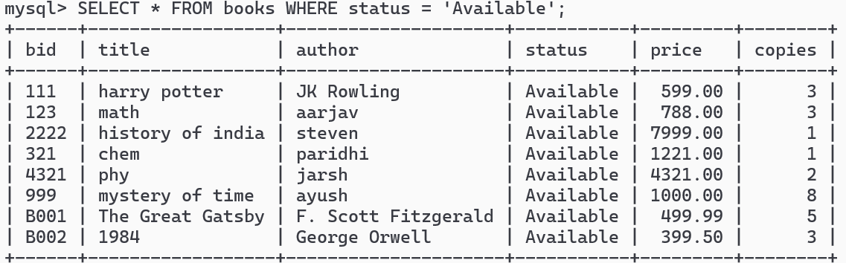

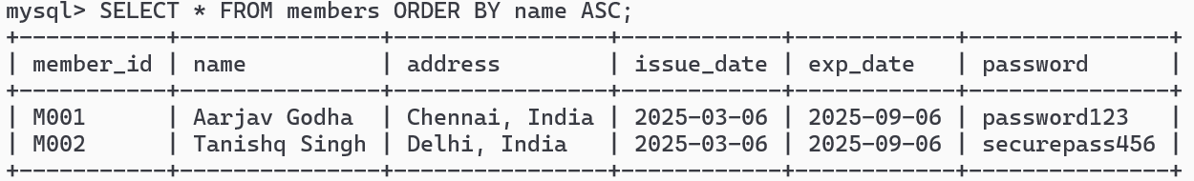

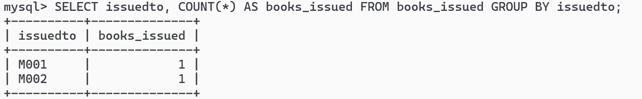

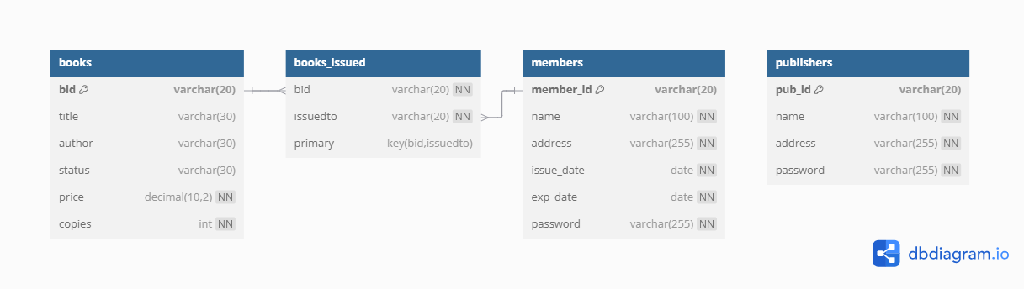

**RELATIONAL SCHEMA**

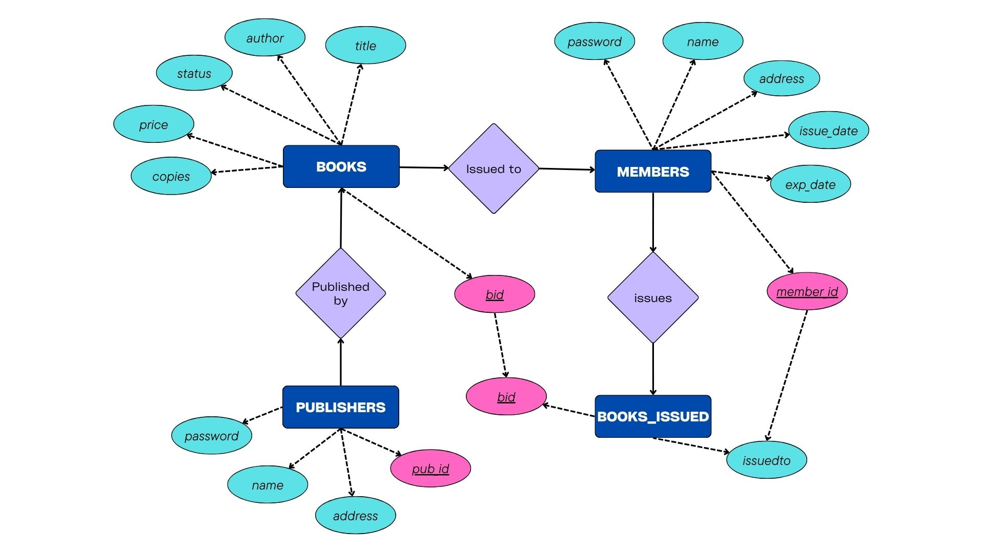

**ER DIAGRAM**