BioBuzzStarterbotAuto: How It Works and What It Needs
Nov 7, 2026 (telemetry updated Nov 12, 2026)
BioBuzzStarterbotAuto is the team's competition autonomous; on the Driver Station it is "BioBuzz StarterBot Auto", next to its teleop partner "BioBuzz StarterBot Teleop". It was called UltronAuto until Nov 12, 2026. Don't confuse it with goBILDA's sample StarterBotAuto (on the Driver Station: "goBILDA Sample Auto (reference)"), which is only for reference.
The auto starts facing the hive, shoots the 4 preloaded balls, drives 8 ft 4 in straight under the hive, turns left and drives 3 ft on to the parking spot (blue tape). The route is measured from the blue base. In a headless test model it finished in about 11.6 s of the 30 s autonomous.

What it does in a match
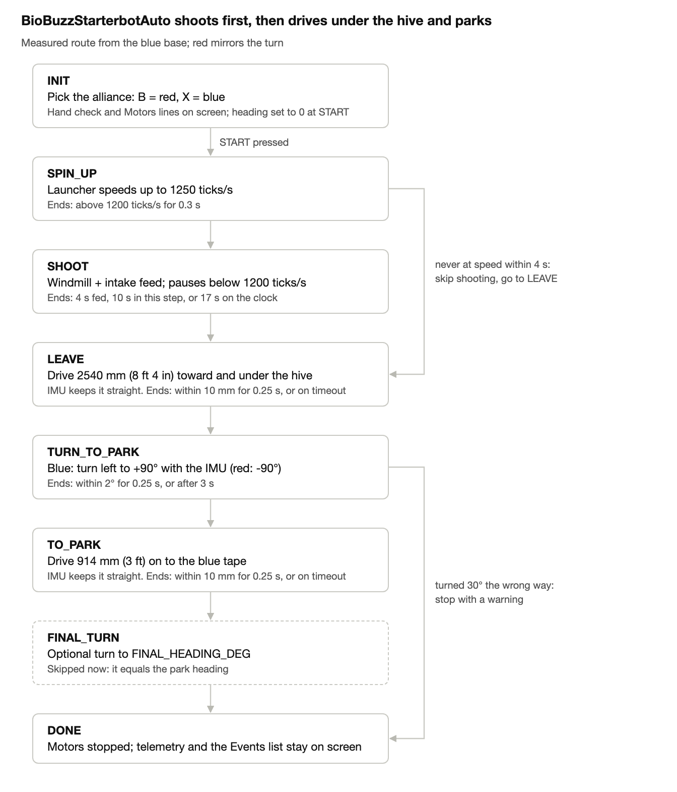
Each step ends only when its condition holds, so a timer or safety check is always running. In the headless test model, spin-up took about 1.4 s, shooting 4 s, leaving 3.7 s, the turn 0.9 s and parking 1.6 s. A missing launcher or intake skips from INIT straight to LEAVE.

How the code is organized
It is an iterative OpMode: the SDK calls loop() about 50 times a second, and each call does a little of the current step. Nothing waits or blocks, so timers and safety checks keep running.
- Settings at the top: route, hardware names, motor directions, shooting and driving values. These are the only lines you should need to change.
- init(): finds each device by name, sets motor directions and brake mode, and resets the encoders. It sets up the launcher's velocity control with goBILDA's tuning (PIDF 40, 0, 0, 12.5) and resets the IMU heading. The launcher, windmill and IMU are each wrapped in try, so a missing device switches to a fallback instead of crashing. All four motors are loaded as DcMotorEx so the telemetry can read their encoder speed; this doesn't change how they drive. Each device's result (found with its settings, or missing with the error) is written to the Events list.
- init_loop(): reads the alliance button (B = red, X = blue) and shows the route (in mm and encoder ticks), the shooting and driving settings, each device's status, the live heading, the encoder counts and the Motors section for the hand check, and the INIT events.
- start(): resets the auto clock and sets heading 0 to the way the robot faces now. If the launcher hardware is missing, it skips straight to LEAVE.
- loop(): the step-by-step program in the flowchart, plus telemetry (see "Reading the Driver Station screen" below).
- Driving straight (startDrive / driveDone): encoders measure the distance with RUN_TO_POSITION, set in the required order: target, then mode, then power. Each loop, the IMU heading error × 0.03 is added to one side's speed limit and subtracted from the other's, steering the robot back onto its line. This is the method of the SDK sample RobotAutoDriveByGyro.
- Turning (startTurn / turnDone): turn power = heading error × 0.02, kept between 0.08 and 0.4; left wheels get -power, right wheels +power. Headings are measured from the start, so a small error in one turn is fixed by the next.
- Mirroring (heading()): on blue, every heading changes sign. Distances don't change.
- Safety: every drive and turn has a timeout. Shooting must end by 17 s so parking always gets time. A turn that moves 30° further from its target stops the robot and shows "Turned the WRONG WAY". A launcher encoder reading about 0 switches the launcher to plain 0.85 power. A motor that turns against its command is reported as WRONG WAY!; this only reports, it doesn't stop the robot.

What it needs in the Control Hub configuration
Only the two drive motors are required; every other device has a fallback, but shooting needs all three shooter devices.
Name | Configuration type | Needed? | If it's missing or wrong
left_drive | Motor (goBILDA 5203, 312 RPM) | Yes, with its encoder cable plugged in | INIT crashes. Without the encoder, the drive steps time out.
right_drive | Motor (goBILDA 5203, 312 RPM) | Yes, with its encoder cable plugged in | Same as left_drive
intake | Motor | For shooting | If this or launcher is missing: no shooting, only LEAVE and PARK
launcher | Motor (6000 RPM), encoder plugged in | For shooting | Missing: no shooting. No encoder: plain power, so shot speed varies with the battery.
windmill | Continuous Rotation Servo | For shooting well | Feeds with the intake only, and a warning shows on screen
imu | Control Hub built-in IMU, added automatically when you scan | Strongly recommended | Falls back to encoder turns, which are less accurate

- Ports: any port works as long as the names match. To match the simulator's Ultron Bot, use motor ports 0 (left), 1 (right), 2 (intake) and 3 (shooter).
- Not used: left_intake_servo and right_intake_servo. They can stay in the configuration.
- Motor directions: left FORWARD and right REVERSE, as in goBILDA's code and StarterBotAuto. With these, the route values are negative, and negative drives the robot toward the hive (the shooter end).
- Windmill direction: REVERSE, so setPower(1) feeds the balls, as in goBILDA's code.
- Intake and launcher directions: both REVERSE, the same as ShooterAutoTest, ShooterTest and HardwareTest (the shooter tests have been verified on the robot). Without these, the launcher spins backward and the intake pushes balls the wrong way.
- Hub mounting: HUB_LOGO = UP and HUB_USB = FORWARD assume the hub lies flat, logo up. If yours is mounted differently, change these two lines; the hand check catches a wrong setting.

The INIT hand check
After INIT and before START, two hand movements confirm the motor directions, the encoders and the IMU. Here "forward" means away from the hive, the opposite way to how the route drives.
Do this | You should see | If not
Lift the robot and spin both wheels forward by hand | Both counts go up | Counts go down: flip the motor directions. A count stays at 0: check that encoder's cable.
Put it down and turn the robot counter-clockwise by hand | Heading goes up, left count goes down, right count goes up | Left goes up: the motors are swapped in the configuration. Heading goes down: fix HUB_LOGO / HUB_USB.

While you push, the Motors section shows the same thing as words: wheels forward should read turning FWD on both drive lines, with the status coasting / pushed (the code isn't driving them, you are).

Reading the Driver Station screen
The screen has three parts, top to bottom. It updates every loop from INIT to DONE.

1. Live values for the current step
Always shown: the state, the alliance, the time spent in this step, the auto clock out of 30 s, and the loop time in ms. Under about 50 ms is fine. Below the step's values, the old lines stay: launcher speed, fed seconds, heading / target, encoder positions and targets, and any WARNING.
Step | What it shows
SPIN_UP | Launcher speed against the target (1250) and the ready level (1200), the steady-at-speed time out of 0.3 s, and the spin-up time out of 4 s. With no launcher encoder: the plain-power countdown instead.
SHOOT | Feeding ON or PAUSED (launcher below 1200), windmill and intake power, fed seconds out of 4.0 with an estimate of balls fired, the number of feed pauses, and the shoot time against the 10 s and 17 s limits.
LEAVE, TO_PARK | The distance asked for and its direction, mm driven and mm left for each wheel, the heading error and the steering correction it causes, left / right power, whether the wheels are on target (and for how long, out of 0.25 s), and the time against the timeout.
TURN_TO_PARK, FINAL_TURN | Turn error (and the error at the start of the turn), turn power for each side, the on-target hold time, and the time against the 3 s timeout. Without an IMU: the ticks left for each wheel.
DONE | The auto time when it finished.

2. Motors
One line per motor: set | told | turning | status.
- set: the direction setting read from the motor (FORWARD or REVERSE).
- told: which way the code is telling it to turn right now: FWD, REV or stop. The drive motors' power is always positive while they drive to a target, so for them "told" comes from which side of the target they are on.
- turning: which way the encoder says it really turns, with its speed in ticks per second. The SDK applies the direction setting to the encoder too, so "told" and "turning" should always match.
Status | Meaning
OK | Turning the way it's told, or stopped when told to stop
starting / reversing | Short, normal moments: speeding up, or overshooting a target
coasting / pushed | Told to stop but still moving: the launcher slowing down, or you pushing the robot in INIT
WRONG WAY! | Turning against the command for 0.3 s or more. Check that motor's direction setting and its motor and encoder ports. Also written to Events and shown as a WARNING.
NOT TURNING (no encoder? stuck?) | Told to turn, but no encoder movement for 1 s. Check the encoder cable, or whether the robot is stuck. Written to Events once. The intake shows this if its encoder isn't plugged in, which is harmless.

The windmill is a servo with no encoder, so its line only shows its setting and the power it's told.
The limits are settings in the Telemetry section at the top of the code: DIRECTION_MIN_VELOCITY (50 ticks/s counts as moving), WRONG_WAY_SECONDS (0.3) and NOT_TURNING_SECONDS (1.0).

3. Events
One line each time a method changes something, stamped with the auto time (or INIT). While running, the newest 12 show; at DONE the whole run shows (up to 40), so you can read the full story after the match.
Event | Values shown
INIT, per device | Found with its directions, PIDF and hub mounting, or missing with the error
START | Alliance and the starting encoder counts
Step change | From → to, and how long the old step took
Launcher ready / never ready / no encoder | Speed and time taken
First ball fed | Windmill and intake power
SHOOT done | Why (all fed, 10 s limit, or 17 s deadline), fed seconds, time taken, number of feed pauses
Launcher off | Velocity 0 or power 0
Drive start | mm, ticks, the targets, the heading held, the timeout
Drive arrived / timed out | mm each wheel drove, the final heading
Turn start | From → to heading, LEFT or RIGHT, the starting error (or the turn arc in ticks without an IMU)
Turn done / timed out / wrong way | Final heading and error
FINAL_TURN skipped, DONE | The heading and encoder counts at the end
Motor WRONG WAY / NOT TURNING | Which motor, what it was told, what the encoder read

Before the first field run
The route was measured on the field from the blue base. BioBuzzStarterbotAuto.java now holds these values, written in red form and mirrored for blue.
Setting | Value in the code | Measured
LEAVE_MM | -2540 | 8 ft 4 in, toward and under the hive
PARK_HEADING_DEG | -90 | Turn left on blue (right on red)
TO_PARK_MM | -914 | 3 ft, on to the blue tape

Fine-tune the route with the Test runs sheet in TeamCode/docs/BioBuzzStarterbotAuto_Route.xlsx.
- Test the windmill servo in the TestHardware utility; it has never been tested.
- BLUE is the default alliance (the INIT screen shows it). Press gamepad1 B for RED, which turns right.
- Run the route three times and log each miss in the Test runs sheet. After each run, read the Events list at DONE and write down any timeout or warning.
- During the first run, check that every Motors line says OK (the intake may say NOT TURNING if its encoder isn't plugged in).
- Check in the game manual that blue is a mirror of red; if not, set MIRROR_FOR_BLUE = false.
- Copy BioBuzzStarterbotAuto.java into the simulator folder, and delete the old UltronAuto and V2 files there so only one auto shows.

