ACCESS THIS DOCUMENT BY SCANNING THIS QR CODE ;

=================================================

<https://docs.google.com/document/d/1Vo9KUuZjJEu3UI86wTAfJ5TOFxGO2VN1B-J8q5Qtruc/edit?usp=sharing>



===========================================

AWS FREE TIER ACCOUNT CREATION STEP BY STEP :

——————————————————————————-

<https://k21academy.com/amazon-web-services/aws-solutions-architect/create-aws-free-tier-account/>

AZURE FREE TIER ACCOUNT CREATION STEP BY STEP:

———————————————————————————

<https://k21academy.com/microsoft-azure/create-free-microsoft-azure-trial-account/>

Application server/ Database Server / Webserver :

======================================

<https://dev.to/k_penguin_sato/web-serverapplication-serverdatabase-server-d4k>

<https://phoenixnap.com/blog/web-server-vs-application-server>

OSI MODEL :

—----------------

<https://www.geeksforgeeks.org/layers-of-osi-model/>

**Linux commands cheat sheet** :

—----------------------------------------

<https://www.interviewbit.com/linux-commands-cheat-sheet/>

<https://www.guru99.com/linux-commands-cheat-sheet.html>

powercfg/batteryreport

file:///C:/Windows/System32/battery-report.html

Microsoft outlook account creation Steps :

———————————————————-

<https://account.microsoft.com/account?lang=en-hk>

CHOCOLATEY SOFTWARE INSTALLATION:-

—————————————————————

<https://chocolatey.org/install>

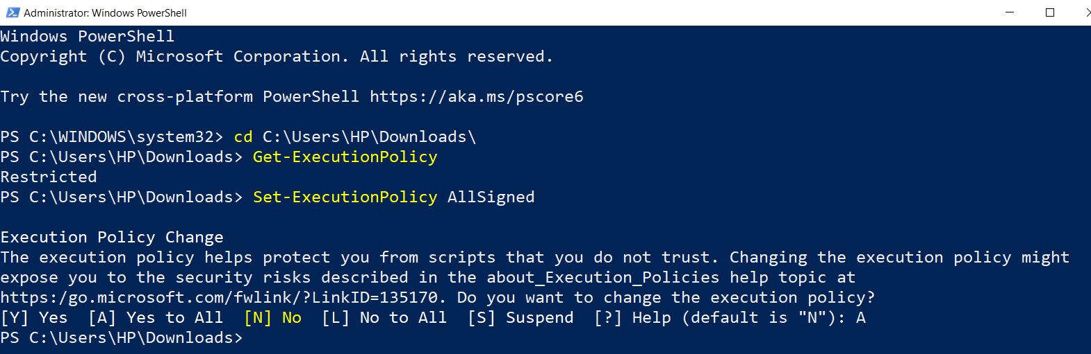

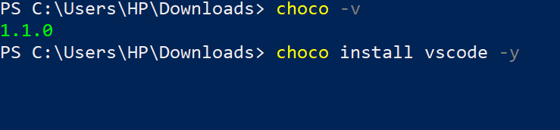

DAY-2 [ Connecting EC2 & VM using SSH ]

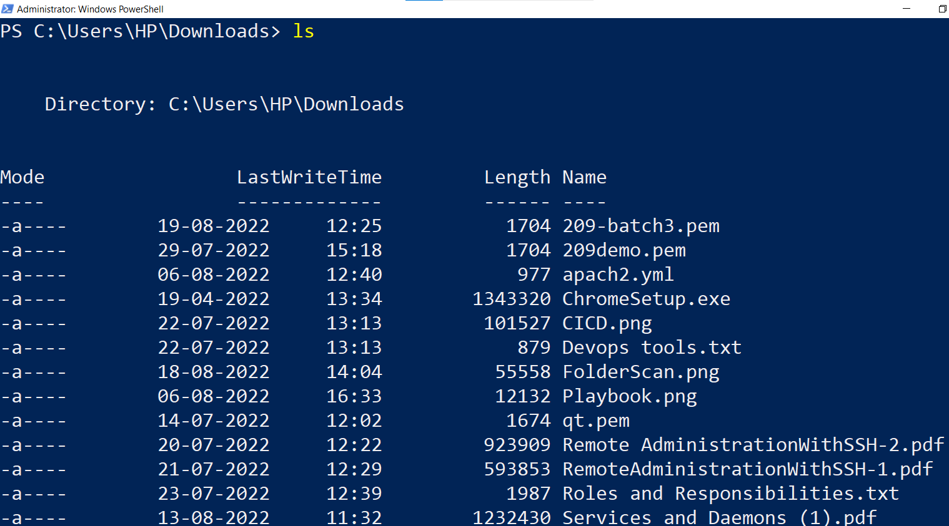

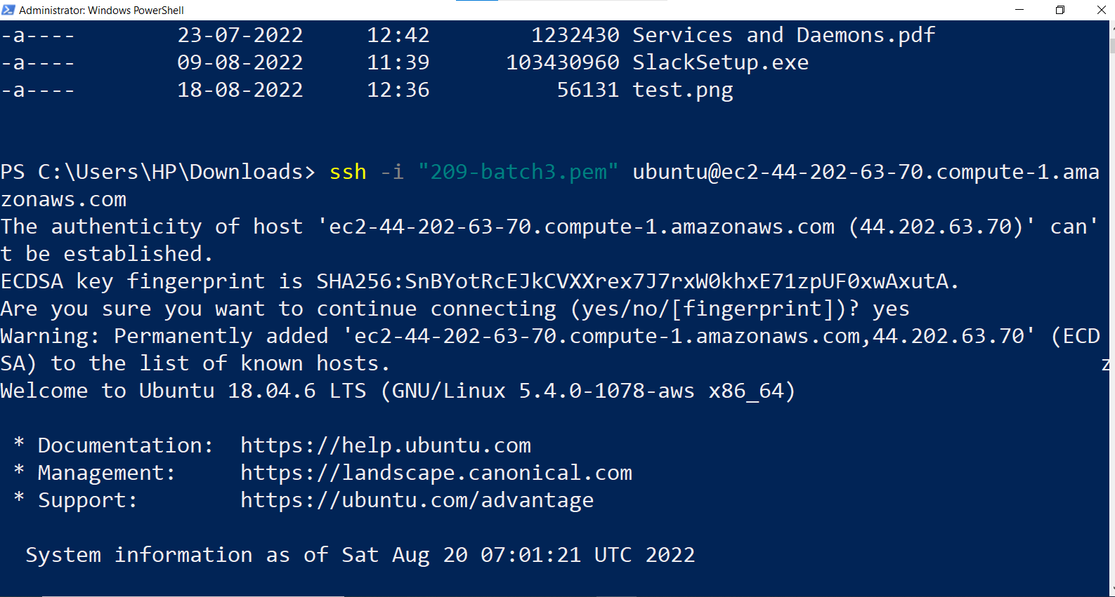

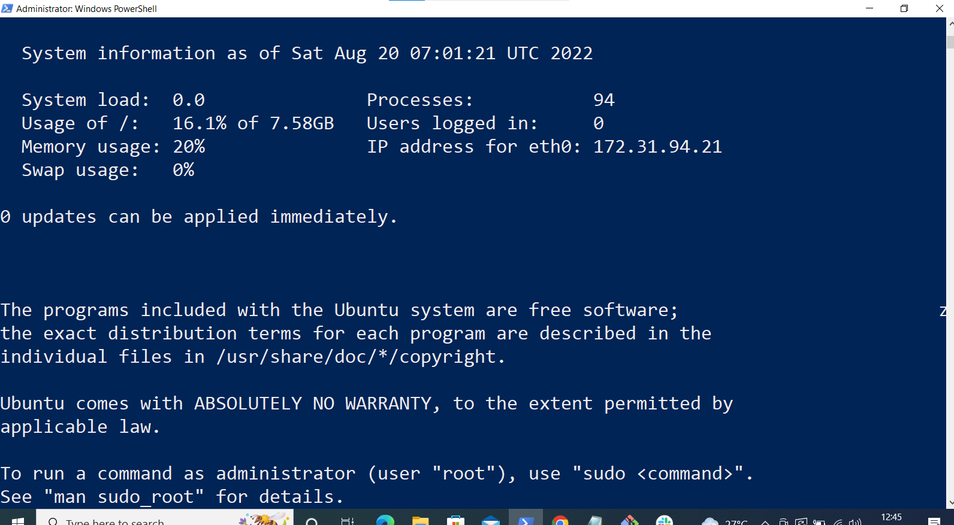

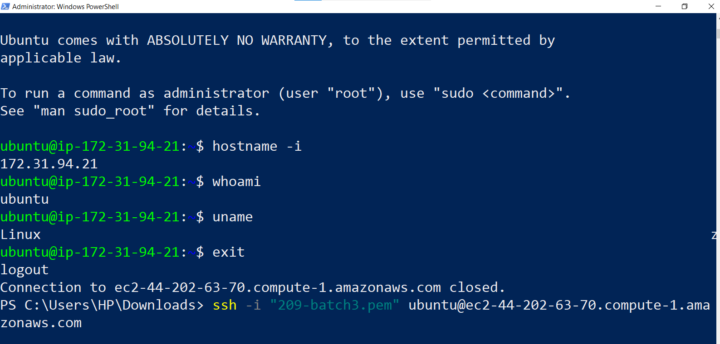

VM Login :

—-----------

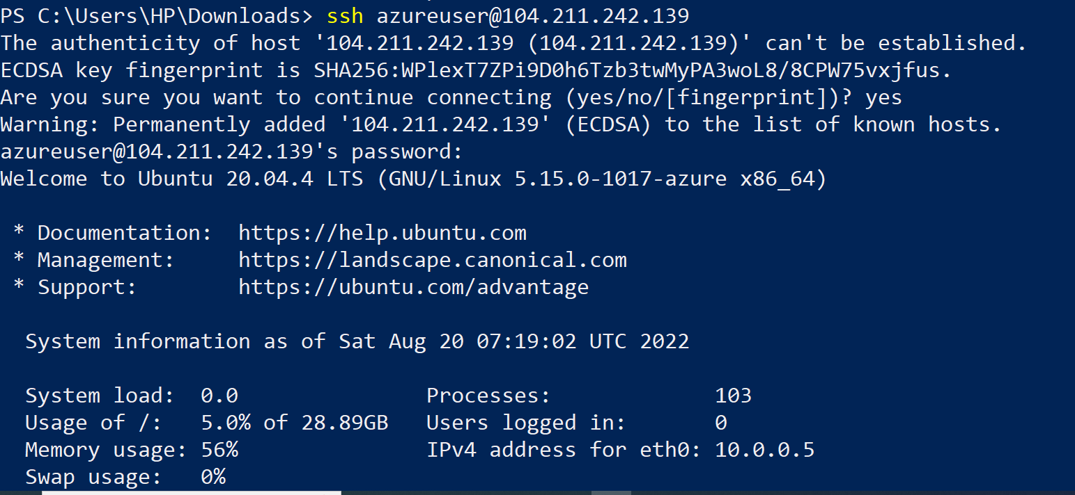

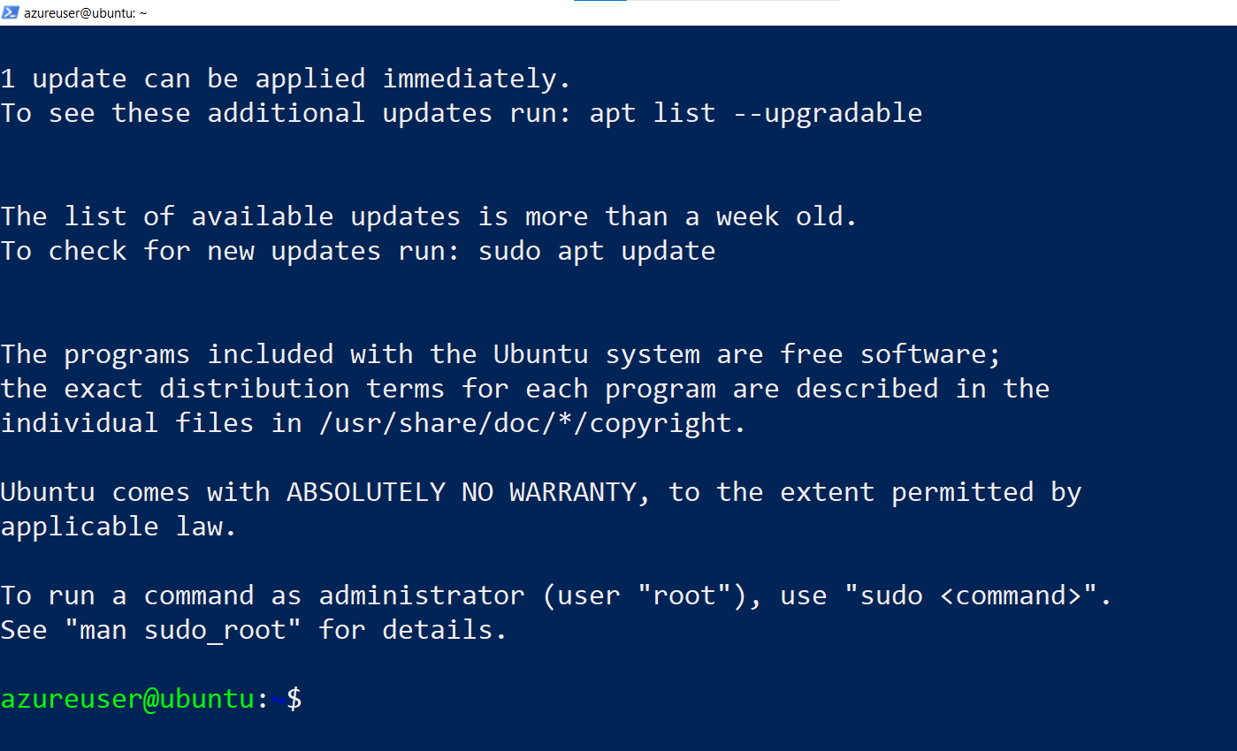

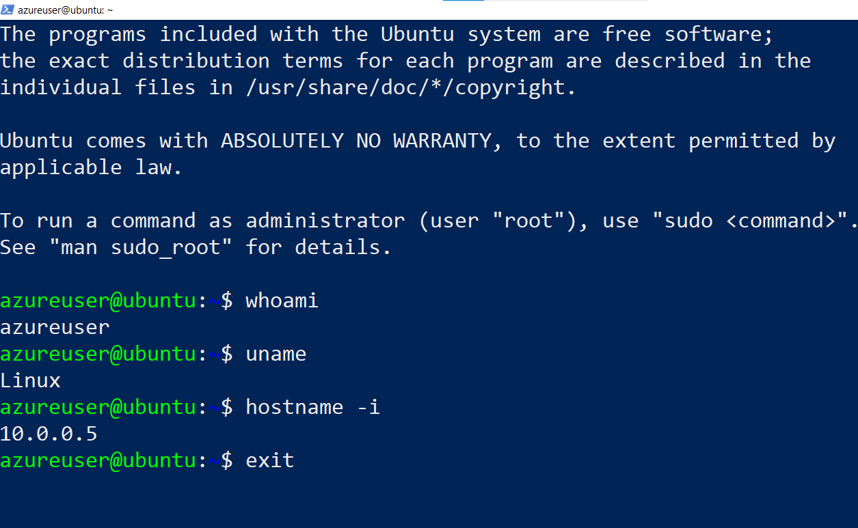

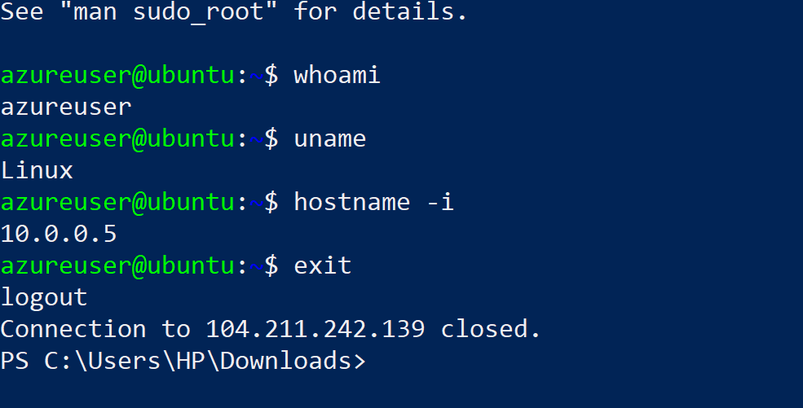

LINUX PRACTICE PLATFORMS

<https://openvim.com/> [ Vi editor practice ]

https://www.tutorialspoint.com/linux_terminal_online.php

https://kinsta.com/blog/linux-commands/

https://labex.io/courses/linux-basic-commands-practice-online

https://www.practicelinux.com/

<https://cocalc.com/features/terminal>

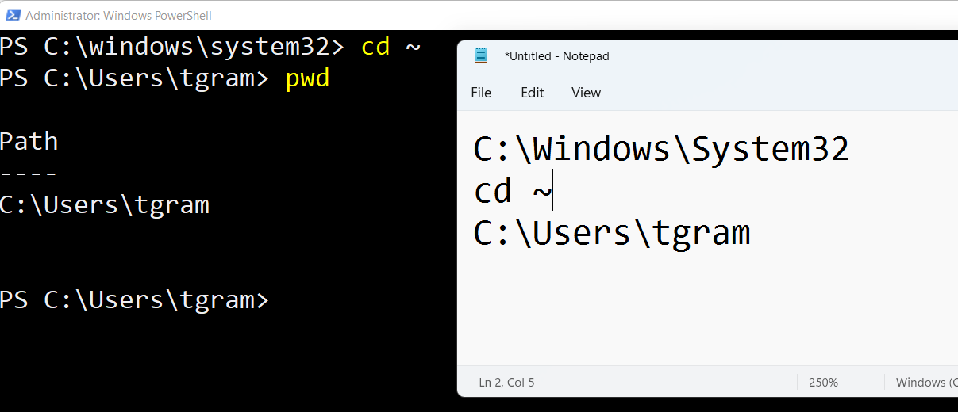

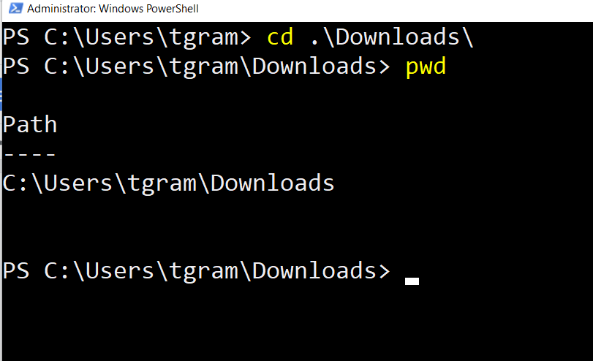

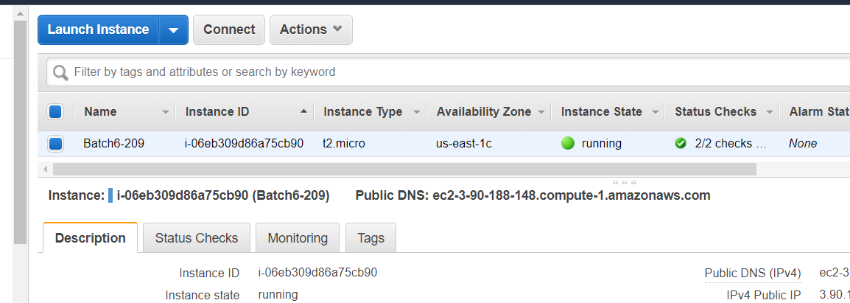

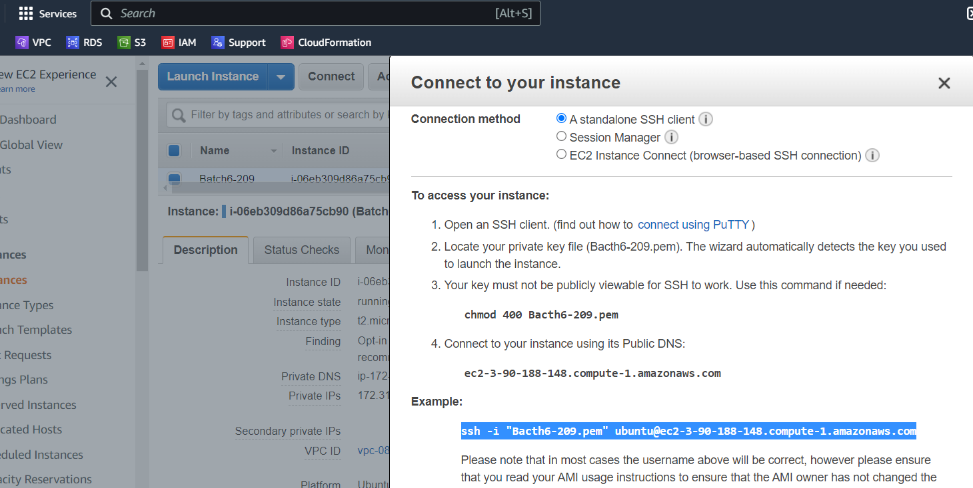

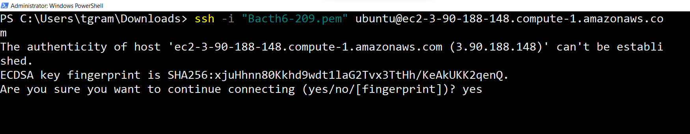

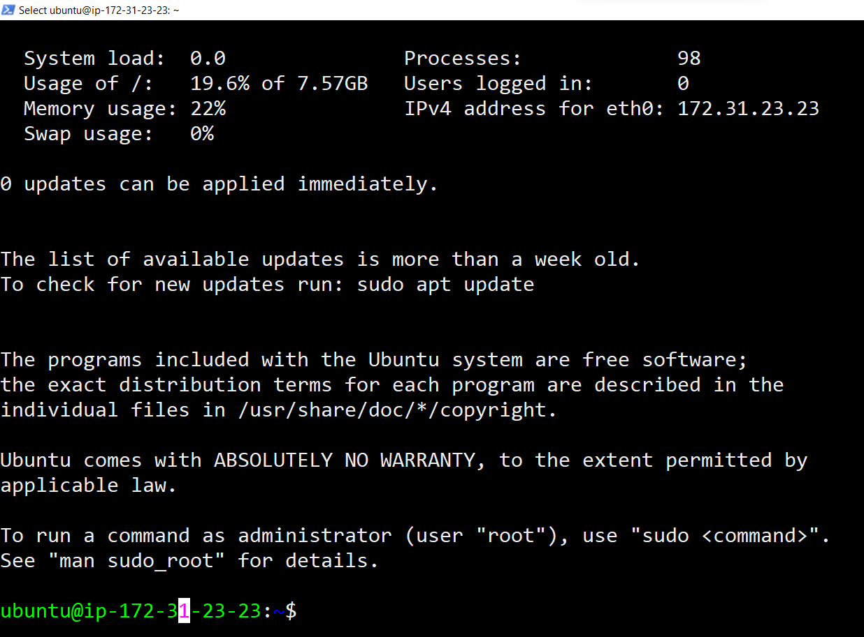

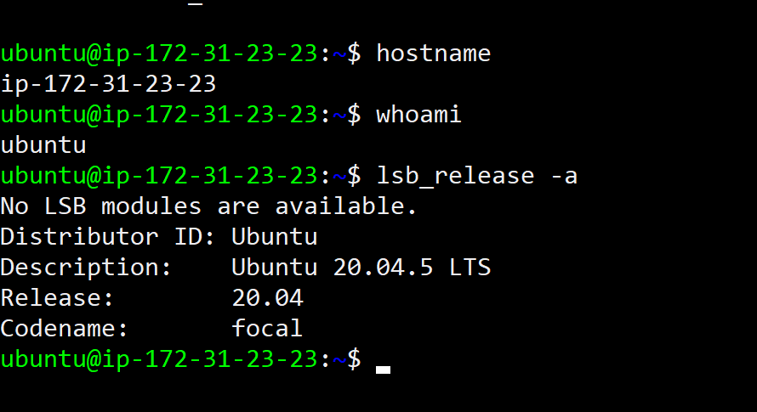

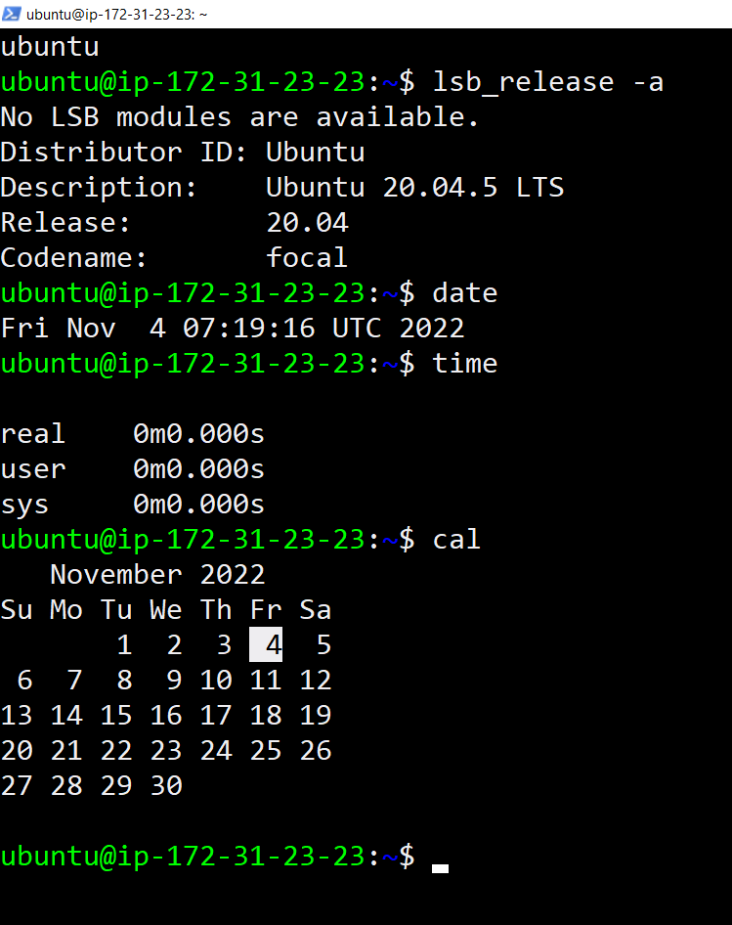

LINUX CHEAT SHEET 👍

======================

<https://www.guru99.com/linux-commands-cheat-sheet.html>

CHOCOLATEY INstallation 👏

—------------------------------------

<https://chocolatey.org/install>

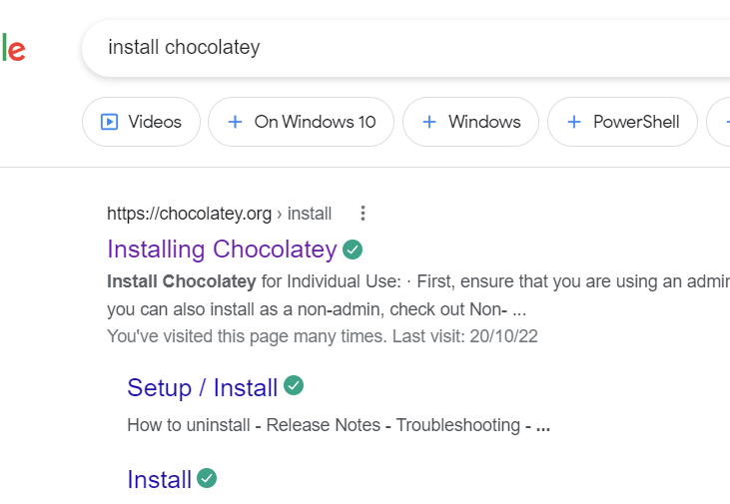

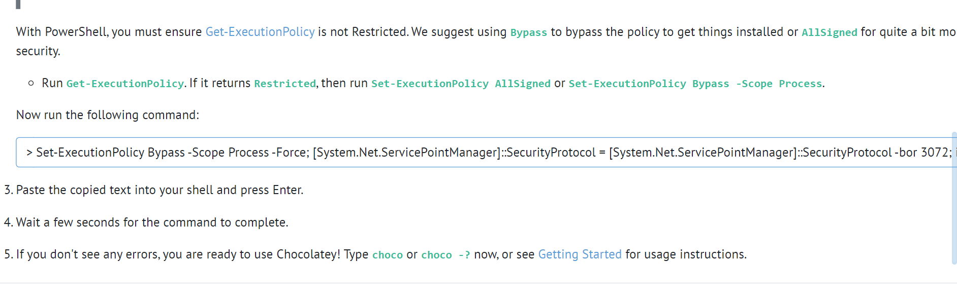

1. [ <https://openvim.com/> ]

1. Install chocolatey software on windows.

2. Install below softwares using chocolatey.

-> Git

-> Vscode [ https://community.chocolatey.org/packages/vscode ]

-> Notepadplusplus [ ]

-> Terraform

-> Vlc

-> Mobaxterm

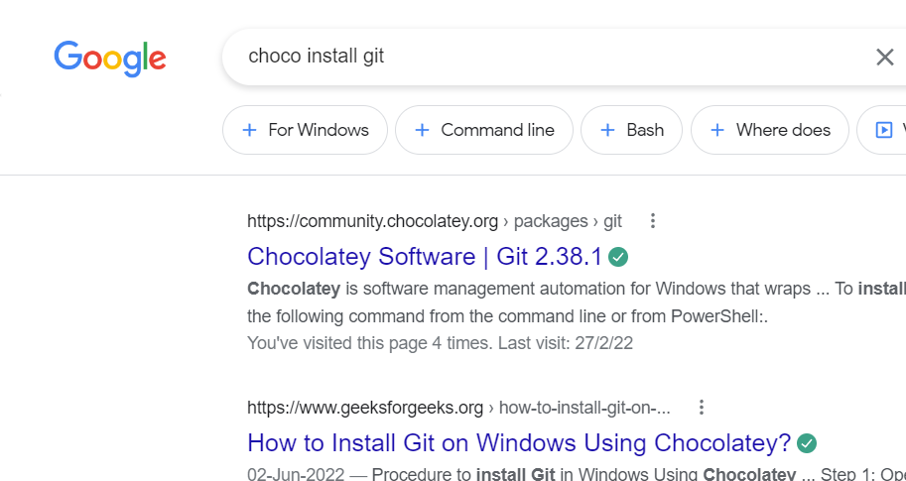

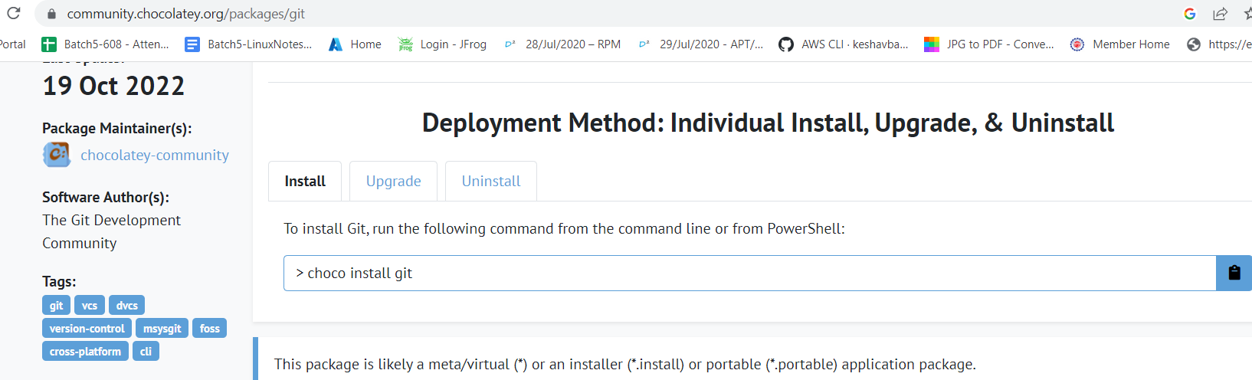

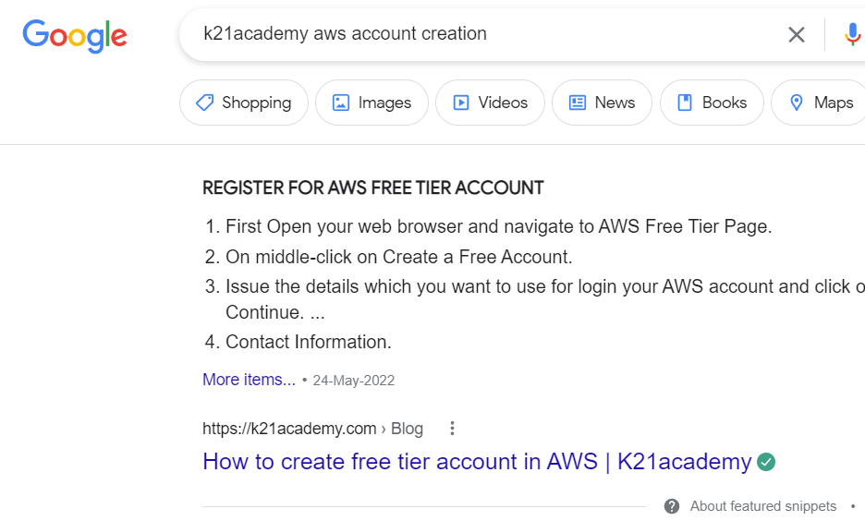

<https://k21academy.com/amazon-web-services/aws-solutions-architect/create-aws-free-tier-account/>

After login into VM 👍

—-----------------------------

ps

ps -aux

Ip addr

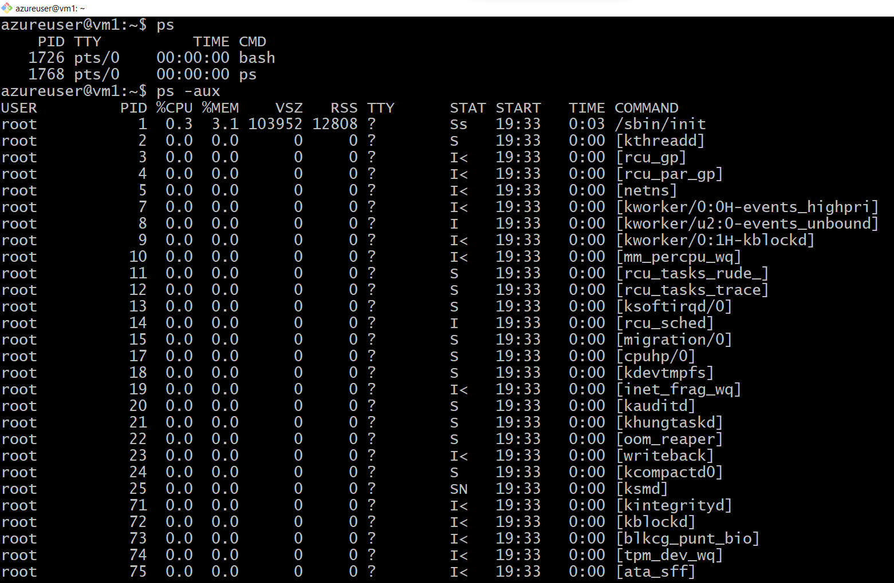

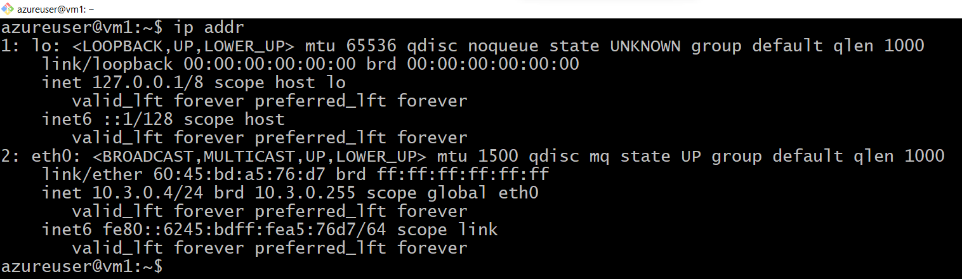

df -h

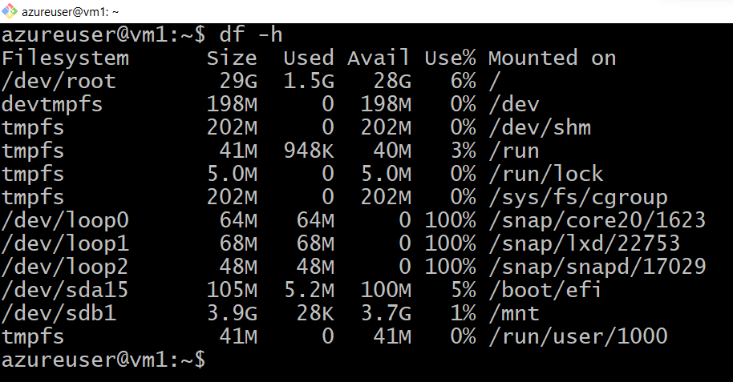

lsblk

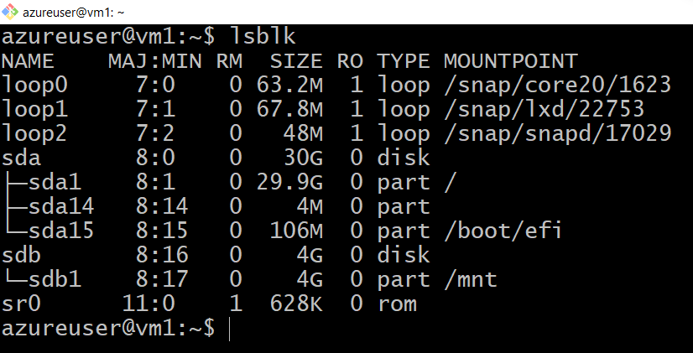

top

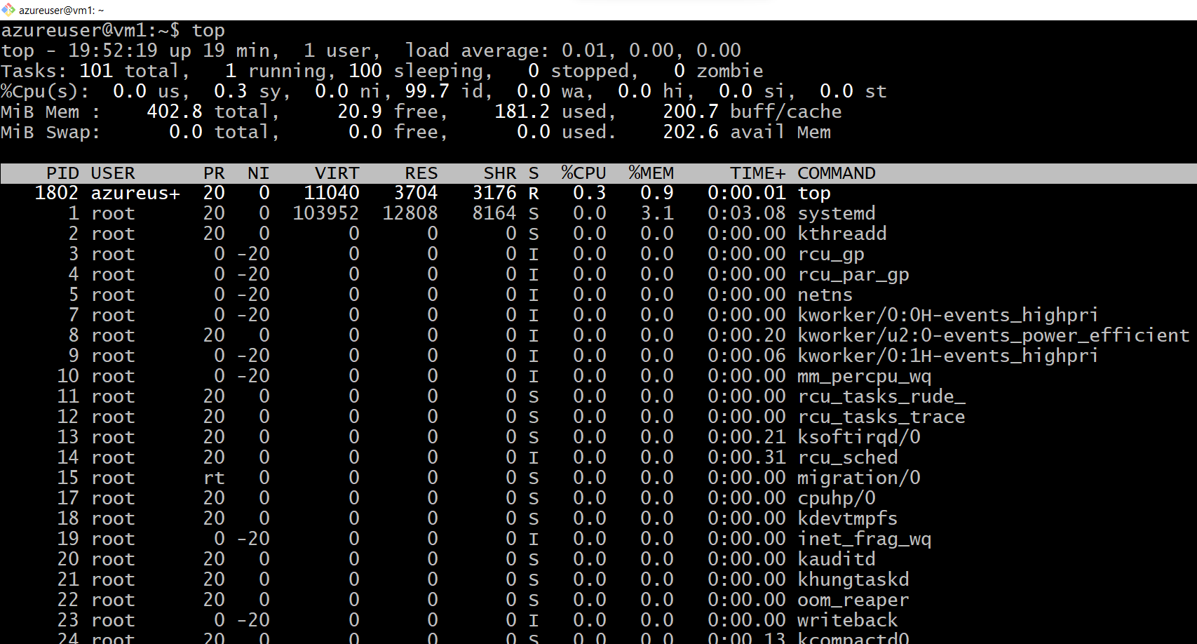

htop

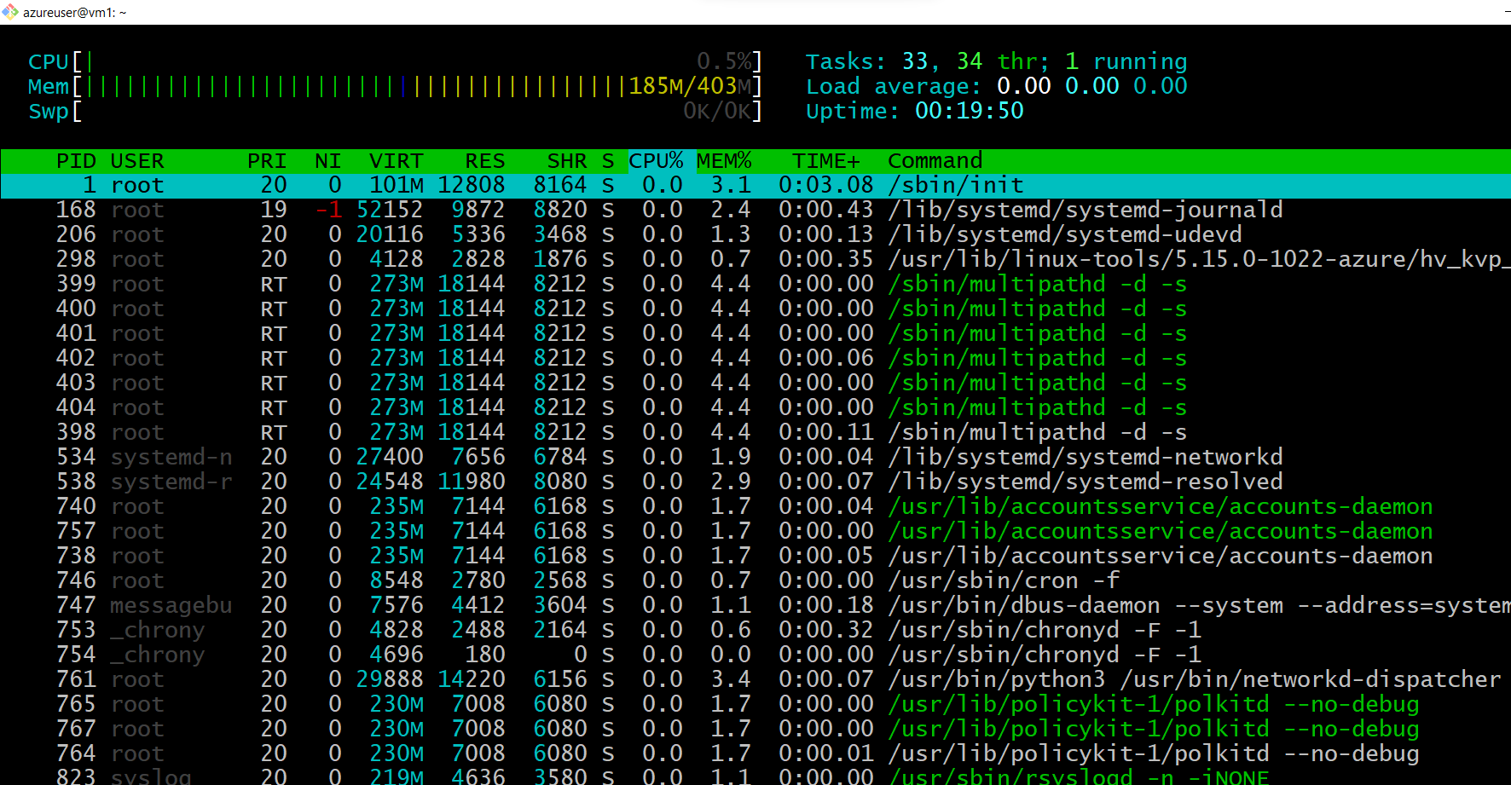

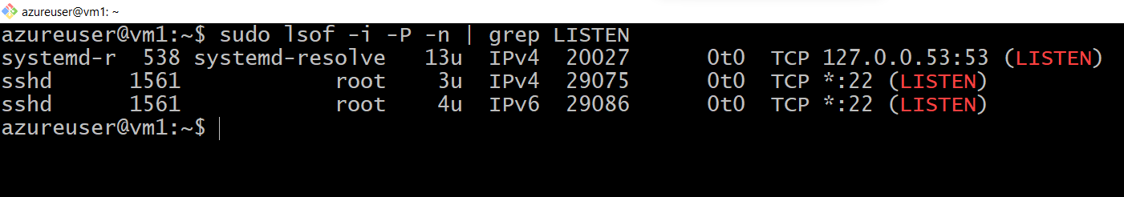

<https://www.cyberciti.biz/faq/unix-linux-check-if-port-is-in-use-command/>

sudo lsof -i -P -n | grep LISTEN

$ sudo netstat -tulpn | grep LISTEN

$ sudo ss -tulpn | grep LISTEN

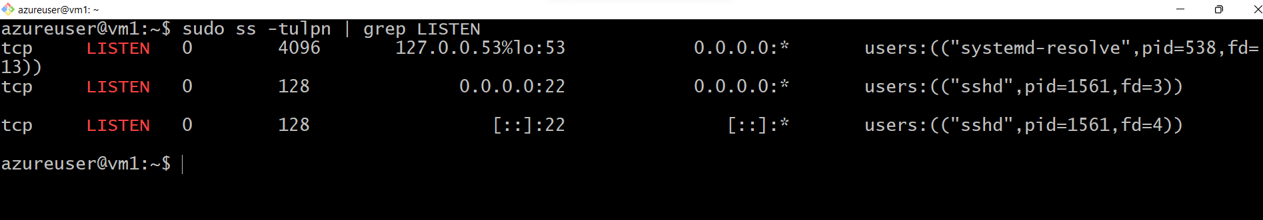

$ sudo lsof -i:22 ## see a specific port such as 22 ##

$ sudo nmap -sTU -O IP-address-Here

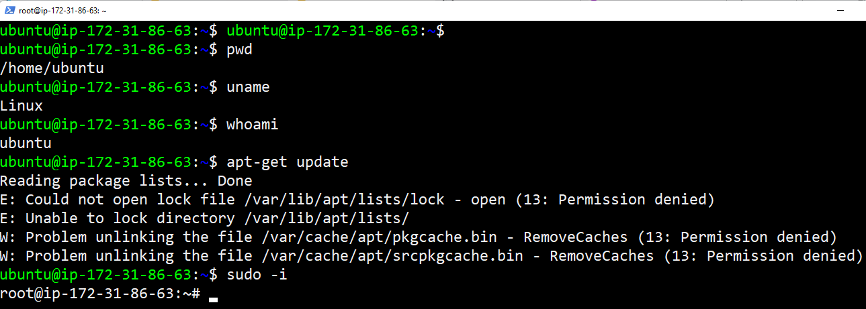

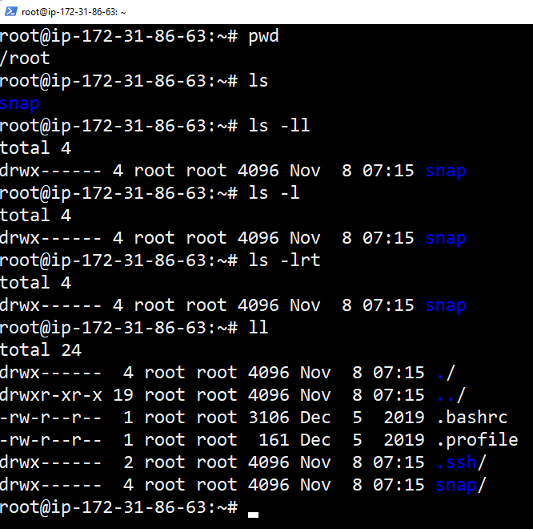

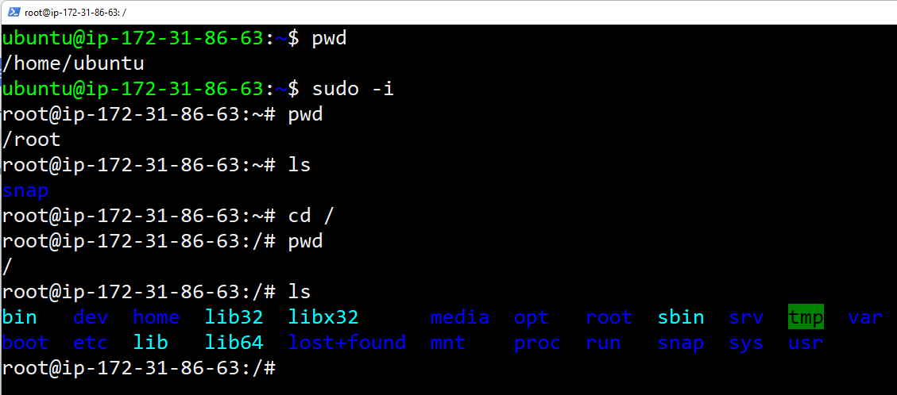

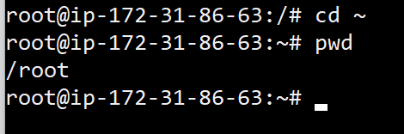

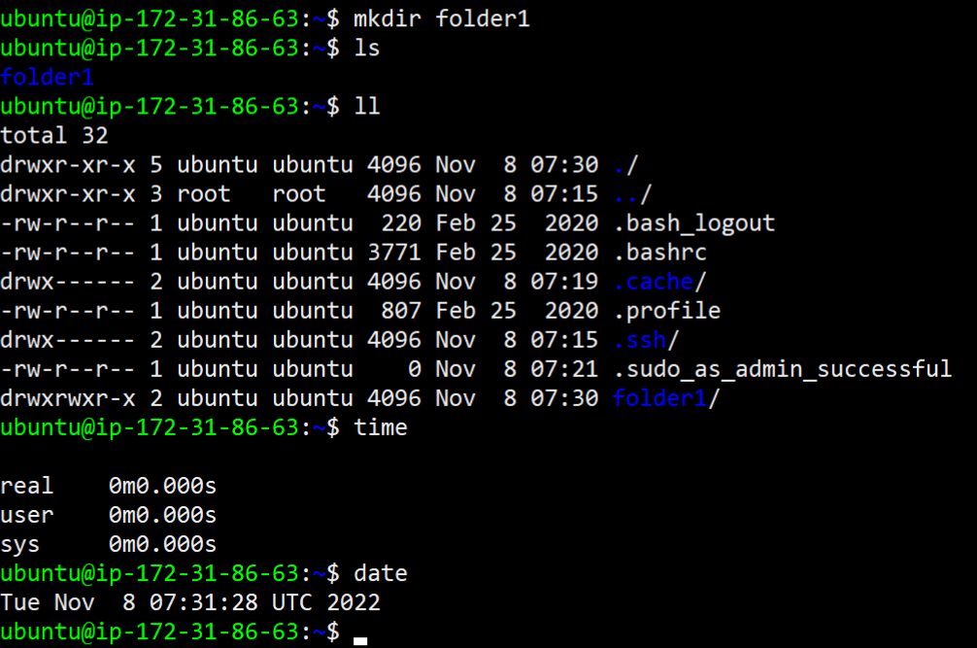

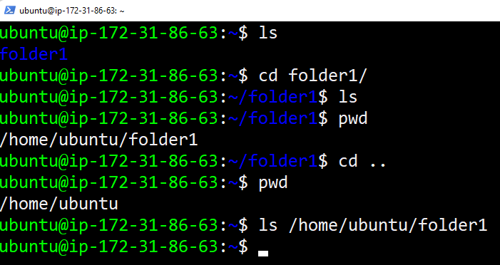

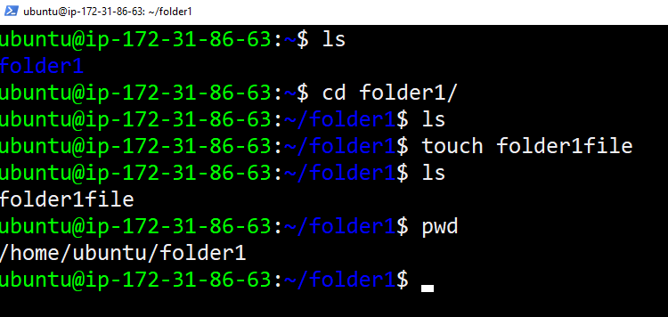

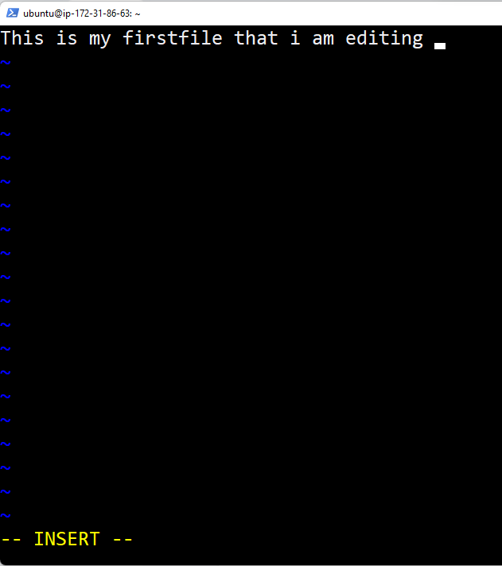

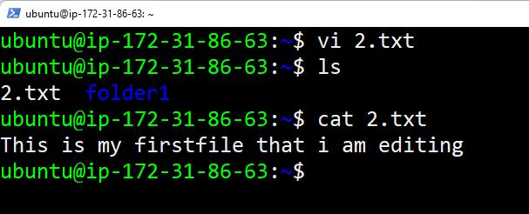

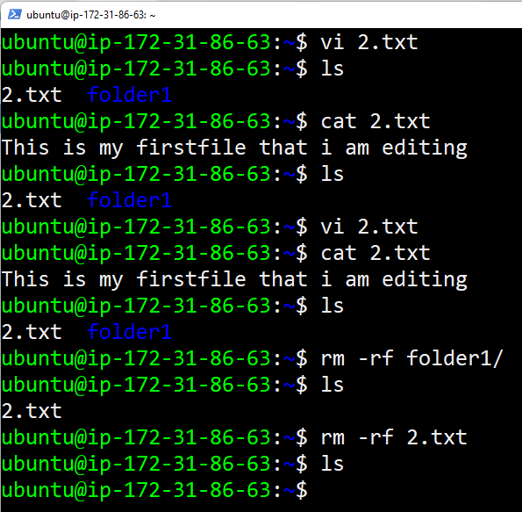

Create 50 files inside a directory and edit files and save

<https://www.ssh.com/academy/ssh/command>

LINUX CHEAT SHEET TO PRACTICE 👍

—----------------------------------------

<https://www.golinuxcloud.com/linux-commands-cheat-sheet/>

<https://www.guru99.com/linux-commands-cheat-sheet.html>

<https://www.guru99.com/linux-pipe-grep.html> [ Grep example ]

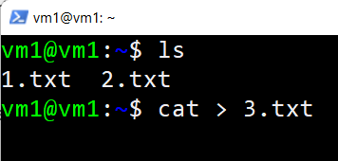

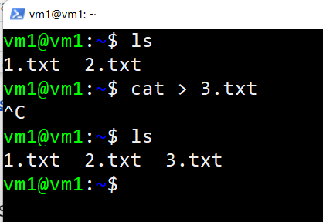

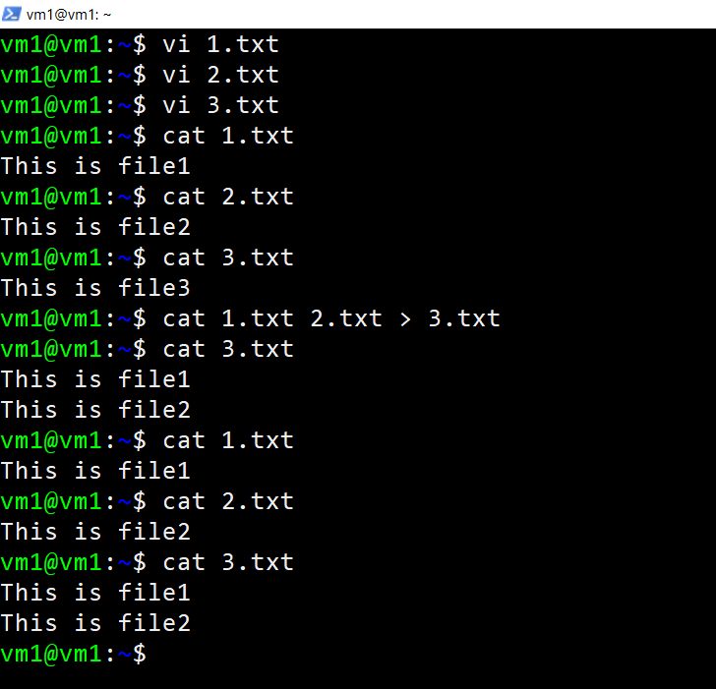

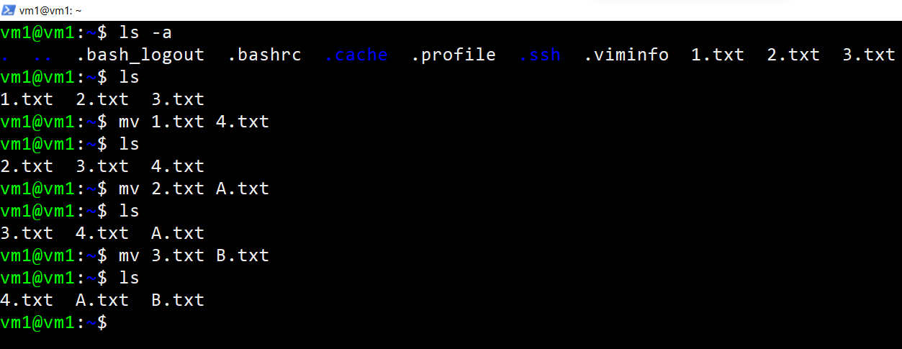

<https://linuxhint.com/cp-command-linux/>

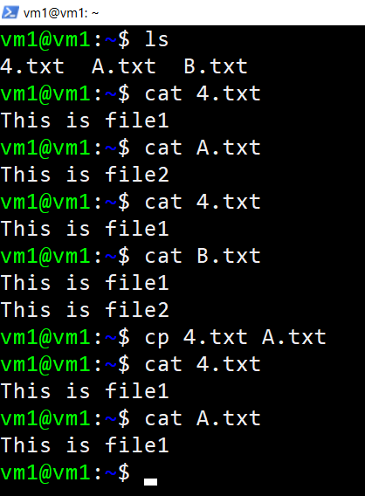

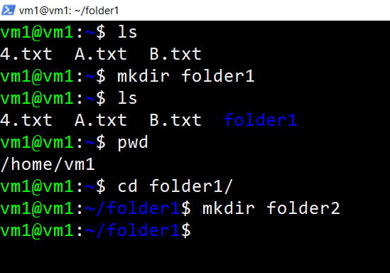

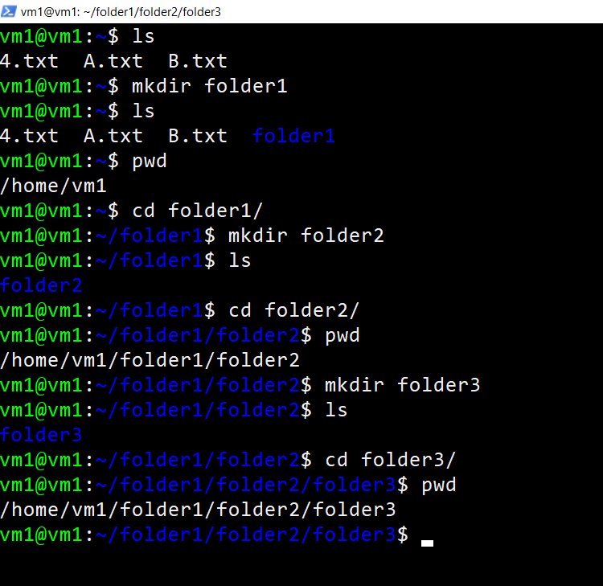

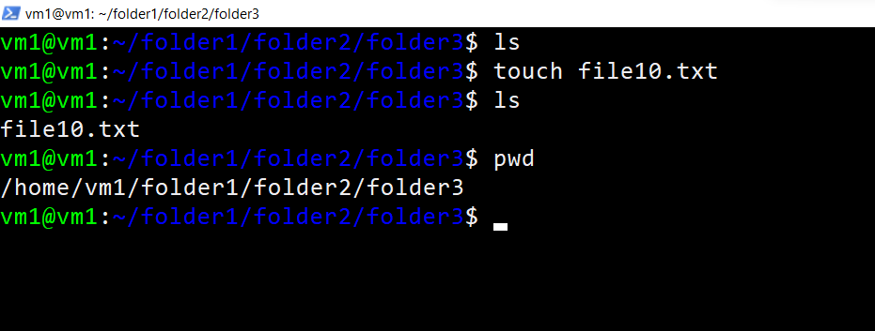

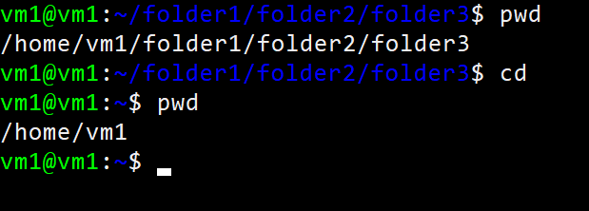

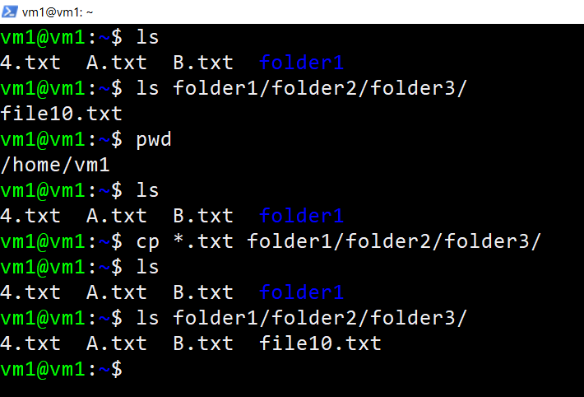

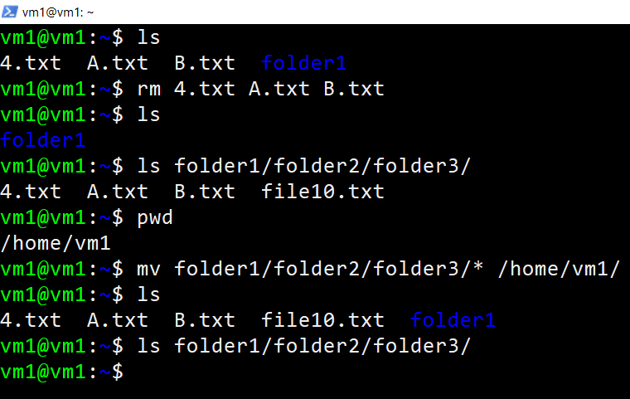

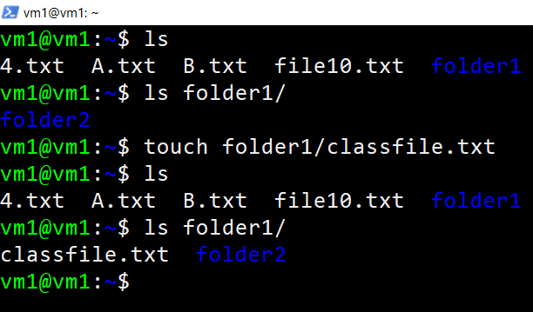

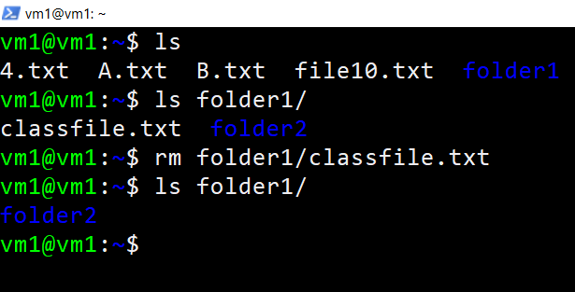

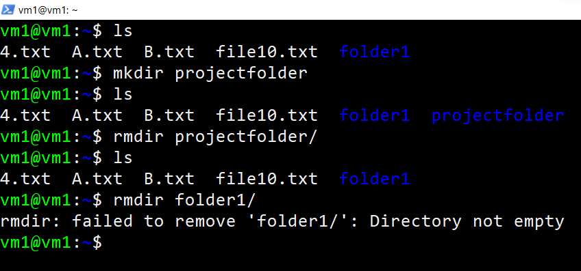

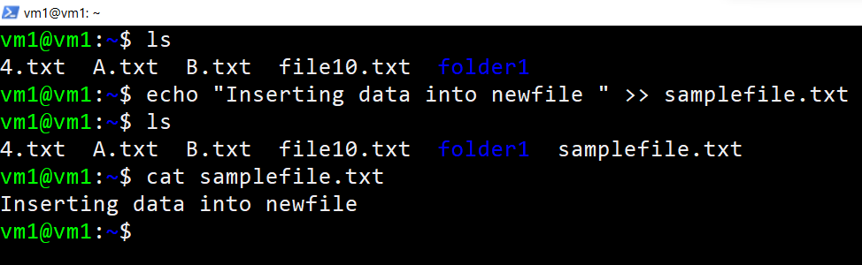

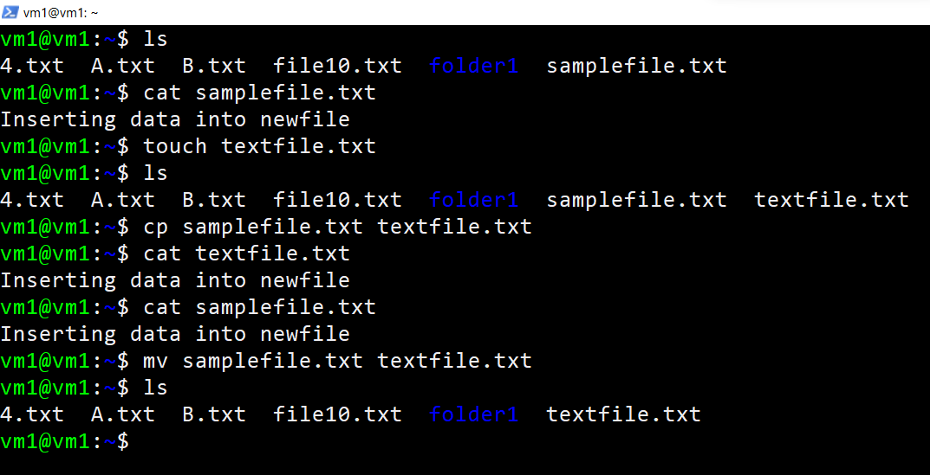

<https://www.linuxtechi.com/cp-command-examples-linux-beginners/>

<https://www.tecmint.com/linux-directory-structure-and-important-files-paths-explained/>

<https://www.howtogeek.com/117435/htg-explains-the-linux-directory-structure-explained/>

