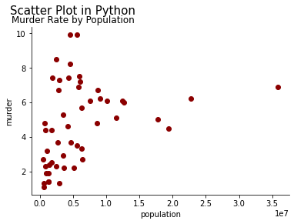

Scatter Plot in Tableau

Bubble chart in Tableau

Density map in Tableau

