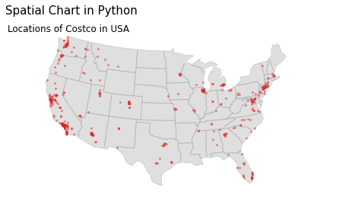

Heat Map in Tableau

Spatial Chart in Tableau

Violin Chart in Tableau

