Tax Audit Fee AY 24-25
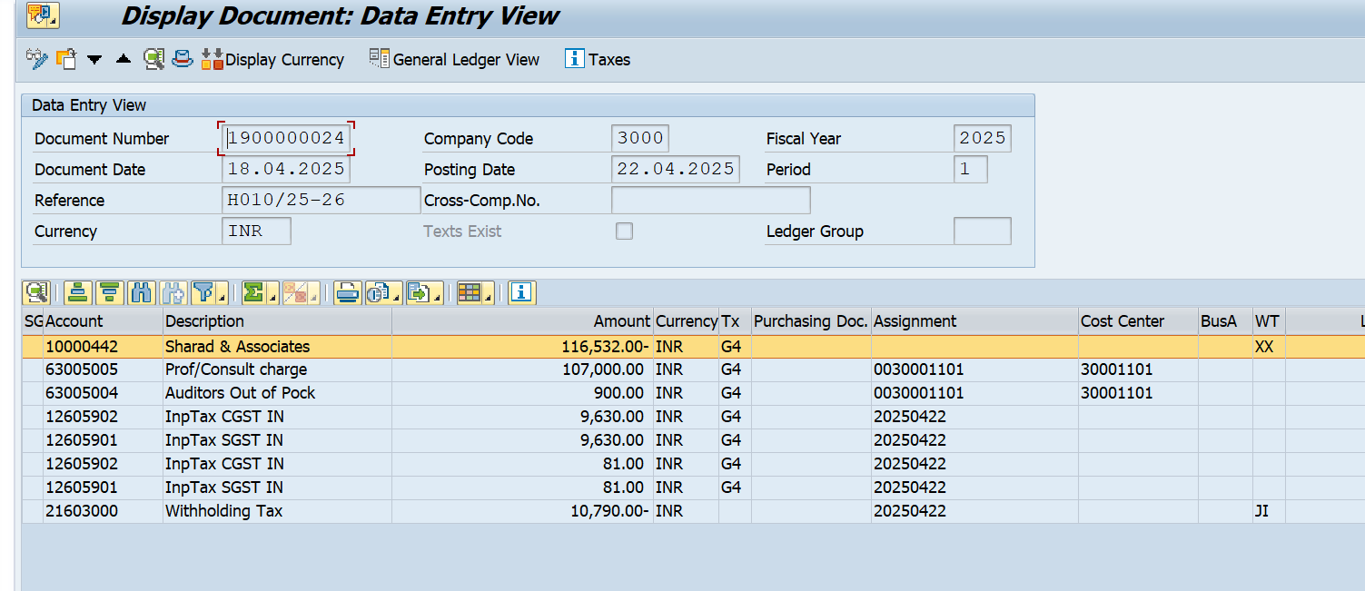

Reimbursement of OPE- Tax Audit-2024-25
